**News Release**

**For immediate release**

**12th April 2016**

**Ancasta confirms big presence at Palma Boat Show**

**The Ancasta Group will be all over the Palma Boat Show 2016, which runs from 28th April to 2nd May 2016, with three different parts of the group represented at the show.**

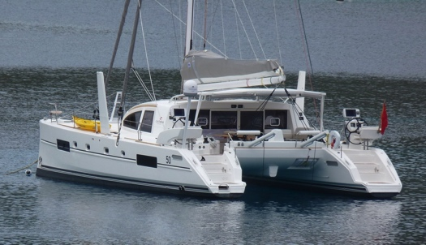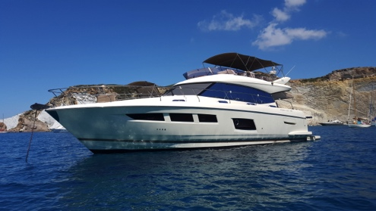As Prestige Yachts main dealers for the Balearics, Ancasta will be welcoming UK visitors to the Prestige stand (nos. 104, 105 and 106). Ancasta Yachts will be presenting two brokerage boats in the marina, a Prestige 550 on berth 237, and a Catana 50 on berth 239. For those looking to buy, or sell their boats, Ancasta International Boat Sales Palma will be present on the quay (stand M-21a). As well as having details available for over 600 used boats, the team can advise on finance, insurance etc. This complete offering means that the Ancasta Group can help visitors to the show explore all options for boat ownership in 2016.

Gentileschi a Prestige 550 for sale through Ancasta Yachts at the Palma Boat Show 2016

Ancasta is now a dealer for Prestige Motor Yachts in the Balearics region. Prestige Yachts sales and servicing is available in the region through Ancasta’s Palma de Mallorca office, which benefits both international clients and locals of all nationalities living in the Balearics. Dealing with Ancasta’s Palma office is made even easier by the multilingual team in place and, as part of the Ancasta Group, the team has the support and backing of the established network.

Fins, a Catana 50, available for sale through Ancasta Yachts at the Palma Boat Show 2016.

Ancasta looks forward to welcoming visitors to Palma Boat Show 2016. Contact Ancasta Palma on +34 971 719678 or email [palma@ancasta.com](mailto:palma@ancasta.com) to arrange viewing appointments.

For more information on Ancasta visit [www.ancasta.com](http://www.ancasta.com)

**ENDS**

**Notes to editors**

* Ancasta International Boat Sales has 15 offices across Europe
* Ancasta is the UK’s largest Prestige Luxury Motor Yachts dealer, the UK’s largest Beneteau Power and the UK’s largest Beneteau Sail dealer
* Ancasta is the main dealer for Prestige Yachts in the Balearic region
* Ancasta is exclusive UK dealer for Lagoon Catamarans
* In addition Ancasta is a new boat dealer for CNB Yacht Builders and McConaghy Yachts
* The Ancasta Group incorporates Hamble Yacht Services Refit & Repair and Advanced Rigging and Hydraulics, both operating from Port Hamble.
* For more information on Ancasta visit www.ancasta.com

Media enquiries via Ancasta International Boat Sales.

Will Blair, Group Marketing Director. Tel: +44 (0)2380 450 000