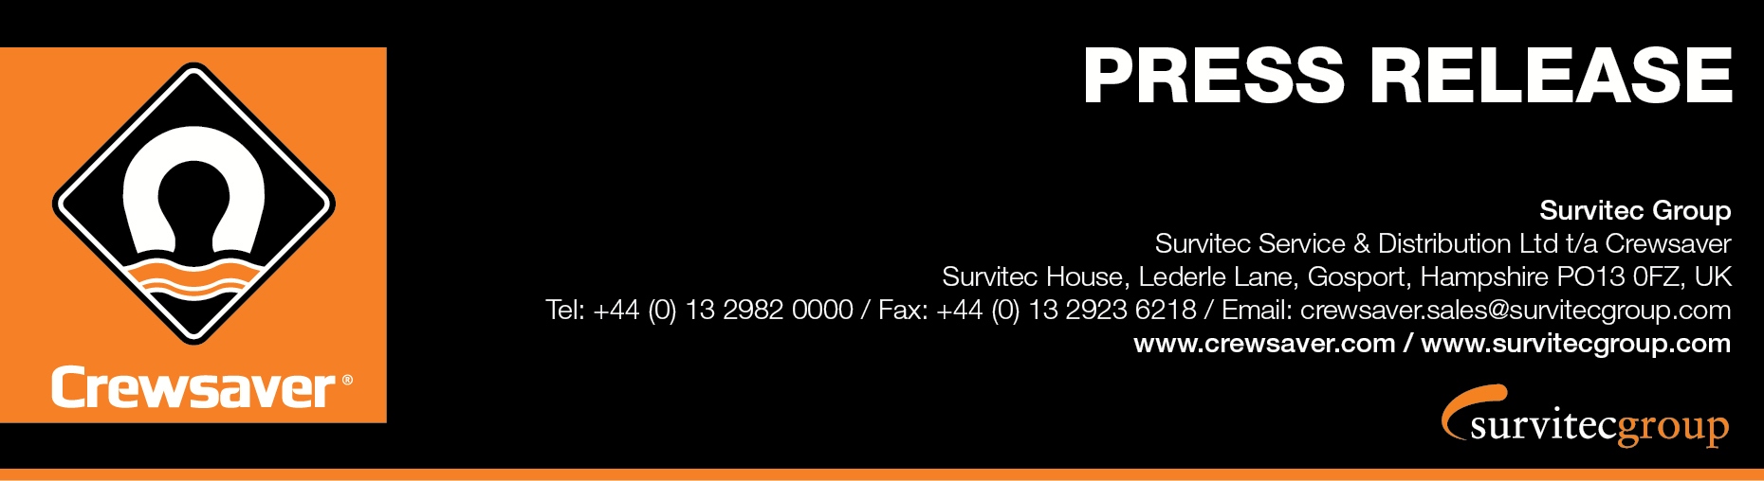
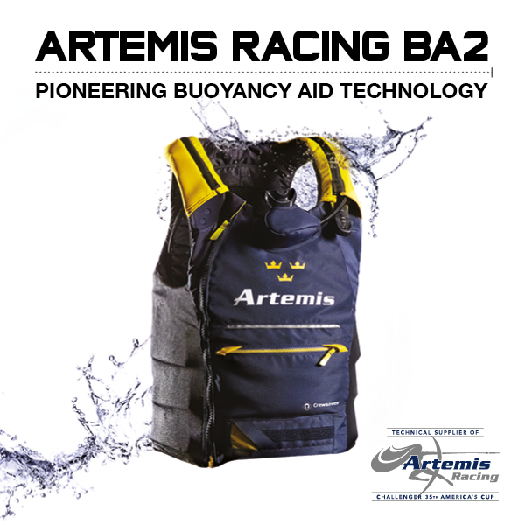
For Immediate Release
12th May 2016

Crewsaver, Technical Supplier of Artemis Racing is proud to introduce its pioneering new buoyancy aids designed exclusively with Artemis Racing for the prestigious 35th America’s Cup.

As part of the exciting safety collaboration with Artemis Racing, Crewsaver developed not one but two armoured buoyancy aids for the 35th America’s Cup taking place in Bermuda in June 2017. The DAME nominated Artemis Racing ErgoFit 50N Extreme buoyancy aid was introduced during the Louis Vuitton America’s Cup World Series in Oman and is now joined by the custom Artemis Racing BA2 50N buoyancy aid. Each buoyancy aid offers a different level of protection, giving the team a choice depending on the conditions of the day. Through Crewsaver’s collaboration with Artemis Racing the exciting decision has been made by Crewsaver to make the ErgoFit 50N Extreme commercially available. As of September 2016 this will give everybody the opportunity to benefit from the same advanced safety and performance technology as an America’s Cup sailor.
Iain Percy, Team Manager for Artemis Racing, comments: “Technology and innovation in the America’s Cup have taken a huge step forward over the last few years, but the technology for commercially available safety equipment did not meet our team's needs. With Crewsaver, we wanted to find a supplier able to develop a best in class series of equipment that meets the demands of this new era of performance sailing. Crewsaver’s dedication to this project has impressed us all and we are extremely proud of the collaboration.”
Ross Wilkinson, Managing Director of Crewsaver says “We are immensely proud of what has been achieved both by the Crewsaver designers and the Artemis Racing team. The Artemis Racing buoyancy aids are a result of over 16 months of hard work and is an impressive piece of engineering combining the very best in safety features, performance and style”.
Armour
The extreme foiling catamarans on which the team operates create a challenging environment requiring the very best in cutting edge performance from its safety equipment. The bespoke Artemis Racing BA2 50N has a removable Force Field CE level 2 full back protector, whilst articulated high density foam also protects the team’s front and sides from impact. The shorter profile Artemis Racing ErgoFit 50N Extreme provides Force Field CE level 1 back protection with high density impact foam in the front panels.
Air Supply Systems
The Artemis Racing BA2 50N is designed to be used in conjunction with a compressed air carbon cylinder and regulator. The cylinder is positioned on the back covered by a super-stretch neoprene pocket to reduce drag and snag risks. The low pressure hose runs over the shoulder and is protected by a neoprene shoulder panel with a burst zip for ease of release. The second stage with mouthpiece is located in a custom 3D pouch on the chest of the buoyancy aid for hands free access allowing full freedom of movement for the wearer.
The Artemis Racing ErgoFit 50N Extreme can also be used with and without an air supply system where a smaller cylinder can be mounted on the chest of the buoyancy aid. The integrated regulator on the front of the jacket also allows for hands free use. In instances where the air system is not required it can simply be removed by unzipping the pouch from the main buoyancy aid.
Design
Both buoyancy aids are low profile with stretch-to-fit designs and approved to the CE ISO 12402 standard. High visibility shoulder panels and various equipment attachment points provide easy access to safety knives and communication equipment. The concealed rear pocket found on each buoyancy aid also offers great storage for a hydration pack where the shoulder panels act as a secure hydration tube exit.
Airflow technology has been applied throughout and has been combined with stretch mesh side panels to allow the transfer of heat. This technology will help the team to regulate their body temperature during the exertions of racing in a range of climates.
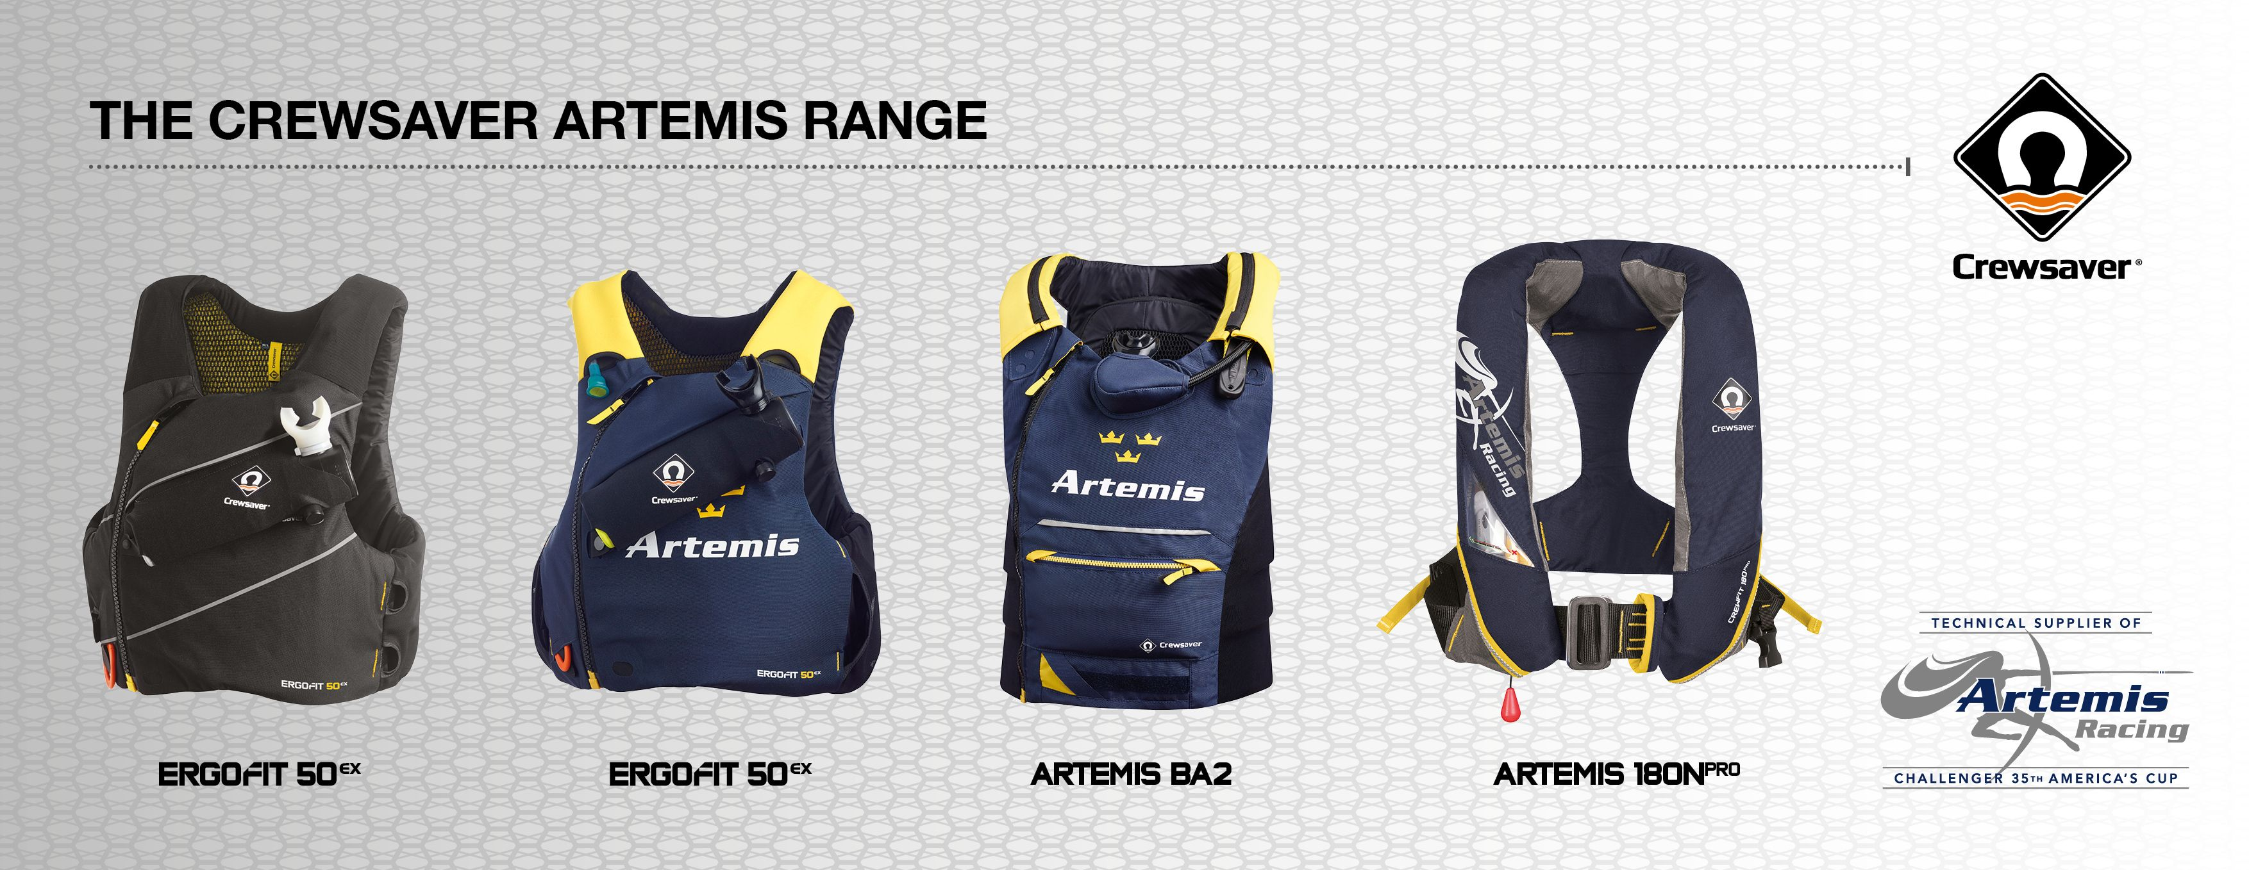

ENDS//
For media information, hi-res images or product tests please contact:

Crewsaver
Hazel Proudlock, Marketing Dept
T +44 (0) 1329 820000
E hazel.proudlock@survitecgroup.com

Or

Alison Willis – Marine Advertising Agency Ltd
T +44 (0) 23 9252 2044
E Alison@marineadagency.com

Notes to Editors

Crewsaver is a world-leading manufacturer of marine safety equipment and clothing for the commercial and leisure marine industries. Based in Gosport, Hampshire, the company designs and manufactures bespoke safety equipment for several countries’ Special Forces, and the aviation and oil industries. Crewsaver is the only company to hold an exclusive contract to supply lifejackets to the UK government’s Environment Agency and the Royal National Lifeboat Institution (RNLI). They are part of the Survitec Group.

www.crewsaver.com

Survitec Group holds market-leading positions worldwide in marine, defence and aerospace survival technology. Headquartered in Birkenhead, the company employs 2000 people across 10 manufacturing sites and 50 service centres, operating through a network of a further 550 distributors and agents to bring its best-in-class products and services to a global customer base. With an extensive history spanning over 160 years and a portfolio of some of the most reputable brands in the safety and survival industry, Survitec is committed to product innovation, technological advancement and quality assurance.
Key products within Survitec’s portfolio include marine, defence and aviation Liferafts, world leading submarine escape technology, lifejackets for commercial airlines and the offshore industry as well as pilot flight equipment, including anti-g clothing used for the Eurofighter and JSF programmes. The Group also pioneered marine evacuation technology and today the unique MarinArk system is used on many major cruise ships across the globe.

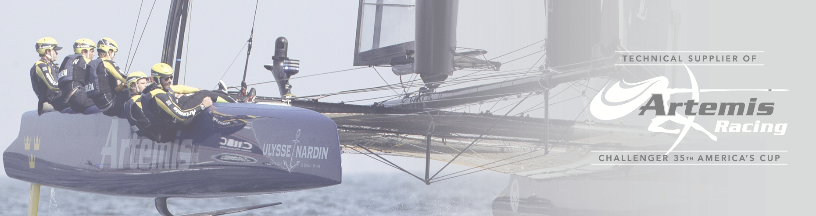
www.survitecgroup.com

