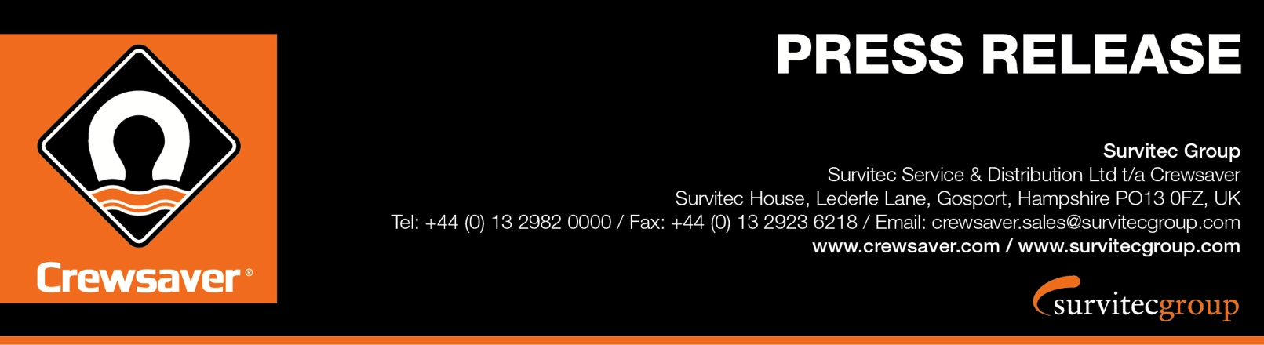
For Immediate Release
Seawork: Stand PB67
23rd May 2016

Survitec Group launches the pioneering Crewsaver Workvest lifejacket range, including the Crewfit XD lifejacket providing the ultimate in comfort, performance & buying flexibility
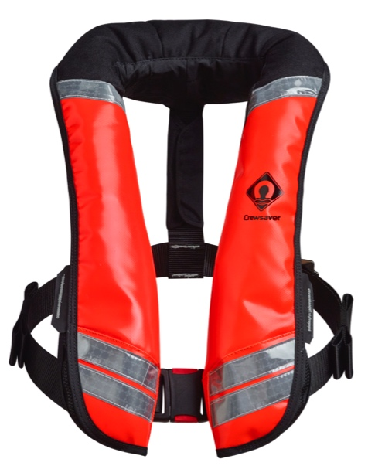
Survitec Group is delighted to launch its pioneering Crewsaver single chamber Workvest range, ideal for the working marine market, at Seawork 14-16th June 2016.

This new range uses the technology and expertise gained by Survitec Group through its work in the design and manufacture of lifejackets for the marine and aviation markets, to create a product range for the working marine market which offers the most advanced comfort and performance technologies to date.

Feedback has shown that many operators are finding their current lifejackets too uncomfortable to wear for periods of time, using Fusion 3D technology Crewsaver now offers companies the opportunity to purchase 3D designed lifejackets, greatly increasing the users comfort over long and continued use.

Bladder design is integral to Crewsaver lifejackets and additionally all Crewsaver lifejackets now come with a unique chin support, helping to keep you comfortable and well supported should you fall into the water. The lifejackets are designed to remain robust and reliable when used constantly, with the option of a wipe clean cover for those operating in the harshest of conditions.

The Crewfit 275N & 150N XD, Crewfit 150N HF and Crewfit 150N make up the complete Workvest range and create a comprehensive catalogue to provide the ultimate in buying flexibility. The XD lifejacket offers an innovative modular design. This allows the buyer to choose from an extensive number of lifejacket options to cater for their individual workforce requirements without the inconvenience of long lead times. A number of configurations such as cover, inflation and harness options will be available.

‘There has been an extensive amount of development in modern lifejacket design recently, improving technology and comfort. It is absolutely vital that this technology is available for the working markets, which is why we are delighted to have been able to make this range available to our commercial customers,’ says Ross Wilkinson, Managing Director for Survitec Group.
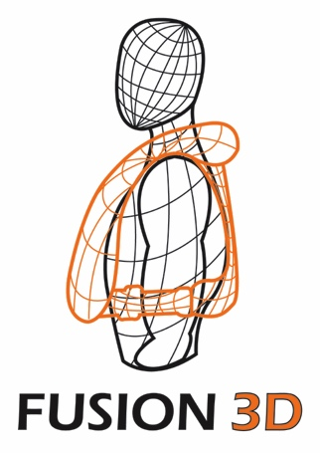
What is Fusion 3D?
The innovative Fusion 3D technology moulds to the shape of your body and sits off the neck giving the user total freedom of movement – it’s so comfortable you will forget you are wearing it, ideal for a busy working environment where the priority is ensuring that employees remain safe at all times.

ENDS//

For media information, hi-res images or product tests please contact:

Crewsaver
Hazel Proudlock, Marketing Dept
T +44 (0) 1329 820406
E hazel.proudlock@survitecgroup.com

Or

Alison Willis – Marine Advertising Agency Ltd
T +44 (0) 23 9252 2044
E Alison@marineadagency.com

Notes to Editors

Crewsaver is a world-leading manufacturer of marine safety equipment and clothing for the commercial and leisure marine industries. Based in Gosport, Hampshire, the company designs and manufactures bespoke safety equipment for several countries’ Special Forces, and the aviation and oil industries. Crewsaver is the only company to hold an exclusive contract to supply lifejackets to the UK government’s Environment Agency and the Royal National Lifeboat Institution (RNLI). They are part of the Survitec Group.

www.crewsaver.com

Survitec Group holds market-leading positions worldwide in marine, defence and aerospace survival technology. Headquartered in Birkenhead, the company employs 2000 people across 10 manufacturing sites and 50 service centres, operating through a network of a further 550 distributors and agents to bring its best-in-class products and services to a global customer base. With an extensive history spanning over 160 years and a portfolio of some of the most reputable brands in the safety and survival industry, Survitec is committed to product innovation, technological advancement and quality assurance.
Key products within Survitec’s portfolio include marine, defence and aviation Liferafts, world leading submarine escape technology, lifejackets for commercial airlines and the offshore industry as well as pilot flight equipment, including anti-g clothing used for the Eurofighter and JSF programmes. The Group also pioneered marine evacuation technology and today the unique MarinArk system is used on many major cruise ships across the globe.

www.survitecgroup.com

