Press Release
For Immediate Release
16th May 2016
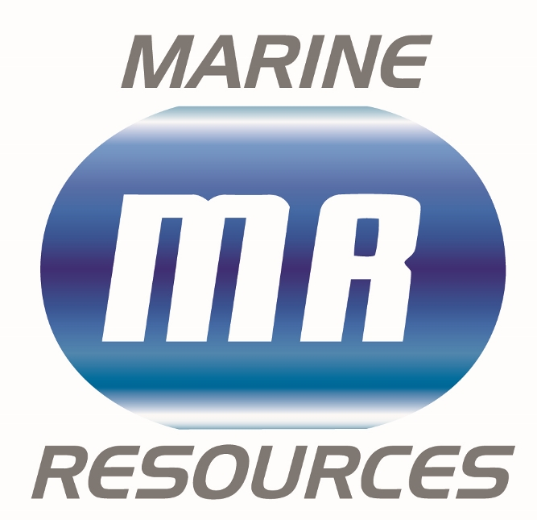
Marine Industry Regatta 2016 welcomes new sponsor, Marine Resources

The Marine Industry Regatta team is delighted to announce that Marine Resources has come on board as BBQ and prize giving sponsor for the Marine Industry Regatta 2016.

Thanks to Marine Resources, competitors attending the BBQ will be able to enjoy a wonderful spread at a greatly reduced cost.

With a band booked, Ian Walker confirmed as a guest speaker and a wonderful selection of prizes donated, the BBQ will make a great end to an exciting day.

Companies are encouraged to invite not only event competitors to the BBQ but also other members of their team to enjoy the evening’s activities. Please also remember to book tickets in advance.

‘It’s great to see the event back again and with a new lease of life, my team are really excited about having a day on the water and are already starting to get competitive. When the opportunity came up to sponsor the event I was delighted to be able to get involved.’ James Ward, Marine Resources

Mike Shepherd, Director of the Marine Advertising Agency, who are also involved with the regatta said “We’re looking forward to the industry coming together for this event. It’s great to have companies from across different marine sectors involved and we warmly welcome Marine Resources sponsorship of the BBQ and prize giving, which will round the event off perfectly.”

The Marine Industry Regatta takes place on Wednesday 1st June 2016, sailing out of Port Solent in Sunsail First 40’s. The regatta is a great way to get together with other marine professionals and to entertain clients and staff. Charitable donations from the

event will raise funds for the John Merricks Sailing Trust and the Andrew Simpson Sailing Foundation, another great reason to get involved.

With only five boats remaining for hire, companies that are interested in taking part are encouraged to book now to avoid disappointment.

For more information on the Marine Industry Regatta 2016, to sign up and to find out who has already signed up, please call Alex Tredget at Sunsail on 02392 222 221 or visit www.marineindustryregatta.com

ENDS//

For media information & hi-res images please contact:

Alison Willis – Marine Advertising Agency Ltd
T +44 (0) 23 9252 2044
E Alison@marineadagency.com

Notes to Editors
Marine Resources
www.marineresources.com

Marine Industry Regatta Is the day each year when the marine industry goes sailing. Originally conceived by Peter Nash (Boating Business, editor) this year the event welcomes the Survitec Group as title sponsor and open up to entries from the commercial sector of the industry. Sailed in Sunsail First 40’s from Port Solent the regatta is a great way to get together with other marine professionals and to entertain clients and staff. We look forward to seeing you all at the breakfast briefing 1st June 2016.

www.marineindustryregatta.com

