News Release
For immediate release
12th May 2016

Marine Advertising Agency adds to web development portfolio with online shop

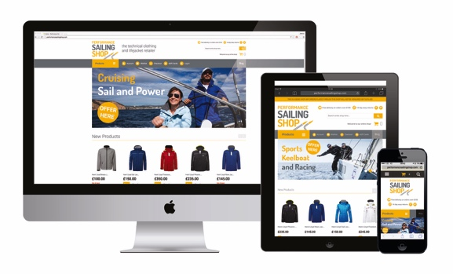
Marine Advertising Agency (MAA) is now able to offer the development of online shops powered by Magento as part of its portfolio of services. www.performancesailingshop.com launches on Friday 13th May 2016 at the popular MAA Press Lunch and the company is confident in its ability to deliver online retail websites using the award-winning Magento eCommerce platform.

Magento is recognised as the leading eCommerce platform to the 2015 Internet Retailer Top 1000, B2B 300 and Hot 100 lists. Magento eCommerce sites offer engaging shopping experiences with the ability to personalise content, reward customer loyalty, and improve business productivity through easy-to-use admin, reporting and analytics, and order and returns management.

MAA has also developed its own eGiftCard plugin. This code can now be easily applied to any existing Magento retail sites enabling quick and easy connection to MAA’s eGiftCard network.

MAA is now able to take marine clients through the process of creating an eCommerce website. MAA’s design team can ensure that the look and feel of the site corresponds to what clients expect from their brand.

The development of eCommerce sites using Magento will sit alongside MAA’s range of services covering every aspect of marketing from advertising, PR, communications and media buying to brand development, websites, email campaigns and social media.

Mike Shepherd set up MAA in 2009, since then the company has enjoyed continued strong growth. MAA was named Best Marine Company to Work For (under 10 employees) at the British Marine awards in March 2016 and is now firmly established as one of the foremost agencies in the marine industry.

For more information visit www.marineadagency.com

ENDS

Media enquiries:

Alison Willis alison@marineadagency.com
Emma Stanbury emma@marineadagency.com

T: 02392 522044

Notes to editors

The Marine Advertising Agency Ltd provides simple, no-nonsense solutions to marine companies` advertising, PR, media buying and communications needs. From brand development and marketing materials to website, apps, email campaigns and social media, MAA offers a straightforward, knowledgeable and service-orientated approach. MAA is able to offer unrivalled value to help clients reach their target markets.

For more information visit www.marineadagency.com

