**News Release**

**For immediate release**

**9th May 2016**

**Ancasta announces line up for Poole Harbour Boat Show (20th-22nd May 2016)**

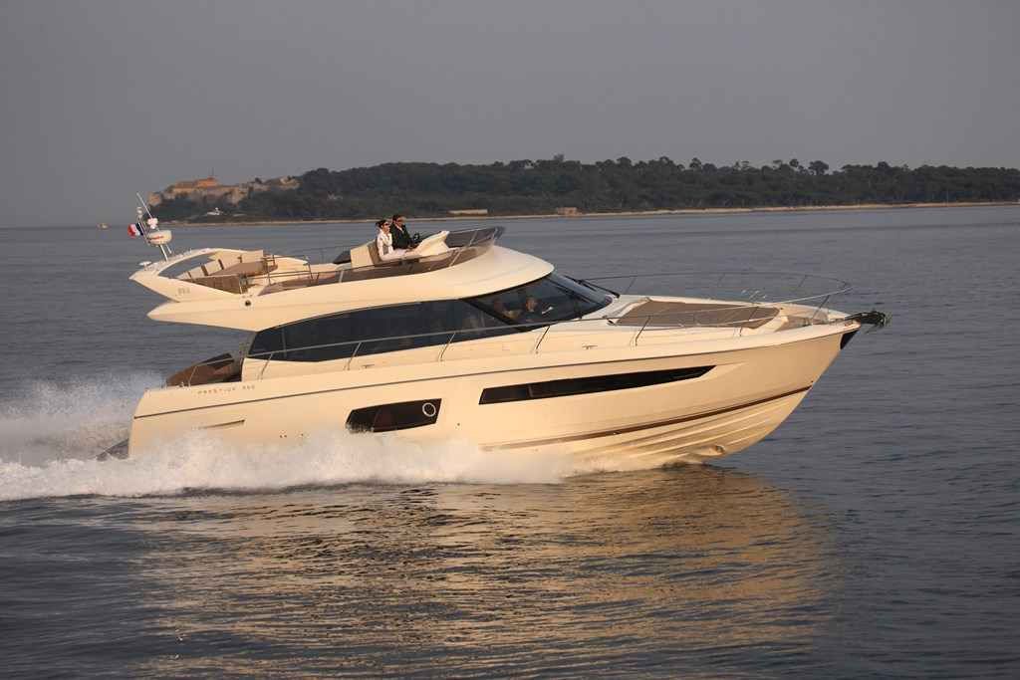Ancasta has announced its line up for Poole Harbour Boat Show 2016, which takes place from 20th to 22nd May 2016. The company will be presenting a selection of sail and power boats from Prestige and Beneteau, including the hugely impressive Prestige 550 and Beneteau’s Gran Turismo 46, which launched at Paris Boat Show in December 2015. Ancasta looks forward to welcoming visitors onto berths A49-46 and A44-38.

Visitors to the show will be able to see the elegant and distinctive Prestige 550, which boasts a contemporary interior, with an innovative layout that gives the owners cabin its own private stairway. Outside, the vast flybridge offers space for socialising, sunbathing and dining.

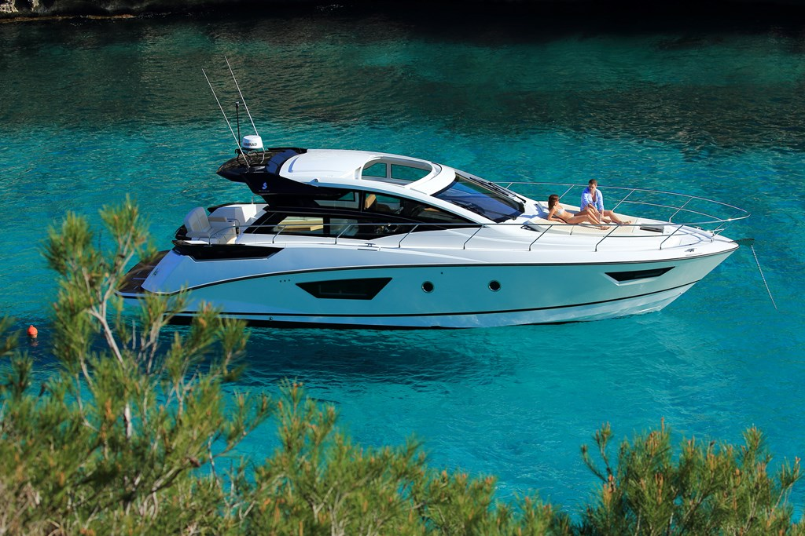Also at the show will be the Gran Turismo 46, which is the latest launch from Beneteau in the Gran Turismo line. The GT46 incorporates the latest generation Beneteau-designed Air Step®2 planing hull and is available with a choice of two or three cabins, offering unrivalled guest accommodation for this size of powerboat. The hard top has electric powered side glazing, which adds to the feeling of space and openness, as does the fully opening glass door.

Ancasta will present the Prestige 550 at the Poole Harbour Boat Show in May 2016

Ancasta’s line up for the show also includes the popular Beneteau Gran Turismo 40, which launched to great acclaim in Cannes in September 2015, the Beneteau Swift Trawler 34, and from Beneteau Sail, the Oceanis 45 and Oceanis 35.

The Beneteau Gran Turismo 46 will be presented by Ancasta at Poole Harbour Boat Show in May 2016

Ancasta is the UK’s largest Prestige Luxury Motor Yachts dealer and the largest UK dealer for Beneteau Power and Beneteau Sail.

Poole Harbour Boat Show is open to the public on Saturday 21st May and Sunday 22nd May from 10am to 6pm. To arrange appointments to view, please contact Ancasta on 02380 450 000 or email beneteaupower@ancasta.com

For more information visit <http://www.ancasta.com/events/poole-harbour-boat-show-2016>

**ENDS**

**Notes to editors**

* Ancasta International Boat Sales has 15 offices across Europe
* Ancasta is the UK’s largest Prestige Luxury Motor Yachts dealer, the UK’s largest Beneteau Power and the UK’s largest Beneteau Sail dealer
* Ancasta is exclusive UK dealer for Lagoon Catamarans
* In addition Ancasta is a new boat dealer for CNB Yacht Builders and McConaghy Yachts
* The Ancasta Group incorporates Hamble Yacht Services Refit & Repair and Advanced Rigging and Hydraulics, both operating from Port Hamble.
* For more information on Ancasta visit www.ancasta.com

Media enquiries via Marine Advertising Agency: Alison Willis - [alison@marineadagency.com](mailto:alison@marineadagency.com), tel: 023 9252 2044