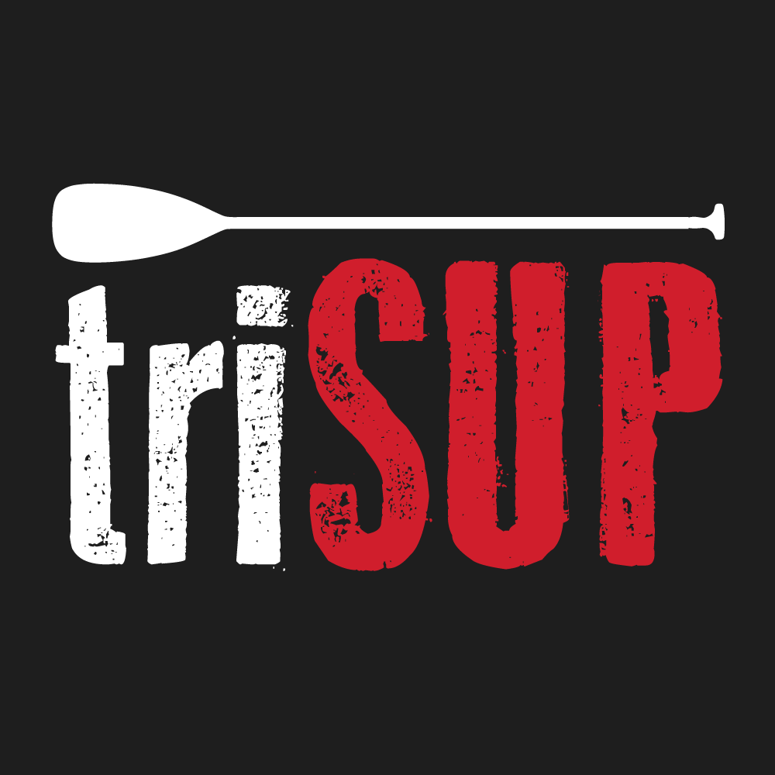
Press Release

For Immediate Release: 03/05/2016
TriSUP Events 2016

Yak Adventure Equipment announced as Official Water Safety & Clothing Partner for TriSUP Events

Yak Adventure Equipment and TriSUP Events are delighted to announce an exciting new partnership. The partnership sees the TriSUP Event Safety Crew fully kitted out with essential Yak protective clothing and safety equipment including the pioneering Xipe buoyancy aid, Sladek cag, Target thermal top, Paddling Pants and Magnum throw bags.

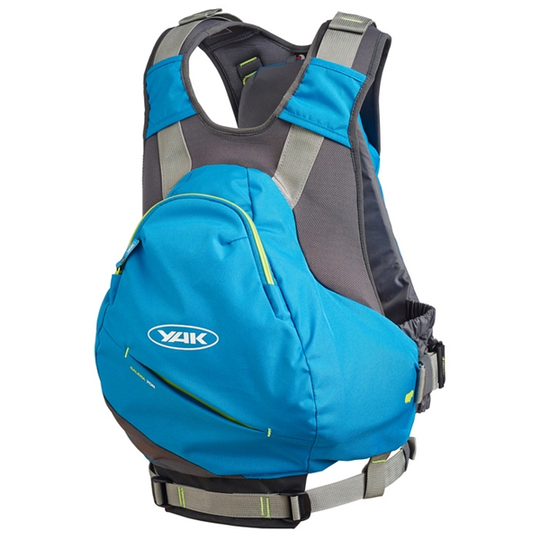
In addition the popular Yak Galena buoyancy aid is now available for hire free of charge by participants during all TriSUP events. The Galena, with its 4D Cast technology provides the maximum in comfort and is the perfect paddle boarding safety companion.

Martin Barden, TriSUP Events Owner says ‘We are delighted to be partnering with Yak to provide unrivalled on-the-water safety at the events. Being able to offer free buoyancy aid hire is sure to be well received by participants’.

Matthew Bridge, Yak Commercial Manager added ‘Paddle boarding is taking the world by storm and it’s fantastic to see such a fresh evolution with the amalgamation of both the paddle boarding and triathlon disciplines. We very much look forward to working with TriSUP over the next few years and also entering our very own Team Yak to the events’.

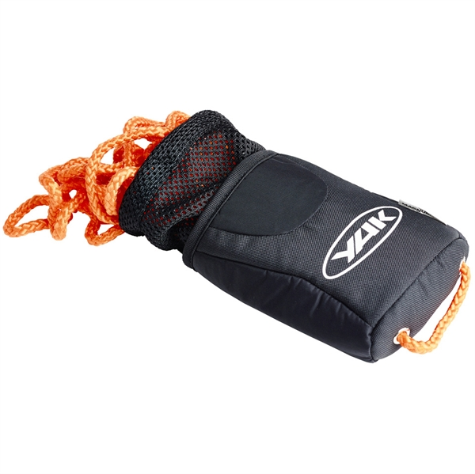
TriSUP Events is an exciting new triathlon format that introduces Stand Up Paddle Boarding in place of the traditional swim stage. Yak Adventure Equipment will also be providing vibrant custom mark buoys from Yak’s sister company, Crewsaver, which will be used in the TriSUP Events to mark the in-water course area.

Don’t miss out; the first TriSUP Event takes place on the 18th June 2016. For further information on TriSUP Events or to enter visit www.trisupevents.co.uk

ENDS//

For media information, hi-res images or product tests please contact:

Yak
Hazel Proudlock, Marketing Dept
T +44 (0) 1329 820406
E hazel.proudlock@survitecgroup.com

Or

Alison Willis – Marine Advertising Agency Ltd
T +44 (0) 23 9252 2044
E Alison@marineadagency.com

Notes to Editors

Part of the Survitec Group which also owns Crewsaver, Yak, produces and manufactures products that are purposely designed for the whitewater, recreational and touring kayaking and canoe markets. A wide range of products suit all styles and experience, giving paddlers more choice and more opportunities to enjoy their sport with total peace of mind. Yak’s products include buoyancy aids, drysuits, cags, trousers, spray decks, gloves, footwear, headwear and buoyancy bags.

Together with Crewsaver, Yak has 50 years of experience manufacturing marine safety products that combine cutting edge technology with high performance and ultimate practicality.

