For Immediate Release:
28th July 2016

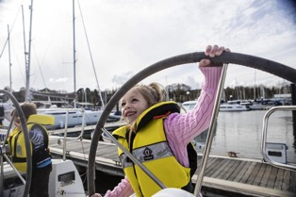
Crewsaver launches fun and interactive children’s lifejacket range
Crewsaver is thrilled to announce the launch of the new Euro 100N lifejacket designed specifically for children. This launch coincides with fun and fresh updates to the existing range to bring you the complete Children’s Lifejacket Range. This range has something to offer no matter what level you are operating at, so whether you need something for general in-water play, dinghy sailing or even ocean sailing, there is a Crewsaver to suit.
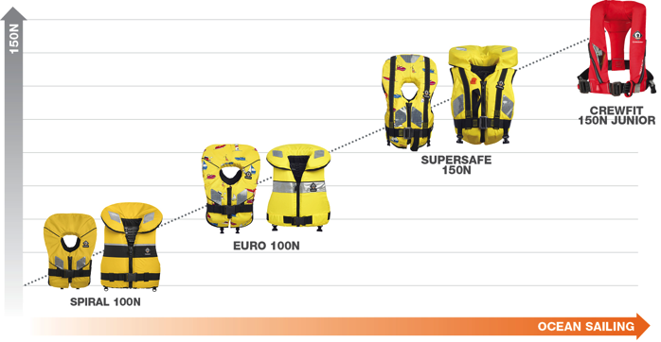
The new Euro 100N is your perfect ‘all-rounder’ and great for inshore use including sailing, powerboating, kayaking and swimming. The 100N of buoyancy reduces fatigue during general in-water activities whilst the inherently buoyant super soft foam provides a comfortable fit. Available in four sizes each complete with dual crotch straps and waist adjusters to provide a suitable fit with easy donning. The vibrant yellow colour combined with reflective tape provides good onboard and in-water visibility.
The children’s lifejacket range also includes the revamped Supersafe 150N foam lifejacket. The Supersafe 150N is perfect for those venturing further offshore including ocean sailing and is one of the only foam lifejackets for children in the 150N ‘Offshore’ rated category. The increase in buoyancy results in quicker spin times, increased collar stability and greater mouth freeboard (distance from water to mouth). Complete with a built-in safety harness, the Supersafe 150N accommodates the use of a safety line which is recommended when sailing in rough conditions or during night sailing.
Entry level to the range is the Spiral 100N which is available in yellow and orange. The inherently buoyant foam lifejacket is great for inshore use including surface watersports and swimming.
For the older child, there is the Crewfit 150N Junior lifejacket. As featured in Crewsaver’s popular Fusion 3D range, this automatic gas lifejacket incorporates unique Fusion 3D technology for the ultimate in comfort. The Crewfit 150N Junior is a great option for older children and is designed to inflate automatically when in contact with water. The unique 150N bladder design includes a peninsular chin support and it offers the most advanced performance solutions available to date. In addition, the lifejacket comes with a helpful indicator window which externally displays the status of the inflator firing mechanism.
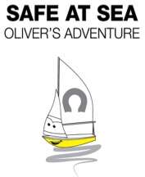
Safe at Sea – Oliver’s Adventure Interactive safety message, encouraging children to wear lifejackets: Crewsaver has created a great children’s storybook titled Oliver’s Adventure. This fun storybook follows the adventures of Oliver, a young sailboat who looks up to Rory the speedboat. SPOILER Rory decides not to wear a lifejacket and gets into trouble. This book was designed as an interactive tool to help parents teach their children the importance of lifejackets in a fun and interactive way. All new children’s foam lifejackets will come with the storybook and the characters can be found printed on both the Supersafe 150N and Euro 100N lifejackets.

Southampton Boat Show 16th – 25th September 2016

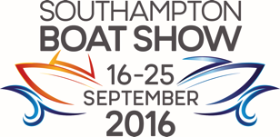
Crewsaver welcomes you to join them at the 2016 Southampton Boat Show on the Crewsaver stand (J250) where the complete children’s lifejacket range will be showcased and available for sizing. Members of the team will be on hand to answer any questions that you may have about safety onboard for you and your loved ones. The complete range will be available for purchase during the show on Crewsaver’s key retailers.

Lifejacket Name | Type | RRP Inc. VAT
Crewsaver Lifejackets: Suitable for swimmers and non-swimmers
Crewfit 150N Junior | Gas, harness | £70
Supersafe 150N | Foam, harness | £65 - £72 size dependent
Euro 100N | Foam | £50 - £52 size dependent
Spiral 100N | Foam | £37.50

For information on lifejacket sizing, servicing, care and maintenance visit: http://www.crewsaver.com/

ENDS//

For media information, hi-res images or product tests please contact:

Crewsaver
Hazel Proudlock, Marketing Dept
T +44 (0) 1329 820406
E hazel.proudlock@survitecgroup.com

Or

Alison Willis – Marine Advertising Agency Ltd
T +44 (0) 23 9252 2044
E Alison@marineadagency.com

Notes to Editors

Crewsaver is a world-leading manufacturer of marine safety equipment and clothing for the commercial and leisure marine industries. Based in Gosport, Hampshire, the company designs and manufactures bespoke safety equipment for several countries’ Special Forces, and the aviation and oil industries. Crewsaver is the only company to hold an exclusive contract to supply lifejackets to the UK government’s Environment Agency and the Royal National Lifeboat Institution (RNLI). They are part of the Survitec Group.

www.crewsaver.com

Survitec Group holds market-leading positions worldwide in marine, defence and aerospace survival technology. Headquartered in Birkenhead, the company employs 2000 people across 10 manufacturing sites and 50 service centres, operating through a network of a further 550 distributors and agents to bring its best-in-class products and services to a global customer base. With an extensive history spanning over 160 years and a portfolio of some of the most reputable brands in the safety and survival industry, Survitec is committed to product innovation, technological advancement and quality assurance.
Key products within Survitec’s portfolio include marine, defence and aviation Liferafts, world leading submarine escape technology, lifejackets for commercial airlines and the offshore industry as well as pilot flight equipment, including anti-g clothing used for the Eurofighter and JSF programmes. The Group also pioneered marine evacuation technology and today the unique MarinArk system is used on many major cruise ships across the globe.

www.survitecgroup.com

