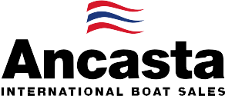

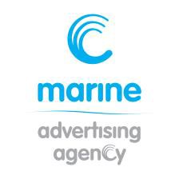
N e w s R e l e a s e
20th July 2016

Ancasta presents UK debuts from Beneteau at Southampton Boat Show

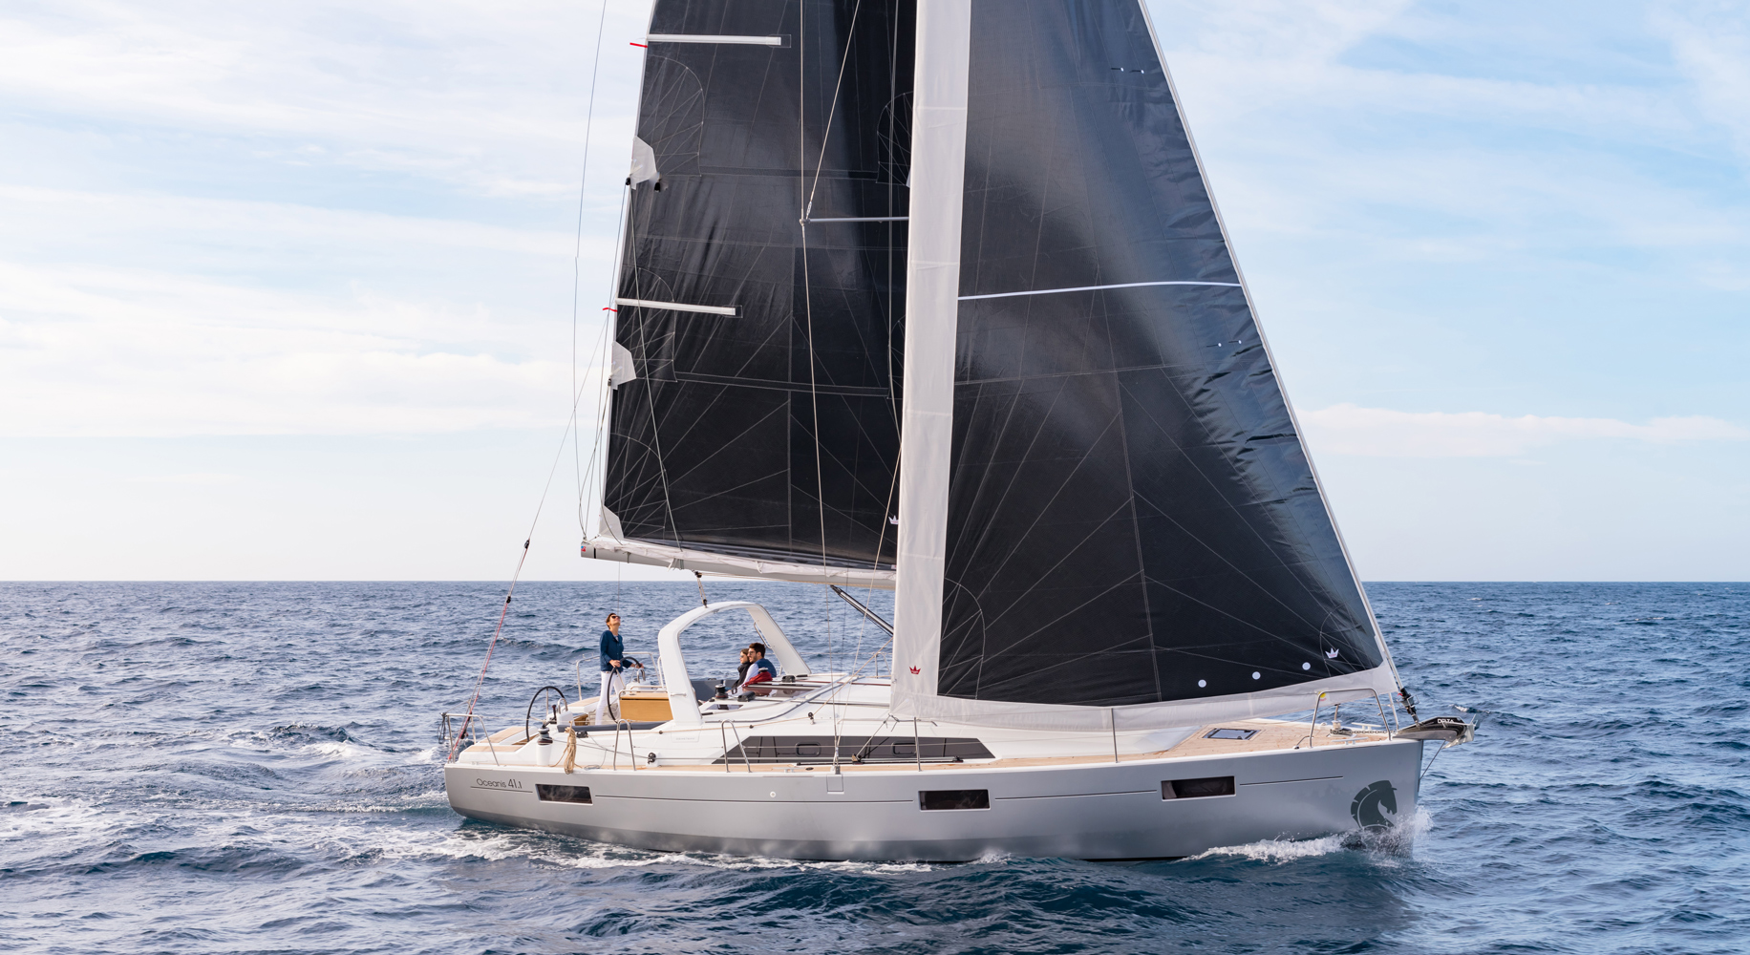
Ancasta will present the UK debut of the Beneteau Oceanis 41.1, Oceanis 38.1 and the Sense 57 at the 2016 Southampton Boat Show as Beneteau moves both sail and power boats on to the water for this year’s show, which takes place 16-25th September 2016. Ancasta is the UK’s largest dealer for both Beneteau Sail and Beneteau Power.
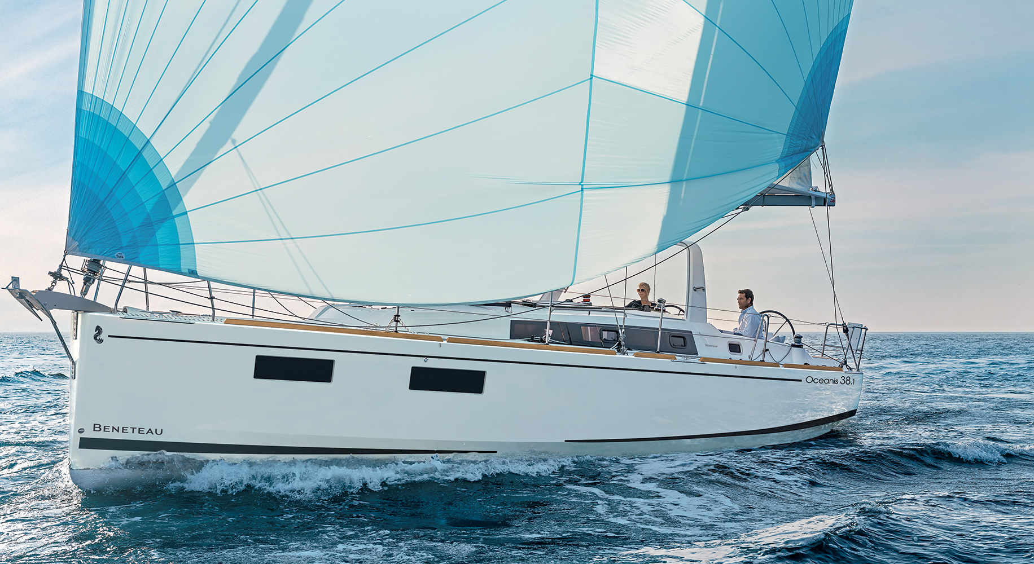
This year, Southampton Boat Show will see the UK debut of two new additions to the enduringly popular Beneteau Oceanis range, known for its innovative engineering, superbly comfortable accommodation and quality workmanship. Both the Beneteau Oceanis 41.1 and Beneteau Oceanis 38.1 sailing yachts are designed with Finot-Conq hulls and Nauta interiors. The Oceanis range continues to offer a variety of different layouts, from number of cabins and bathrooms to a choice of galley layout, enabling clients to customise their boats to suit their style of sailing.
Beneteau Oceanis 41.1
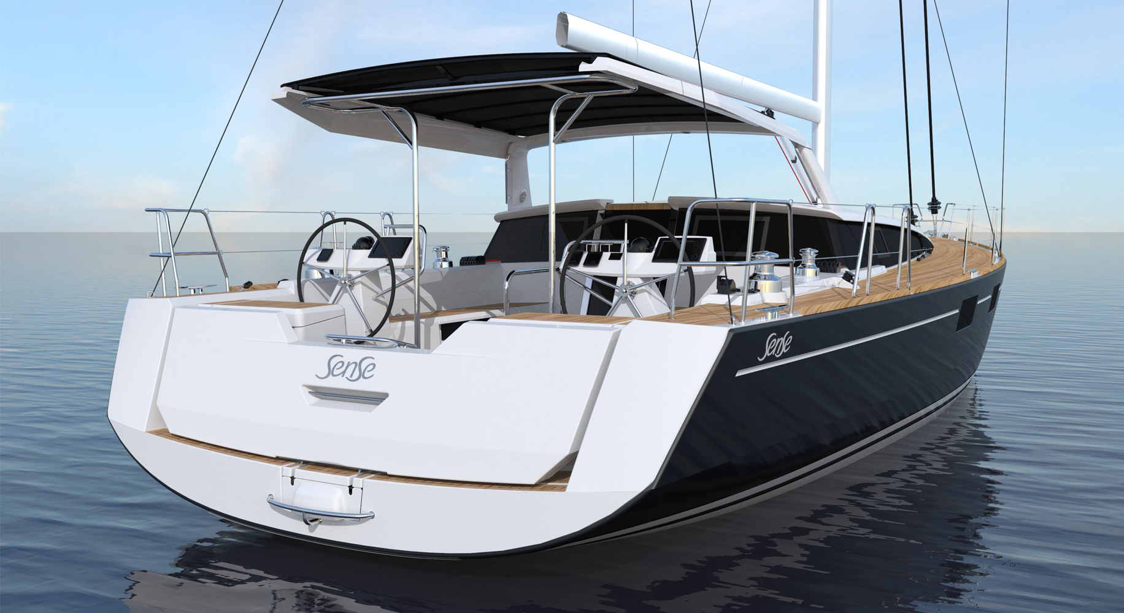
The latest addition to Beneteau’s Sense range, the Sense 57, also has its UK debut at Southampton Boat Show this year. The Sense 57 is an ocean cruising yacht with a unique style. Features include an exterior galley with plancha and sink concealed in the helm seats, large hull portholes to give an extensive sea view and flood the interior with light, and an opening semi-hard top Bimini.
Beneteau Oceanis 38.1
This year, for the first time, the entire Beneteau Power and Beneteau Sail display will be on the water, giving easy access to all models and enabling visitors to see the boats afloat.
Other highlights from Ancasta’s new boat brands include the Beneteau Gran Turismo 46, the latest generation sports cruiser, and the Prestige 680, which debuted at London Boat Show this year and has proved phenomenally popular.
Beneteau Sense 57
The full list of new boats that Ancasta will be presenting at the show is as follows:
Lagoon 450F
Lagoon 42

T: 023 9252 2044
E: Alison@marineadagency.com www.marineadagency.com
Marine Advertising Agency
15 Haslar Marina
Gosport PO12 1NU

Prestige 680
Prestige 550
Prestige 500
Prestige 450
From Beneteau Sail –
Oceanis 35
Oceanis 38.1 – UK debut
Oceanis 41.1 – UK debut
Oceanis 45
Oceanis 48
Sense 57 – UK debut
From Beneteau Power –
Swift Trawler 30
Gran Turismo 40
Gran Turismo 46
Gran Turismo 49 Fly

Ancasta will be at Southampton Boat Show from 16th to 25th September 2016. Contact Ancasta now to make an appointment to view any of the above, email enquiries@ancasta.com or call +44 2380 450000.

For more information visit: http://www.ancasta.com/events/southampton-boat-show-2016/

ENDS

Notes to editors
  - Ancasta International Boat Sales has 15 offices across Europe
  - Ancasta is the UK’s largest Prestige Luxury Motor Yachts dealer, the UK’s largest Beneteau Power and the UK’s largest Beneteau Sail dealer
  - Ancasta is exclusive UK dealer for Lagoon Catamarans
  - In addition Ancasta is a new boat dealer for CNB Yacht Builders and McConaghy Yachts
  - The Ancasta Group incorporates Hamble Yacht Services Refit & Repair and Advanced Rigging and Hydraulics, both operating from Port Hamble.
  - For more information on Ancasta visit www.ancasta.com Media enquiries via Marine Advertising Agency:
Alison Willis - alison@marineadagency.com Tel: 023 9252 2044

T: 023 9252 2044
E: alison@marineadagency.com www.marineadagency.com
Marine Advertising Agency
15 Haslar Marina
Gosport PO12 1NU

