N e w s R e l e a s e
26th July 2016

Ancasta makes seeing World Launches from Lagoon, Prestige and Beneteau easy for UK customers at Cannes Yachting Festival

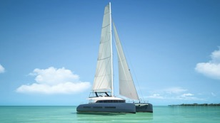
Ancasta is offering to help UK clients looking to see World Launches from Lagoon, Prestige and Beneteau at Cannes Yachting Festival, which takes place 6th-11th September 2016. This year’s show promises to be exciting with the much-anticipated launch of the Lagoon Seventy7, the Prestige 630 and Beneteau Oceanis 62 Yacht. Ancasta is the UK’s largest dealer for both Beneteau Sail and Beneteau Power, and Prestige Luxury Motor Yachts and as well as exclusive dealer in the UK for Lagoon Catamarans.
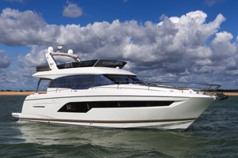
The Lagoon Seventy7 is set to be the largest Lagoon Catamaran to date and as such it’s, not surprisingly, generating a high level of excitement. The Lagoon Seventy7 is true to Lagoon’s core values, space is cleverly utilised on board and a choice of layouts and interior finishes mean that personalisation is possible. She is set to be a worthy flagship of the Lagoon range.
Lagoon Seventy7
The latest addition to the Prestige range is the Prestige 630, which follows on from the successful launch of the Prestige 680 earlier this year. This new Prestige looks set to emulate the popularity of the Prestige 680, as Prestige Motor Yachts goes from strength to strength.
Prestige 630
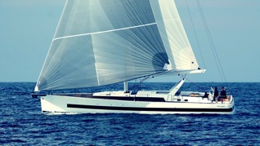
From Beneteau, Cannes will see the World Launch of the Oceanis 62 Yacht. A collaboration between Berret Racoupeau Yacht Design and Italian stylist Pierrangelo Andreani, who designed the yacht’s striking interior, the Oceanis 62 Yacht is the first of its kind. Olivier Racoupeau designed her with performance, safety and perfect manoevrability in mind, with maximum length on the waterline and a perfectly centred sail plan. The huge hull portholes give the Oceanis 62 Yacht a distinctive look and serve to bathe the interior in light.
Oceanis 62 Yacht

An outdoor galley located at the stern of the boat, six sun beds and a swimming platform that feels more like a terrace over the sea, add to the luxurious feel of this beautiful yacht.
Also at the show will be the popular Prestige 680 and Beneteau Gran Turismo 46, while CNB will be bringing two CNB 76, enabling test sails to take place.
The full list of new boats that Ancasta will be able to present at the show is as follows:

Lagoon 630 Motor Yacht
Lagoon Seventy7 - WORLD LAUNCH
Lagoon 52F
Lagoon 450S
Lagoon 42
Lagoon 39
Prestige 750
Prestige 680
Prestige 630 - WORLD LAUNCH
Prestige 550
Prestige 500
Prestige 450
Prestige 420
Beneteau Sense 57
Beneteau Oceanis 62 Yacht - WORLD LAUNCH
Oceanis 60
Oceanis 55
Oceanis 48
Oceanis 45
Oceanis 41.1
Oceanis 38.1
Beneteau Gran Turismo 49 fly
Beneteau Gran Turismo 46
Beneteau Gran Turismo 40
Beneteau Swift Trawler 50
Beneteau Swift Trawler 44
Beneteau Swift Trawler 34
Beneteau Swift Trawler 30
CNB 76
Bordeaux 60
Ancasta will have a huge team at Cannes Yachting Festival from 6th to 11th September 2016. The show represents a fantastic opportunity to see world launches and a wide range of new boats from Beneteau, Lagoon, Prestige and CNB, in a beautiful setting on the sunny Côte d’Azur. Contact Ancasta now to explore your options and make appointments to view any of the above, email enquiries@ancasta.com or call +44 2380 450000.

For more information visit: http://www.ancasta.com/events/yachting-festival-cannes-2016/

ENDS

Notes to editors

  - Ancasta International Boat Sales has 15 offices across Europe
  - Ancasta is the UK’s largest Prestige Luxury Motor Yachts dealer, the UK’s largest Beneteau Power and the UK’s largest Beneteau Sail dealer
  - Ancasta is exclusive UK dealer for Lagoon Catamarans
  - In addition Ancasta is a new boat dealer for CNB Yacht Builders and McConaghy Yachts
  - The Ancasta Group incorporates Hamble Yacht Services Refit & Repair and Advanced Rigging and Hydraulics, both operating from Port Hamble.
  - For more information on Ancasta visit www.ancasta.com

Media enquiries via Marine Advertising Agency:
Alison Willis - alison@marineadagency.com Tel: 023 9252 2044

