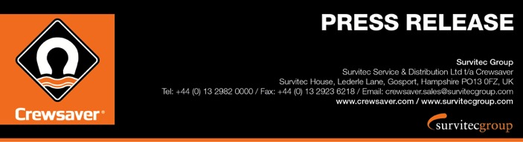
For Immediate Release:
13th September 2016
Southampton Boat Show 16th – 25th September 2016
Ocean Hall – J250

Crewsaver reveals exclusive offers on lifejackets, liferafts, Aurora pyrotechnics and McMurdo electronics for Southampton Boat Show 2016 visitors

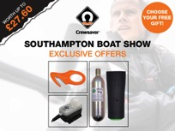
Crewsaver has revealed the exclusive Southampton Boat Show offers that will be available through its retail network at the show, which takes place 16th – 25th September 2016. Visitors will benefit from exclusive show offers on the highly popular Fusion 3D lifejacket range, ISO ocean liferafts, Aurora pyrotechnics and McMurdo electronics, giving access to all of the latest safety products at highly competitive rates.

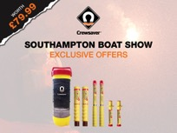
In addition, knowledgeable sales representatives will be on hand on both the Crewsaver stand and on our retailers’ stands to talk visitors through the choices and recommend the best options to suit each individual’s requirements.

Show Offers include:

Electronics
- McMurdo S20 Smartfind WAS £179.95 NOW £149.95

Lifejackets
- Take your pick! Choose between a FREE rearming kit, lifejacket light or ErgoFit safety cutter with any Crewfit 180N Pro. Worth up to £27.60.
- FREE rearming kit with any ErgoFit 190N or 290N standard automatic lifejacket. Worth up to £31.
- FREE ErgoFit safety cutter with any ErgoFit 190N or 290N Hammar lifejackets. Worth up to £15.95.
- Artemis Racing Crewfit 180N Pro lifejackets now PRICE MATCH the same price as the Crewsaver Crewfit 180N Pro plus your take your pick FREE gift!

Pyrotechnics
- Up to 40% off of Crewsaver Aurora Pyrotechnics

Liferaft
- FREE Aerial Inshore Flare Pack with any Crewsaver ISO Ocean liferaft purchase. Worth £79.99
Find Crewsaver at the following retailers:
Andark Diving & Watersports F001
Force4 Chandlery B017 & J247
Jimmy Green Marine J206
Marine Super Store F006
Marinestore F003
Pinnel & Bax J226
Performance Sailing Shop B013

Are you #LifejacketSafe ?

Visit the Crewsaver stand (J250) to find out how you can be #LifejacketSafe and enter our competition to win an Abu Dhabi Ocean Racing lifejacket as worn by the victorious Abu Dhabi Ocean Racing Team. A prize that will surely be the envy of any sailor!

ENDS//

For media information, hi-res images or product tests please contact:

Crewsaver
Hazel Proudlock, Marketing Dept
T +44 (0) 1329 820406
E hazel.proudlock@survitecgroup.com

Or

Alison Willis – Marine Advertising Agency Ltd
T +44 (0) 23 9252 2044
E Alison@marineadagency.com

Notes to Editors

Crewsaver is a world-leading manufacturer of marine safety equipment and clothing for the commercial and leisure marine industries. Based in Gosport, Hampshire, the company designs and manufactures bespoke safety equipment for several countries’ Special Forces, and the aviation and oil industries. Crewsaver is the only company to hold an exclusive contract to supply lifejackets to the UK government’s Environment Agency and the Royal National Lifeboat Institution (RNLI). They are part of the Survitec Group.

www.crewsaver.com

Survitec Group holds market-leading positions worldwide in marine, defence and aerospace survival technology. Headquartered in Birkenhead, the company employs 2000 people across 10 manufacturing sites and 50 service centres, operating through a network of a further 550 distributors and agents to bring its best-in-class products and services to a global customer base. With an extensive history spanning over 160 years and a portfolio of some of the most reputable brands in the safety and survival industry, Survitec is committed to product innovation, technological advancement and quality assurance.
Key products within Survitec’s portfolio include marine, defence and aviation Liferafts, world leading submarine escape technology, lifejackets for commercial airlines and the offshore industry as well as pilot flight equipment, including anti-g clothing used for the Eurofighter and JSF programmes. The Group also pioneered marine evacuation technology and today the unique MarinArk system is used on many major cruise ships across the globe.

www.survitecgroup.com
