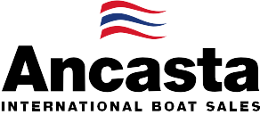

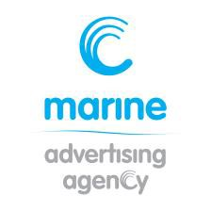
N e w s R e l e a s e
FOR IMMEDIATE RELEASE
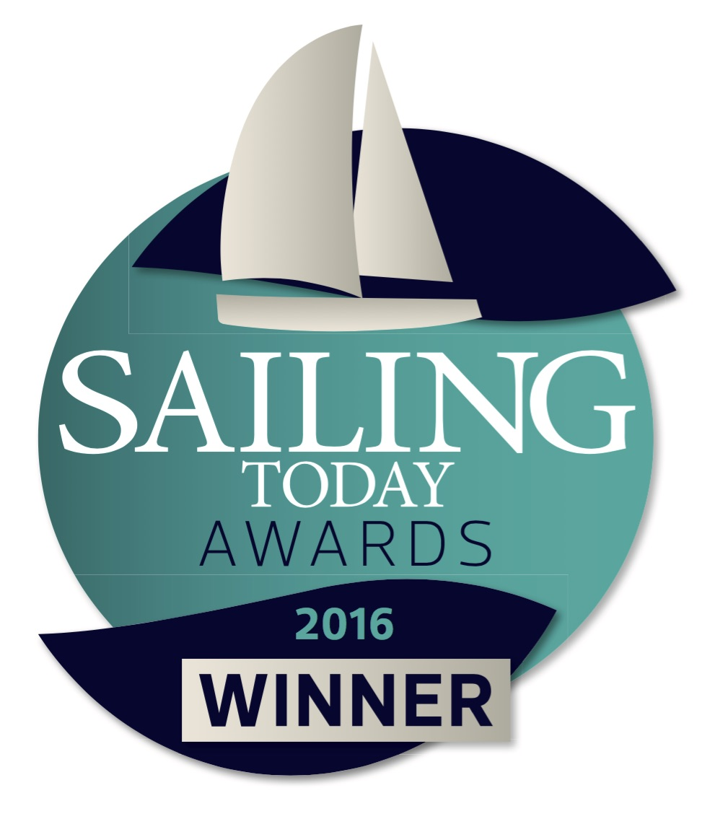
16th September 2016

Ancasta celebrates win for Lagoon 42 in Sailing Today 2016 awards

Ancasta is celebrating after the Lagoon 42 was announced as the winner in the Multihull category in the 2016 Sailing Today awards, which were presented at a champagne reception on Friday 16th September 2016 at Southampton Boat Show. Ancasta is the exclusive UK dealer for Lagoon Catamarans.
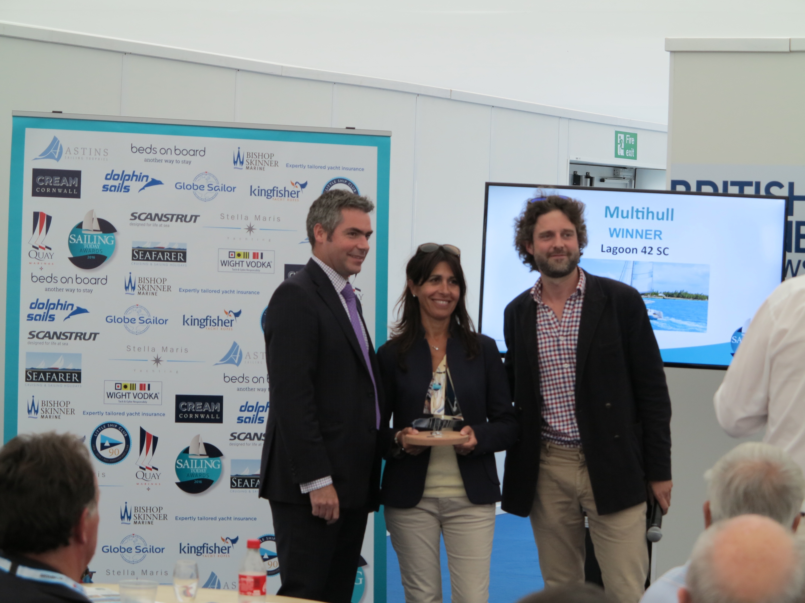
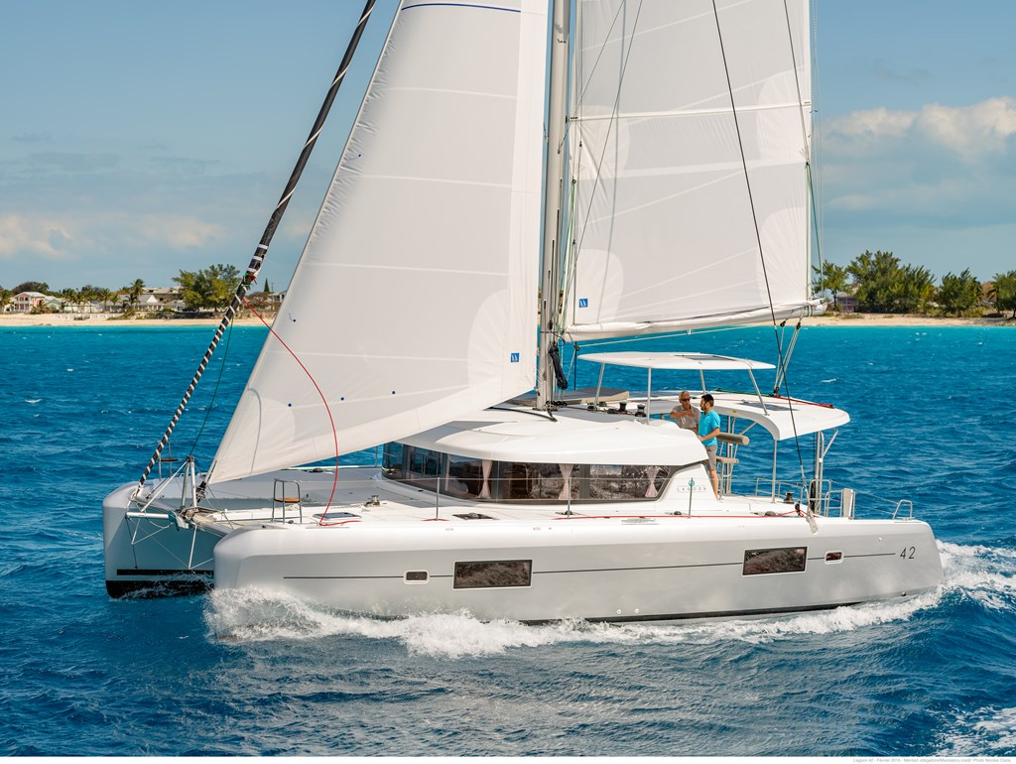
Sailing Today editor Sam Fortescue, who presented the awards, said: “Anyone who has chartered or cruised in the world’s warmer waters will recognise the distinctive outline of Lagoon’s phenomenally successful catamarans. The newly launched 42 is at once familiar and exciting, with a host of subtle tweaks to the lines around the bows and a new coachroof. Moving the mast aft has improved the boat’s balance, but she’s still a strong performer, even upwind. And we love the improved communications between helm and cockpit, which flows seamlessly into the saloon on the same level. Expect to see one soon – they’re selling like hotcakes!”
The award-winning Lagoon 42
Alexandre Dauberville, Marketing Director for Lagoon, is delighted with the award. Commenting on the win, he said “An amazing award for us! We are really proud of it, having worked so hard in many key areas of design and construction to push the limit of performance and comfort in this important size category. This is the second year in a row that we have been awarded following the success of the 450F last year. We very much appreciate this recognition from Sailing Today and its readers.”
The winners of the annual awards, which were launched in 2015, were decided by public vote. Voting launched in the August issue of Sailing Today and thousands of readers got involved.
Isabella Dessi from Lagoon receives the Sailing Today award from
Sam Fortescue, Editor, Sailing Today

Marine Advertising Agency
15 Haslar Marina
Gosport
PO12 1NU
T: 023 9252 2044
E: Alison@marineadagency.com
www.marineadagency.com
Marine Advertising Agency
15 Haslar Marina
Gosport PO12 1NU

Visitors to Southampton Boat Show can view the Lagoon 42 on berth M177. Ancasta is also proud to be presenting the Lagoon 450, which topped the Multihull category in the 2015 Sailing Today awards, at the show on berth M179.

ENDS

Notes to editors

About Ancasta
  - Ancasta International Boat Sales has 14 offices across Europe
  - Ancasta is the UK’s largest Prestige Luxury Motor Yachts dealer, the UK’s largest Beneteau Power and the UK’s largest Beneteau Sail dealer
  - Ancasta is exclusive UK dealer for Lagoon Catamarans
  - In addition Ancasta is a new boat dealer for CNB Yacht Builders and McConaghy Yachts
  - The Ancasta Group incorporates Hamble Yacht Services Refit & Repair and Advanced Rigging and Hydraulics, both operating from Port Hamble.
  - For more information on Ancasta visit www.ancasta.com
About Sailing Today
Sailing Today is the high-quality monthly magazine for adventurous cruising sailors. It has over 30,000 readers every month who love the mix of cruising stories, destinations near and far, interviews, rigorous boat and gear tests, skills and technical briefings. Sailing Today was first published in May 1997.

Media enquiries via Marine Advertising Agency:
Alison Willis - alison@marineadagency.com Tel: 023 9252 2044

Marine Advertising Agency
15 Haslar Marina
Gosport
PO12 1NU

T: 023 9252 2044
E: alison@marineadagency.com
www.marineadagency.com

