**News Release**

**For immediate release**

**21st September 2016**

**Marine industry charity 5-a-side Southampton Boat Show tournament raises £1000 for Southampton hospital charities**

Teams from across the UK marine industry came together on the evening of Tuesday 20th September 2016 to help raise £1000 for the Paediatric Intensive Care Unit (PICU) and G4 Surgery at Southampton General Hospital at the annual Marine Advertising Agency 5-a-side football tournament.

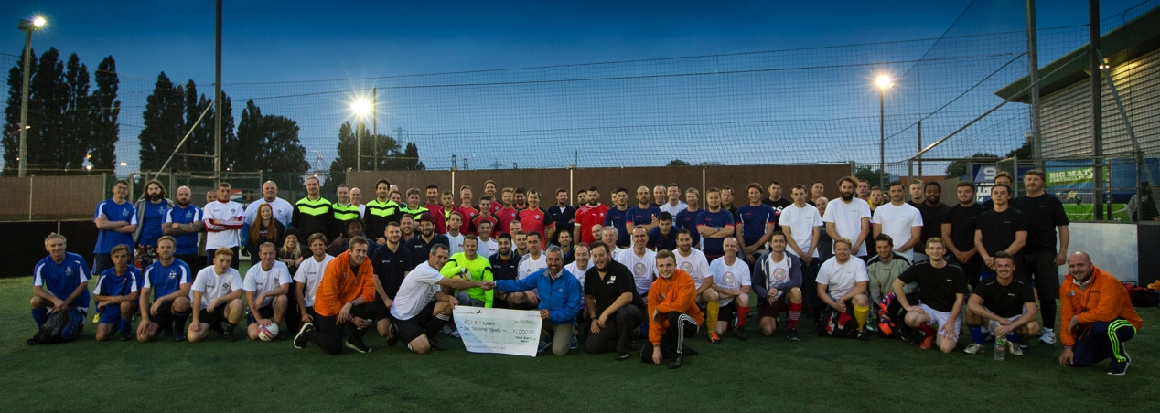

The tournament, which takes place during the Southampton Boat Show each year, brought together over 100 players in 12 teams. Southampton General Hospital staff fielded two teams and Southampton FC’s sponsorship department also put a team together, competing alongside marine industry teams. New entrants included a joint Crewsaver and Marine Super Store team, and a team from Premier Marinas. Unfortunately Dean & Reddyhoff’s Haslar Harriers were unable to play this year but they were still keen on supporting the cause with a donation. Tournament veterans, PSP Logistics, took home the silverware, winning the main Cup competition with a 4:1 victory over Lewmar.

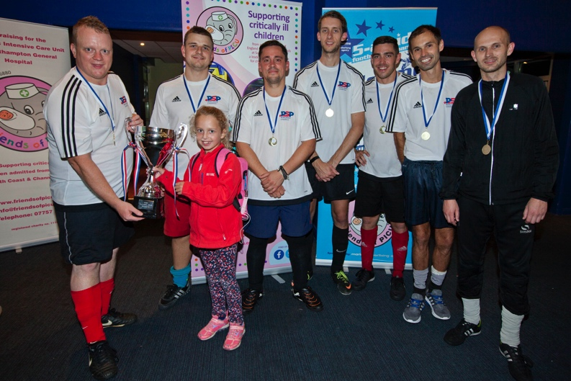

The Plate competition was won by last year’s Cup winners; The Yacht Market, who beat British Marine after a tense penalty shoot out 9:8 in the final.

Southampton fans were treated to the sight of ex-England and Saints legend, Matt le Tissier, who happened to be playing another match at Goals Southampton, where the tournament took place.

The tournament raised £1,000 for PICU and G4 Surgery ward at Southampton General Hospital. Mike Shepherd, Director of the Marine Advertising Agency (MAA), which organises the tournament said, “We’re delighted that the marine industry continues to support this fantastic cause. Friends of PICU and G4 surgery are causes

Tournament winners PSP Logistics are presented with the Cup by Anna Shepherd, daughter of organiser Mike Shepherd from Marine Advertising Agency. Anna has been supported by Friends of PICU and G4 surgery ward.



that are very close to our hearts. We like to think that the tournament offers a bit of light relief during the Southampton Boat Show, but it can get pretty competitive!” Mike’s daughter, Anna Shepherd, who has been supported by the units, was on hand to present the winners with their medals.

Southampton is the lead centre for paediatric intensive care in south central England with a catchment area that stretches from Dorset to Surrey to the Channel Islands. PICU provides first class care and treatment to over 900 critically ill children every year admitting children with both medical and surgical problems ranging in age from birth to 18 years.

The MAA 5-a-side will take place again during next year’s Southampton Boat Show on the evening of 19th September 2017. Teams should get in touch with MAA to book their places.

**ENDS//**

Notes to editors

The Marine Advertising Agency was founded in 2009 by Mike Shepherd. MAA prides itself on providing no-nonsense solutions to marine companies’ advertising, PR and marketing needs. MAA’s current clients include Crewsaver, Ancasta,, Superyacht Tenders and Toys, and British Marine Boat Shows, and the company is now providing services on a pan-European and international basis for its growing list of clients. For more information visit: <http://www.marineadagency.com>

The Southampton Boat Show runs from 16-25th September 2016. For more information visit: [http://www.southamptonboatshow.com](http://www.southamptonboatshow.com/2012/home.aspx)

Media enquiries

Email: [mike@marineadagency.com](mailto:mike@marineadagency.com) or alison@marineadagency.com

Tel: +44 (0) 23 9252 2044

Get high-resolution images of all the action from the tournament in the image gallery in our Media Centre:

<http://marineadagency.com/gallery/5-side-football-2016/>