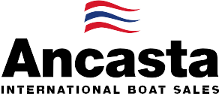

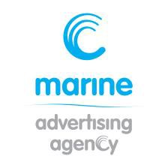
N e w s R e l e a s e
25th August 2016

Ancasta to present Prestige 560 on UK debut at Southampton Boat Show

Ancasta has announced that the Prestige 560 will have her UK debut at Southampton Boat Show, which takes place 16th-25th September 2016.
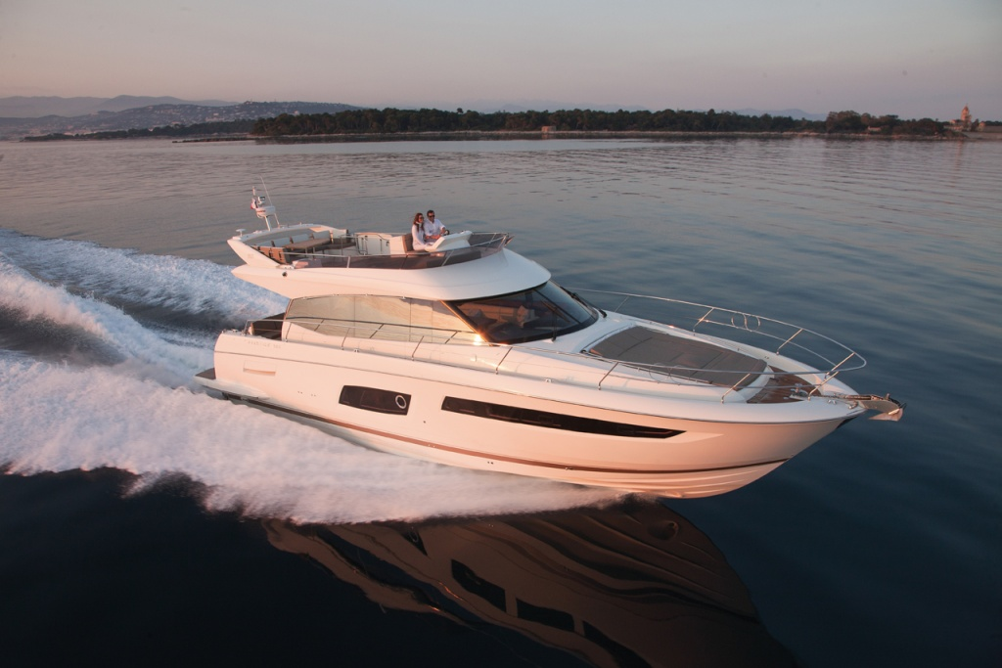
The Prestige 560 will be the largest model in the Prestige Flybridge collection. The 560 boasts the elegant, distinctive design which epitomises the Prestige Flybridge collection. This new model features a light and airy contemporary interior, supremely comfortable master cabin and innovative design features including a new elongated swimming platform. Cummins Zeus Pods give ultimate speed and control.
Prestige 560
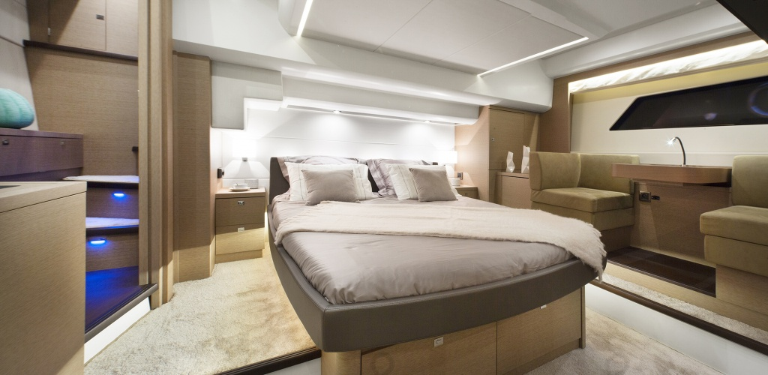
Ancasta is the UK’s largest Prestige Luxury Motor Yachts dealer. Ancasta will be at Southampton Boat Show from 16th to 25th September 2016.
Prestige 560 – master cabin

Contact Ancasta to make an appointment to view the Prestige 560, email enquiries@ancasta.com or call +44 2380 450000.

For more information visit: http://www.ancasta.com/events/southampton-boat-show-2016/

ENDS

T: 023 9252 2044
E: Alison@marineadagency.com www.marineadagency.com
Marine Advertising Agency
15 Haslar Marina
Gosport PO12 1NU

Notes to editors
  - Ancasta International Boat Sales has 14 offices across Europe
  - Ancasta is the UK’s largest Prestige Luxury Motor Yachts dealer, the UK’s largest Beneteau Power and the UK’s largest Beneteau Sail dealer
  - Ancasta is exclusive UK dealer for Lagoon Catamarans
  - In addition Ancasta is a new boat dealer for CNB Yacht Builders and McConaghy Yachts
  - The Ancasta Group incorporates Hamble Yacht Services Refit & Repair and Advanced Rigging and Hydraulics, both operating from Port Hamble.
  - For more information on Ancasta visit www.ancasta.com Media enquiries via Marine Advertising Agency:
Alison Willis - alison@marineadagency.com Tel: 023 9252 2044

T: 023 9252 2044
E: alison@marineadagency.com www.marineadagency.com
Marine Advertising Agency
15 Haslar Marina
Gosport PO12 1NU

