*****Press release – Immediate release*****
5th October 2016

Unique opportunity to acquire the new Spirit P40 through
Superyacht Tenders and Toys

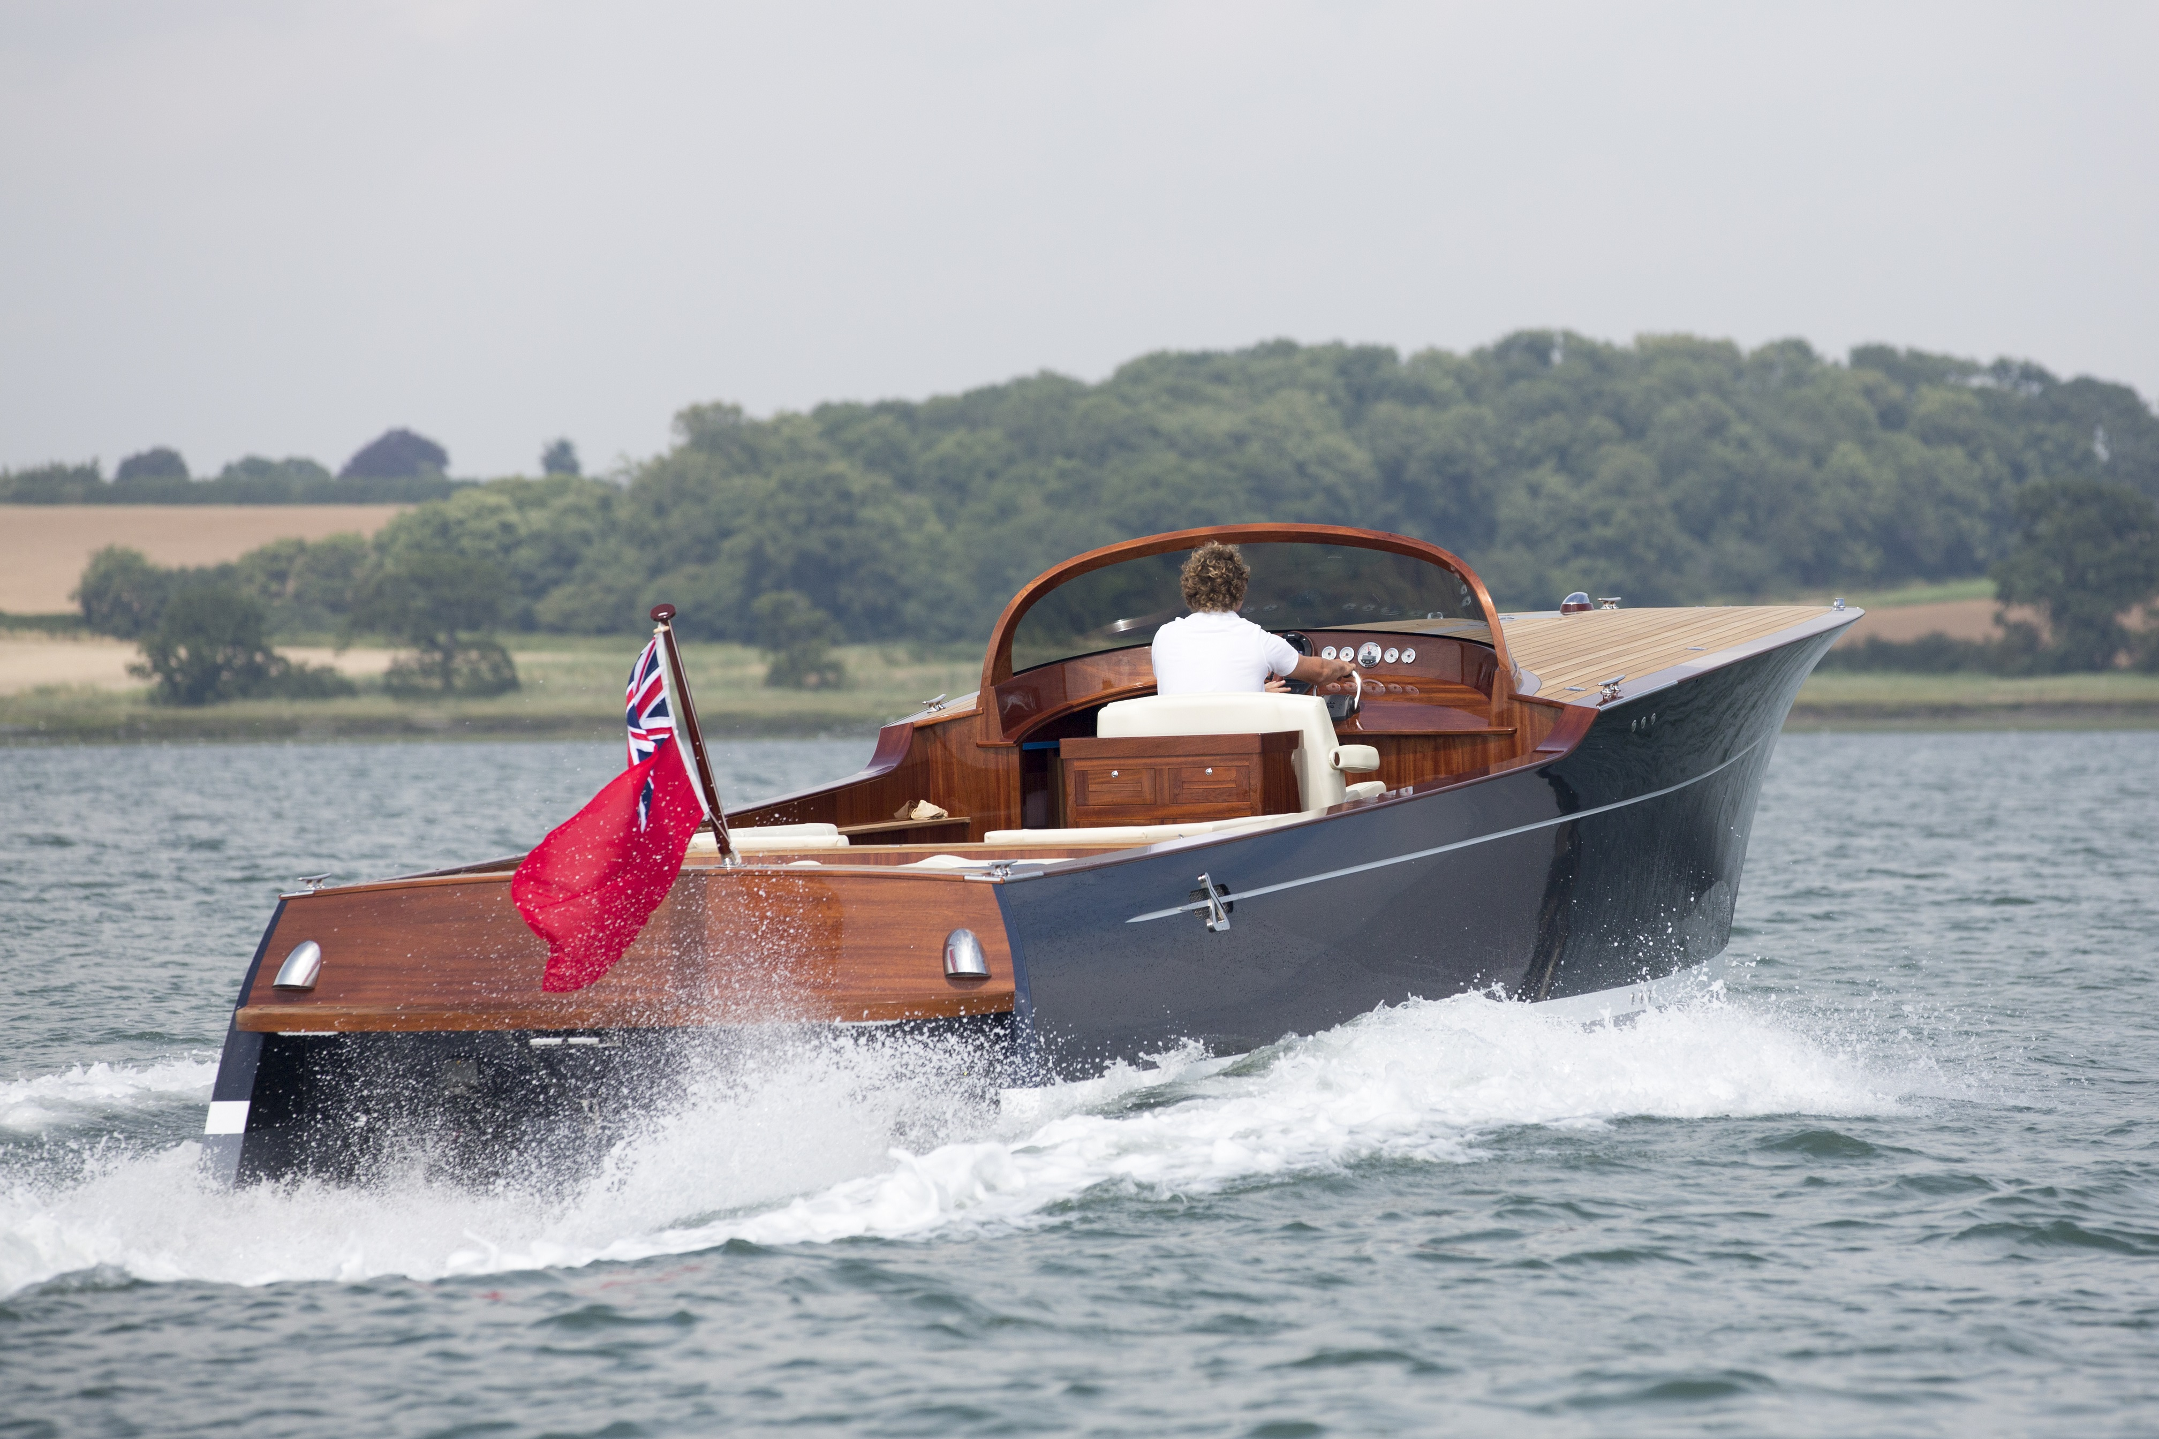
Superyacht Tender and Toys is offering a Spirit P40 for sale. This is a unique opportunity to acquire this sophisticated boat, which showcases the iconic lines and structural integrity synonymous with Spirit Yachts’ modern classic design and build. Spirit Yachts has incorporated practicality as well as beauty into the Spirit P40, offering the flexibility of either a luxurious leisure motor cruiser or stylish superyacht tender.

The cruising option layout includes an open-plan double-berth, although additional accommodation in the deck saloon can be incorporated. With dining space below or alfresco in the cockpit, there is the option to specify an enclosed or semi-enclosed wheelhouse. The galley is well equipped with a cooker, grill and oven, along with sink, fridge and ample storage for crockery and provisions.

Fully air-conditioned down below with a fitted 220v generator, the P40 also includes an en-suite with separate shower and an electric flushing toilet. A bimini, aft deck shower and swim platform with fold-down swim ladder on the transom provide added cruising benefits.

Displacing only 4.5 tonnes, the P40 is powered by two Yanmar 260hp inboard engines, which deliver a top speed of 36 knots and a cruising speed of 29 knots. The hull is fitted with four half-moon venturi chines, which draw a cushion of air under the boat and reduce drag.

“The P40 is a beautifully handcrafted boat”, says Richard Booth, Project Manager at Superyacht Tenders and Toys. “It is superbly finished using the highest quality materials and it oozes style and sophistication on the water. The ride and handling are smooth and responsive. The boat glides effortlessly across the water and it was a joy to helm. This is a boat to be truly proud of and is the definition of a luxury superyacht tender”

To book a private test drive or viewing, please contact Superyacht Tenders and Toys at info@superyachttenderandtoys.com
To learn more about Superyacht Tenders and Toys, visit
www.superyachttendersandtoys.com
ENDS
Images:
High Res Gallery
http://superyachttendersandtoys.com/image-gallery/new-spirit-p40/
Media enquiries via Marine Advertising Agency:
Alison Willis, alison@marineadagency.com
Emma Stanbury, emma@marineadagency.com
T: 023 9252 2044
Or
Josh Richardson, Superyacht Tenders and Toys
T: UK +442380016363
T: France +33489733347
T: US +19643029066
E: info@superyachttendersandtoys.com
Notes to Editors:
Superyacht Tenders and Toys is the leading independent consultancy and management company specialising in all superyacht tender and toy needs and provides practical solutions for the World’s finest yachts.

