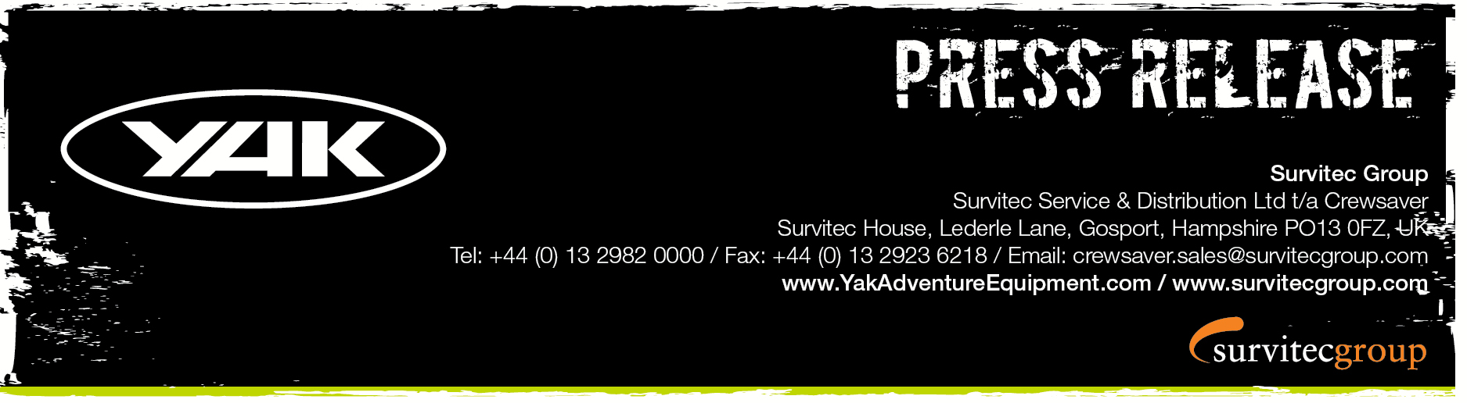
For Immediate Release
13th September 2016

Yak Adventure Equipment High Back 60N has arrived!

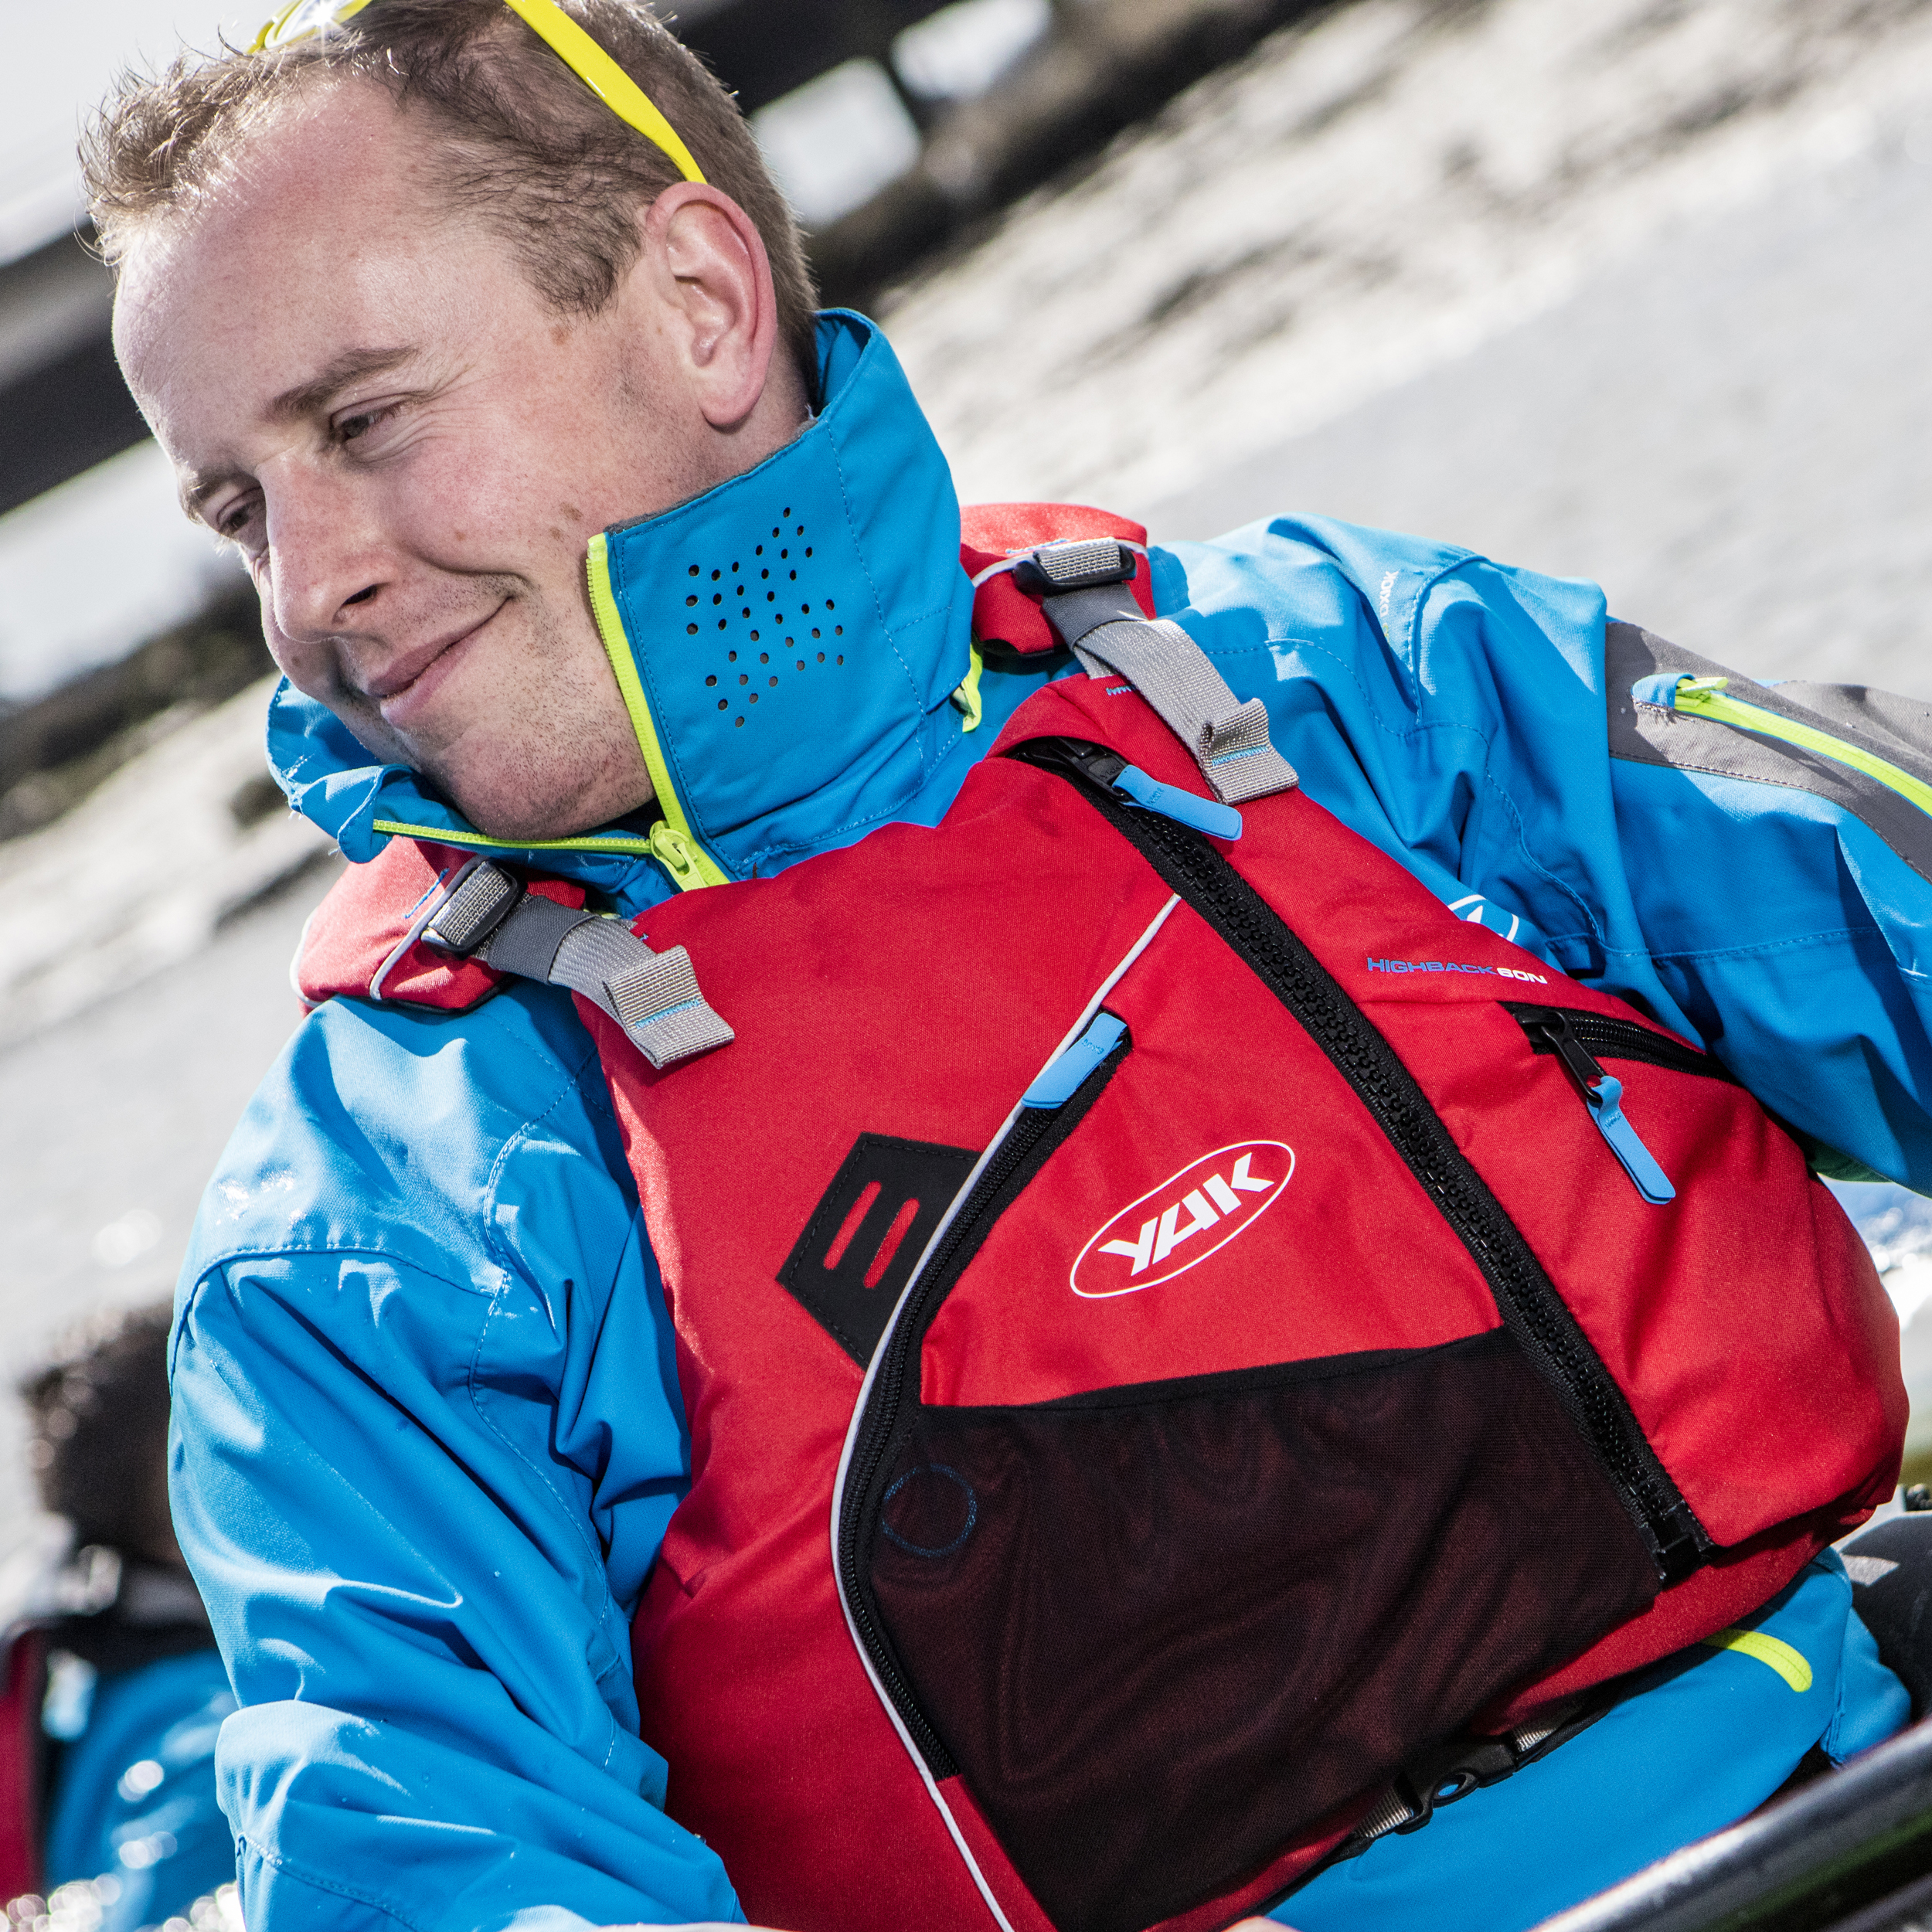
Yak Adventure Equipment is delighted to announce the launch of the long awaited Yak High Back 60N buoyancy aid. Following feedback from Yak’s retailers & distributors at PADDLEexpo 2015, the Yak design team has been hard at work putting together the most exciting and most technologically advanced touring and recreational adventure buoyancy aid available to-date.

The High Back 60N not only offers an innovative High Back, raised back solution, to ensure maximum comfort when out on the water but additionally a breathable air mesh, helping to ensure you remain cool and comfortable when out on the water on warmer days.
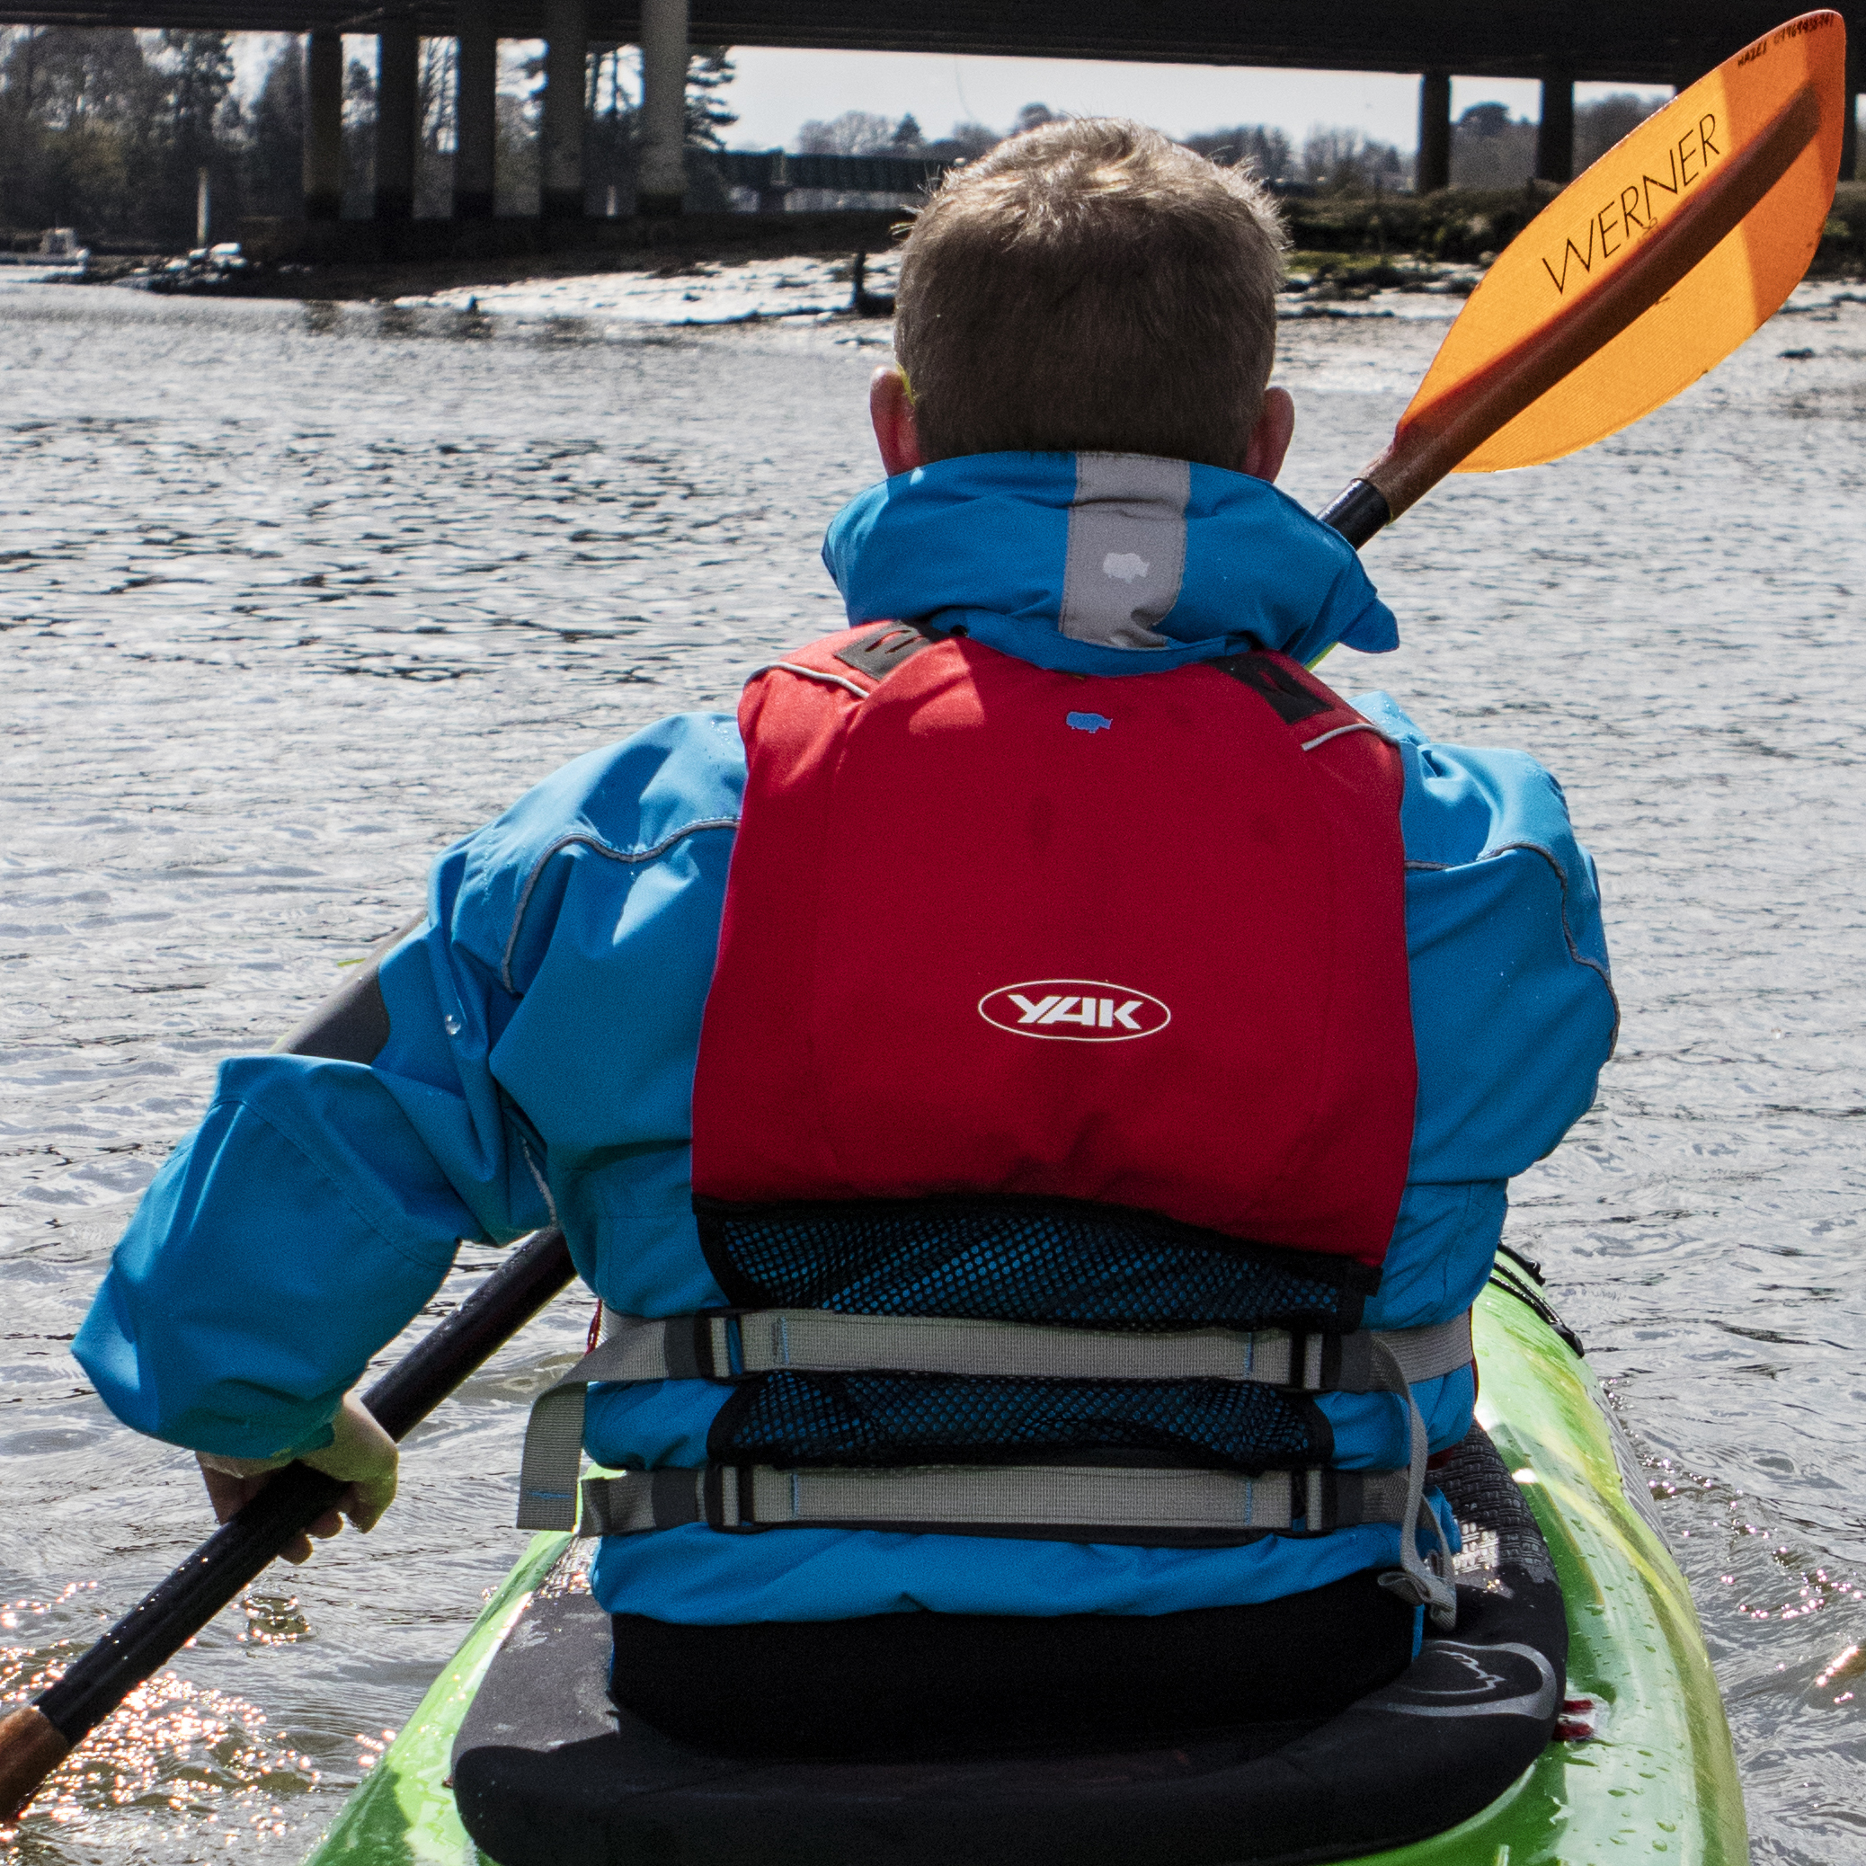
Suitable for those who undertake a multitude of adventure activities including touring kayakers and fishermen alike, key features include:

- Raise High Back profile
- Breathable air mesh solution
- Multiple attachment points
- Extra-large front pockets
- Twin waist adjustment to ensure optimum fit

‘The Yak High Back 60N is a great addition to the Yak range; it offers the ideal solution for those in raised seat kayaks who take long trips out on the water and require maximum comfort.’ Pete Ford, Yak Brand Manager

Fully approved to ISO standards and offering 60N of buoyancy the Yak High Back 60N is available for £65 RRP inc VAT. The High Back will be available in all good Yak Adventure Equipment retailers as of 1st October 2016

ENDS//

For media information, hi-res images or product tests please contact:

Hazel Proudlock, Marketing Dept - Yak Adventure Equipment
T +44 (0) 1329 820406
E hazel.proudlock@survitecgroup.com

Or

Alison Willis – Marine Advertising Agency Ltd
T +44 (0) 23 9252 2044
E Alison@marineadagency.com

Notes to Editors
Part of the Survitec Group which also owns Crewsaver and Yak Adventure Equipment produces and manufactures products that are purposely designed for whitewater, recreational and touring kayaking as well as canoeing. A wide range of products suit all styles and experience, giving paddlers more choice and opportunity to enjoy their sport with total peace of mind. Yak’s products include buoyancy aids, drysuits, cags, trousers, spray decks, gloves, footwear, headwear and buoyancy bags.

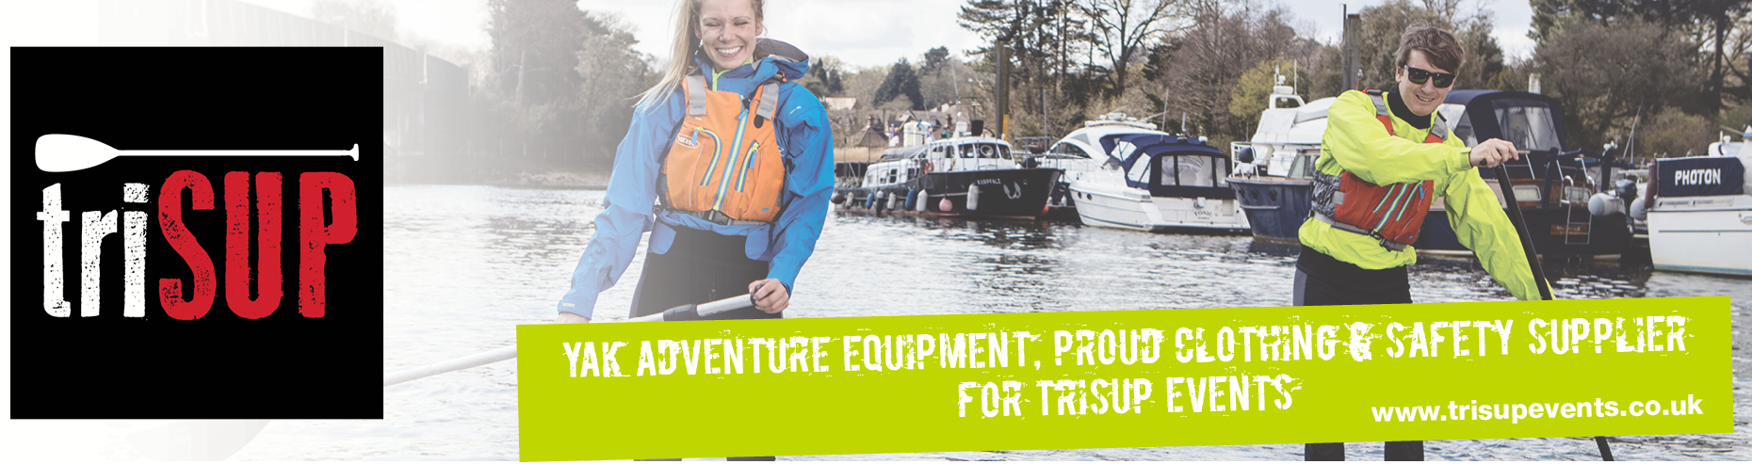
Together with Crewsaver, Yak has 50 years of experience manufacturing marine safety products that combine cutting edge technology with high performance and ultimate practicality.

