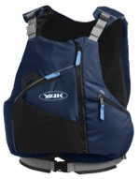
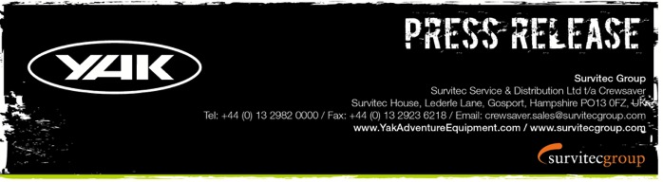
For Immediate Release
28th September 2016

Yak Adventure Equipment is back at PADDLEexpo 2016!
Find us on stand L-34

Yak Adventure Equipment is delighted to be back at PADDLEexpo and this year’s show sees the exciting launch of the pioneering High Back 60N buoyancy aid. The High Back 60N features unique buoyancy placement coupled with Airflow technology to provide the ultimate in comfort no matter what type of boat and backrest system you are using. The complete Yak range will be showcased at the show including the ever popular whitewater, touring & recreational collections that will satisfy even the most demanding adventurer.

In addition, the show will be a platform to announce the winner of the #WheresYakAt competition. Yak have received hundreds of competition entries in photo form capturing the mischievous ‘squishy Yaks’ during their paddling adventures and other shenanigans, and with the competition closing on the 10th October 2016 there are still plenty more to come! Not to forget, new for this year is the #WheresYakAtDoubleUp competition. Exclusively for paddlers who kept last year’s green Yak and now have this year’s blue and, of course, who have taken them both out paddling and got photo-snapping!

The big question on everyone’s mind is will there be a new Yak for 2017? You bet there will! Better yet, we will be giving them out for the very first time direct from the Yak stand (L-34) so why not pop over and grab yours!
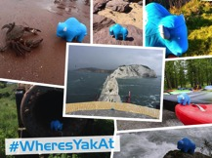

- New product launch
- Exclusive show offers
- Expert advice
- View the complete range of Yak Adventure Equipment
- #WheresYakAt winner announced
- Receive your FREE squishy Yak

‘We have great product to sell at generous show prices, new product to launch and an exciting competition running – what more could you want to offer your customers at a trade show.’ Pete Ford, Yak Adventure Equipment Brand Manager

ENDS//

For media information, hi-res images or product tests please contact:

Hazel Proudlock, Marketing Dept - Yak Adventure Equipment
T +44 (0) 1329 820406
E hazel.proudlock@survitecgroup.com

Or

Alison Willis – Marine Advertising Agency Ltd
T +44 (0) 23 9252 2044
E Alison@marineadagency.com

Notes to Editors
Part of the Survitec Group, which also owns Crewsaver, Yak Adventure Equipment produces and manufactures products that are purposely designed for whitewater, recreational and touring kayaking as well as canoeing. Yak Adventure Equipment offers a wide range of products to suit all styles and experience, giving paddlers more choice and opportunity to enjoy their sport with total peace of mind. Yak’s products include buoyancy aids, drysuits, cags, trousers, spray decks, gloves, footwear, headwear and buoyancy bags.

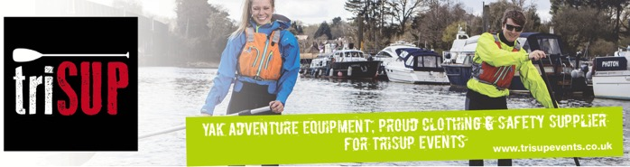
Together with Crewsaver, Yak has 50 years of experience manufacturing marine safety products that combine cutting edge technology with high performance and ultimate practicality.

