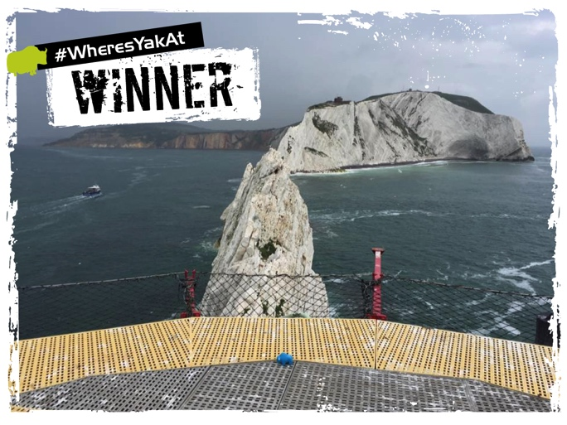
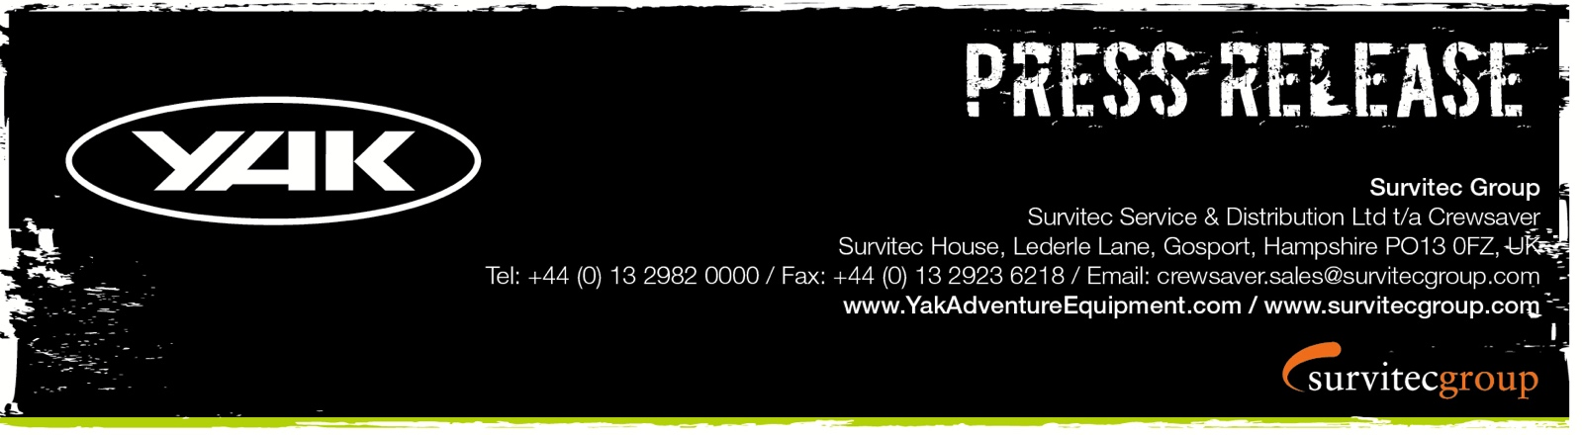
For Immediate Release
11th October 2016

#WheresYakAt and #WheresYakAtDoubleUp Competition Winners Announced!
Yak is delighted to announce the winners of its #WheresYakAt and #WheresYakAtDoubleUp photo competition, which was launched in May 2016 with the chance to win £500 and £1000 worth of Yak adventure gear. Yak has been overwhelmed by competition entries over the summer months with photos capturing the company’s squishy Yak mascots paddling the French Alps, sunbathing on a lily pad and even making friends with a cow in Switzerland! However Yak’s most epic adventure was captured by winner Phil Hawtin, who came across a Yak taking a stroll on the heli-pad at the Needles lighthouse. Phil received the most ‘likes’ for his photo and is now the proud owner of an exclusive Yak voucher worth £500 to spend on any Yak Adventure Gear of his choosing. Congratulations!
“Most Kayakers only get to see the lighthouse from below, the view from above is possibly better.” – Derroll Pedder, Yak Facebook page follower
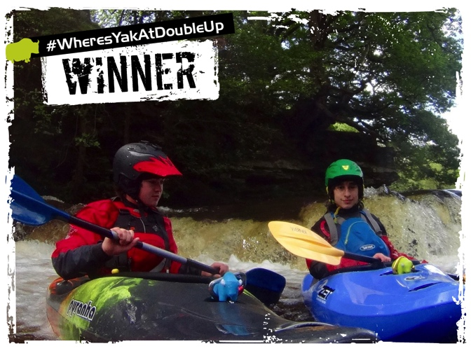
New this year was the #WheresYakAtDoubleUp competition whereby two Yaks were required to enter. Dedicated Yak fans that still had their green Yak from last year’s competition as well as this year’s blue Yak, captured the Yak family and posted on Facebook for the chance to win £1000 of Yak adventure gear. After much deliberation Yak-sponsored TriSUP Events selected the winning image of the Yaks (and a Yak Galena 70N buoyancy aid) taking part in a spot of river running! Congratulations to the 2016 #WheresYakAtDoubleUp competition winner Julia Aldous who wins £1000 worth of Yak Adventure Gear.
#WheresYakAt WINNER – Prize: £500 worth of Yak Adventure Gear
- Phil Hawtin

#WheresYakAt DoubleUp Winner – Prize: £1000 worth of Yak Adventure Gear

- Julia Aldous

#WheresYakAt special mentions go to the below, they each win a set of Yak Target base layers

- Jamie Magee who spotted Yak reclining on a lily pad at Allan Tarn, Coniston
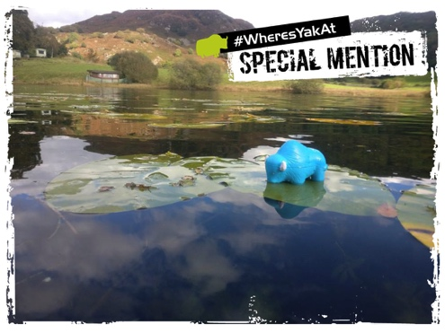

- El Reevo in Morocco who came across Yak at the top of Toubkal in the Atlas Mountains
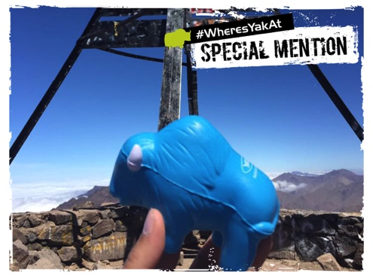

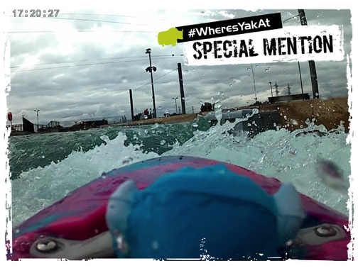
- Nick Kay for his video footage capturing Yak playing on the whitewater at Lee Valley White Water Centre

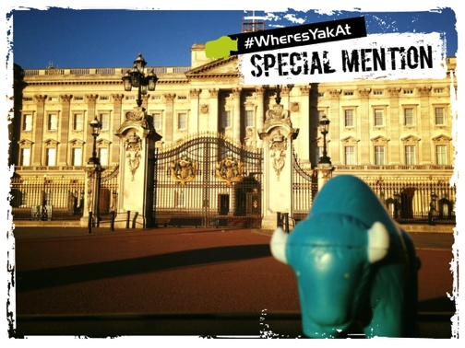
- Mat Fry who met Yak sightseeing at the gates of Buckingham Palace

Watch this space for a new addition to the Yak family. Herds of orange Yaks may soon be on the loose and looking for adventure.
ENDS//

For media information, hi-res images or product tests please contact:

Hazel Proudlock, Marketing Dept - Yak Adventure Equipment
T +44 (0) 1329 820406
E hazel.proudlock@survitecgroup.com

Or

Alison Willis – Marine Advertising Agency Ltd
T +44 (0) 23 9252 2044
E Alison@marineadagency.com

Notes to Editors
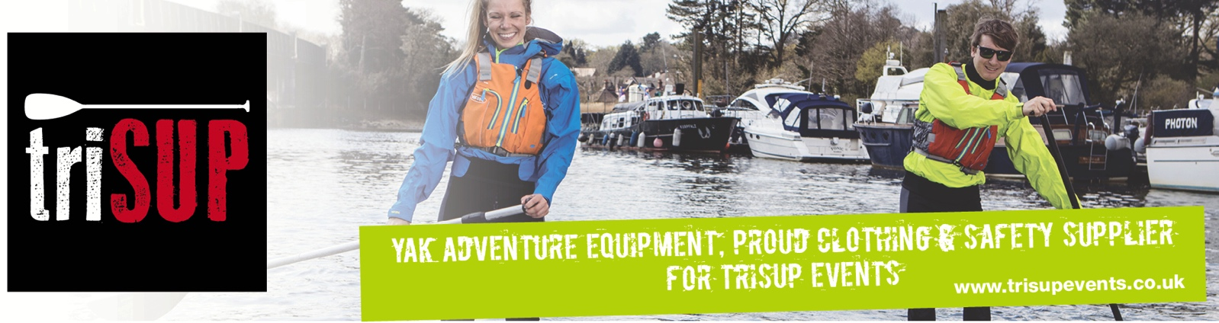
Part of the Survitec Group which also owns Crewsaver and Yak Adventure Equipment produces and manufactures products that are purposely designed for whitewater, recreational and touring kayaking as well as canoeing. A wide range of products suit all styles and experience, giving paddlers more choice and opportunity to enjoy their sport with total peace of mind. Yak’s products include buoyancy aids, drysuits, cags, trousers, spray decks, gloves, footwear, headwear and buoyancy bags. Together with Crewsaver, Yak has 50 years of experience manufacturing marine safety products that combine cutting edge technology with high performance and ultimate practicality.

