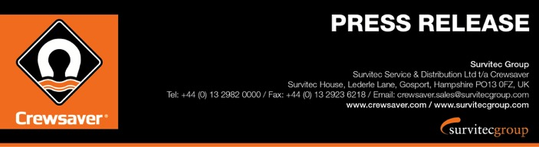
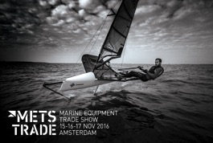
For Release: 15th November 2016

Crewsaver launches pioneering new buoyancy aid collection at METSTRADE 2016, stand 03.128, to create complete personal lifesaving range

The new Crewsaver buoyancy aid range, available for 2017, will be launched at METSTRADE 2016.
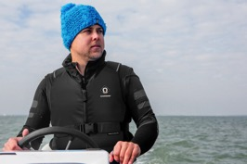
A large percentage of the boating world still does not wear any kind of personal flotation device. As a manufacturer of integral safety equipment the challenge for Crewsaver has been to reduce this number through the design of safe, comfortable and stylish personal flotation equipment including this brand new range of buoyancy aids.

This new range offers a variety of new features including a unique foam construction and an internal breathable mesh lining helping to ensure maximum comfort. Additionally, it features a distinct shape-to-fit design that provides a minimalistic bespoke fit.

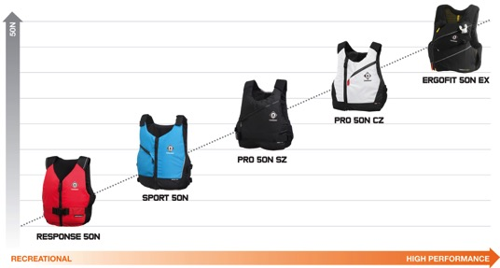
‘Two years on from the launch of our Fusion 3D leisure lifejacket range; we are delighted to now be able to launch our new buoyancy aid equivalent. Every one of our buoyancy aids is now Fusion3D designed and offers a multitude of features that clearly increase and develop as you go up the range, helping to ensure there is something to offer everyone that is both comfortable and affordable.’ Hannah Burywood, Marketing Manager

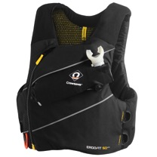
ERGOFIT 50N EX
The Crewsaver ErgoFit 50N EX ‘High Impact’ buoyancy aid, a revolution in personal safety equipment, provides the most advanced specification a buoyancy aid has to offer to date. Combining high specification safety features such as Spare Air attachments, body armour and line cutter stowage, with a low profile, and snag free design, you can expect nothing but the best in safety and performance technology. The ErgoFit 50N EX is available with and without armour protection. RRP: £80 RRP: £160 with armour

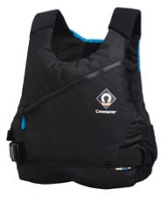
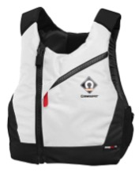
PRO 50N SZ & PRO 50N CZ
Fusion 3D design and unique body shaping foam that adapts to the profile of the wearer, combined with internal Airflow mesh ensure that the Pro 50N fits each user perfectly whilst offering the ultimate in comfort, fit and breathability performance. These features, plus an expandable bellow pocket with attachment point, make this the perfect safety companion for a multitude of watersport activities. The low profile Pro 50N is available in both centre zip ‘CZ’ and side zip ‘SZ’ options. The Pro 50N CZ is available in both a stylish bright white and black and the Pro 50N SZ is available in black/grey and black/blue options. RRP: £59.95
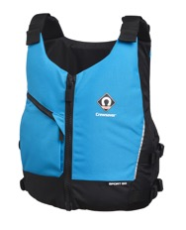

SPORT 50N
The Sport 50N offers the ideal solution for those who seek a high quality product at a highly competitive price point. Adjustable shoulder and dual waist straps combined with a unique arrangement of lightweight soft foam mean that the Sport 50N provides a bespoke and comfortable fit. This centre zip buoyancy aid features an expandable bellow pocket and reflective piping. Available in bright blue and red options. RRP: £49.95

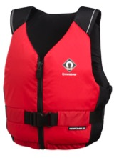
RESPONSE 50N
The perfect introduction to the Crewsaver buoyancy aid range, the Response 50N provides an entry-level buoyancy aid with an advanced contoured foam construction helping to ensure comfort and correct fit. In addition the Response 50N houses an array of features including a centre zip, padded shoulder straps, adjustable waist, key pocket and reflective print detailing. Available in red and black colour options. RRP: £34.95

For more information and to arrange a viewing of these exciting new products at METS please contact: Hazel Proudlock, Marketing Dept
T +44 (0) 1329 820406 / E hazel.proudlock@survitecgroup.com

ENDS//

For media information, hi-res images or product tests please contact:

Crewsaver
Hazel Proudlock, Marketing Dept
T +44 (0) 1329 820406
E hazel.proudlock@survitecgroup.com

Or

Alison Willis – Marine Advertising Agency Ltd
T +44 (0) 23 9252 2044
E Alison@marineadagency.com

Notes to Editors

Crewsaver is a world-leading manufacturer of marine safety equipment and clothing for the commercial and leisure marine industries. Based in Gosport, Hampshire, the company designs and manufactures bespoke safety equipment for several countries’ Special Forces, and the aviation and oil industries. Crewsaver is the only company to hold an exclusive contract to supply lifejackets to the UK government’s Environment Agency and the Royal National Lifeboat Institution (RNLI). They are part of the Survitec Group.

www.crewsaver.com

Survitec Group holds market-leading positions worldwide in marine, defence and aerospace survival technology. Headquartered in Birkenhead, the company employs 2000 people across 10 manufacturing sites and 50 service centres, operating through a network of a further 550 distributors and agents to bring its best-in-class products and services to a global customer base. With an extensive history spanning over 160 years and a portfolio of some of the most reputable brands in the safety and survival industry, Survitec is committed to product innovation, technological advancement and quality assurance.
Key products within Survitec’s portfolio include marine, defence and aviation Liferafts, world leading submarine escape technology, lifejackets for commercial airlines and the offshore industry as well as pilot flight equipment, including anti-g clothing used for the Eurofighter and JSF programmes. The Group also pioneered marine evacuation technology and today the unique MarinArk system is used on many major cruise ships across the globe.

www.survitecgroup.com

