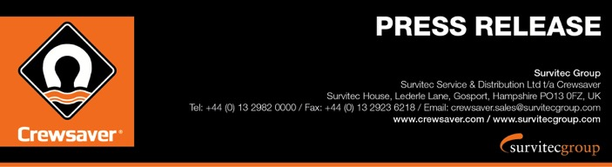
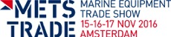
For Release: 15th November 2016

Crewsaver completes personal lifesaving range with product launches at METSTRADE 2016

Immerse yourself in Crewsaver’s ‘World of Lifejackets’ at METSTRADE 2016 - Stand 03.128

Crewsaver has become one of the only lifejacket and buoyancy aid manufacturers able to provide the global commercial and leisure sectors with a comprehensive catalogue of personal lifesaving products following the launch of its new buoyancy aid range at METSTRADE 2016.

Crewsaver is inviting visitors to METSTRADE to join them on the Crewsaver stand 03.128 to immerse themselves in its world of lifejackets. The launch of the new buoyancy aid range means that the company now offers personal flotation solutions for every level, so whatever activity or operation is being undertaken; Crewsaver has a product to suit.

The complete range offers the company’s most advanced design and performance technology to date. Unique Fusion 3D comfort technology is built around the most advanced safety features. METSTRADE is the ideal opportunity to view the whole of the complete lifesaving product range and talk with one of Crewsaver’s highly experienced technical sales representatives.

Crewsaver’s World of Lifejackets and Buoyancy Aids includes:

- Buoyancy aid range – New for 2017
- Fusion 3D ISO & USCG lifejacket ranges
- Children’s lifejacket range
- Commercial ISO & SOLAS Workvest lifejacket range

‘Two years on from the launch of our Fusion 3D leisure lifejacket range, we have seen a huge increase in the number of people buying lifejackets, the Fusion 3D design makes the product a lot more comfortable therefore people are more likely to wear them. Additionally offering a complete range of personal lifesaving solutions means that we have something for everyone and can clearly identify the product best suited to the individual’s needs both in terms of features and price point.’ Hannah Burywood, Marketing Manager

During the show Crewsaver will also be exhibiting its range of Aurora pyrotechnics and its liferaft range, which includes the Ocean ISO and SurvitecZodiac SOLAS liferafts, creating the most comprehensive safety catalogue available.

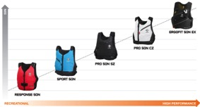
- Buoyancy aid range – New for 2017

- Fusion 3D ISO & USCG lifejacket ranges
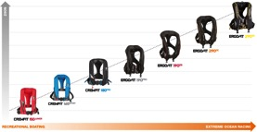
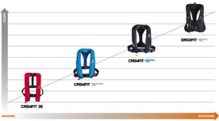
- Children’s lifejacket range
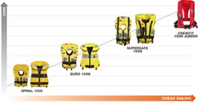

- Commercial ISO & SOLAS Workvest lifejacket range

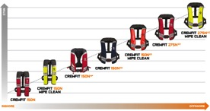

For more information and to arrange a viewing of these exciting new products at METS please contact:
Hazel Proudlock, Marketing Department
T +44 (0) 1329 820406
E hazel.proudlock@survitecgroup.com

ENDS//

For media information, hi-res images or product tests please contact:

Crewsaver
Hazel Proudlock, Marketing Dept
T +44 (0) 1329 820406
E hazel.proudlock@survitecgroup.com

Or
Alison Willis – Marine Advertising Agency Ltd
T +44 (0) 23 9252 2044
E Alison@marineadagency.com

Notes to Editors

Crewsaver is a world-leading manufacturer of marine safety equipment and clothing for the commercial and leisure marine industries. Based in Gosport, Hampshire, the company designs and manufactures bespoke safety equipment for several countries’ Special Forces, and the aviation and oil industries. Crewsaver is the only company to hold an exclusive contract to supply lifejackets to the UK government’s Environment Agency and the Royal National Lifeboat Institution (RNLI). They are part of the Survitec Group.

www.crewsaver.com

Survitec Group holds market-leading positions worldwide in marine, defence and aerospace survival technology. Headquartered in Birkenhead, the company employs 2000 people across 10 manufacturing sites and 50 service centres, operating through a network of a further 550 distributors and agents to bring its best-in-class products and services to a global customer base. With an extensive history spanning over 160 years and a portfolio of some of the most reputable brands in the safety and survival industry, Survitec is committed to product innovation, technological advancement and quality assurance.
Key products within Survitec’s portfolio include marine, defence and aviation Liferafts, world leading submarine escape technology, lifejackets for commercial airlines and the offshore industry as well as pilot flight equipment, including anti-g clothing used for the Eurofighter and JSF programmes. The Group also pioneered marine evacuation technology and today the unique MarinArk system is used on many major cruise ships across the globe.

www.survitecgroup.com

