Press Release
For Immediate Release
13th December 2016
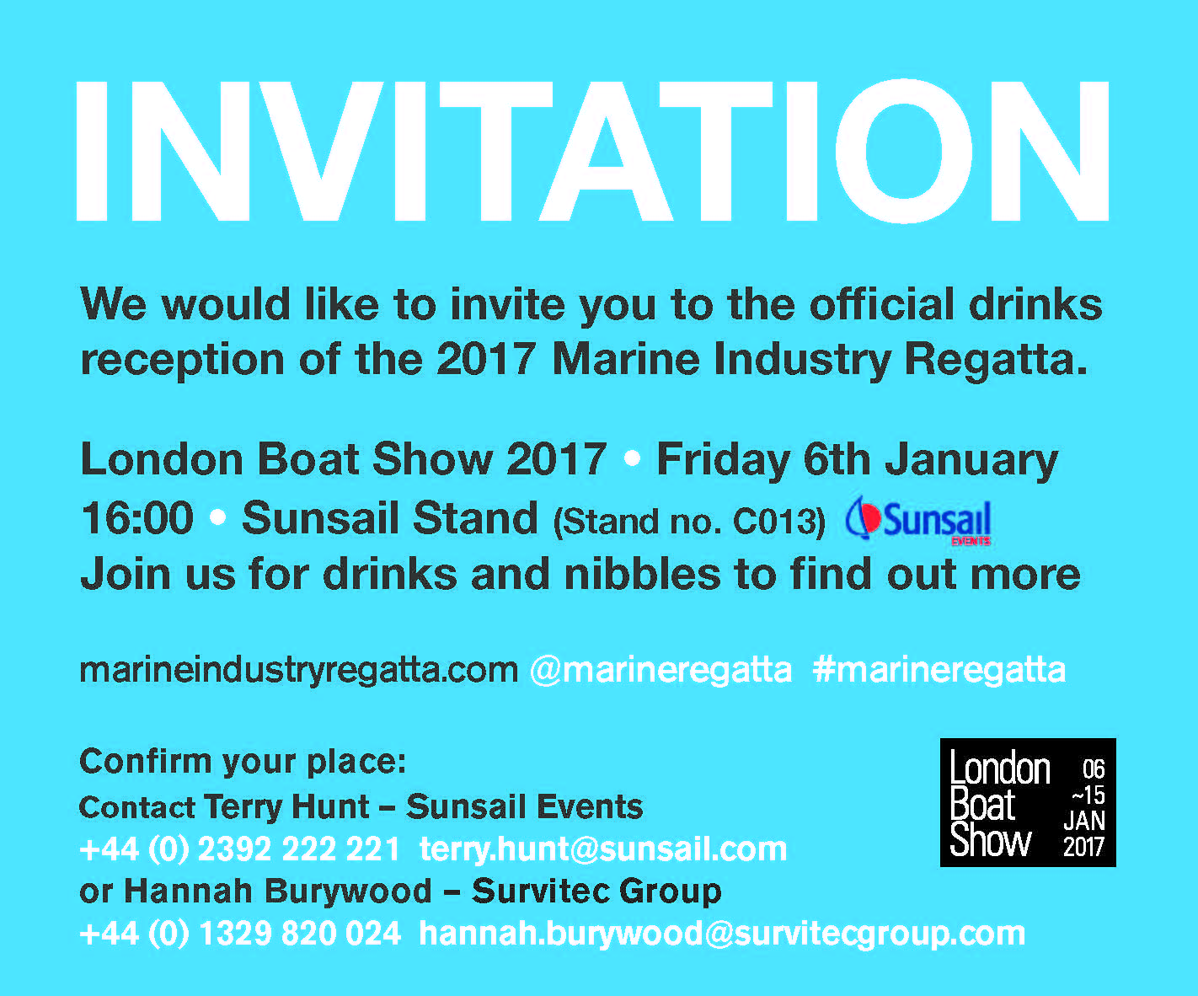
Survitec Group Marine Industry Regatta to host Drinks Reception at London Boat Show 2017

The Marine Industry Regatta team is delighted to announce that there will be a drinks reception hosted on the Sunsail stand at London Boat Show. The event will give people in the industry the opportunity to speak to members of the team and find out more about the event whilst enjoying some bubbly and nibbles.

Marine Industry Regatta Drinks Reception
6th January 2017
4pm
Sunsail Stand C013

The Marine Industry Regatta takes place on Wednesday 17th May 2017, sailing out of Port Solent in Sunsail First 40’s. The regatta is a great way to get together with other marine professionals and to entertain clients and staff. Charitable donations from the event will raise funds for the John Merricks Sailing Trust and the Andrew Simpson Sailing Foundation, another great reason to get involved.

Marine Industry Regatta 2017 raising funds for…
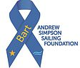
ENDS//

For media information & hi-res images please contact:

Alison Willis – Marine Advertising Agency Ltd
T +44 (0) 23 9252 2044
E Alison@marineadagency.com

Notes to Editors

Survitec Group Marine Industry Regatta is the day each year when the marine industry goes sailing. Originally conceived by Peter Nash (Boating Business) the event is now organised by Survitec Group who also hold the position as title sponsor, the Marine Advertising Agency and Sunsail UK. Sailed in Sunsail First 40’s from Port Solent, the regatta is a great way to get together with other marine professionals and to entertain clients and staff. We look forward to seeing you all at the breakfast briefing 17th May 2017.

www.marineindustryregatta.com

