For Release: 3rd January 2017
London Boat Show: 6th – 15th January 2017
Stands: A026 / A056 / B039

Crewsaver to WOW visitors at the London Boat Show 2017 with its extensive safety range, exclusive offers and expert advice.

It is with delight that Crewsaver announces its attendance at the 2017 London Boat Show. Visitors to the show will be able to view Crewsaver’s complete leisure range and speak to its friendly safety experts for guidance on lifejackets, liferafts, emergency beacons, pyrotechnics and much more.

The London Boat Show provides an opportunity for visitors to immerse themselves in Crewsaver’s collection of safety equipment including the ergonomic Fusion 3D lifejacket range. The range, which, due to popular demand, has grown from that presented at last year’s show, now includes the blue Crewfit 165N Sport available in an automatic non-harness version, ideal for inshore powerboating.

Crewsaver is offering visitors to the show*
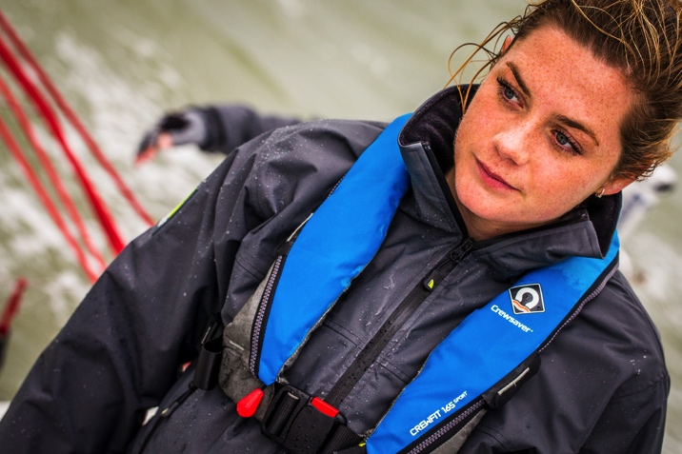
- FREE Aerial Inshore Flare Pack with any Crewsaver ISO Liferaft. Worth £88.00
- FREE Safety Line with every ErgoFit 290N Lifejacket. Worth £58.00
- FREE ErgoFit Knife with every ErgoFit 190N Hammar lifejacket. Worth £17.50
- FREE Rearming Kit with every ErgoFit 190N Automatic Lifejacket. Worth £30.00
- CHOOSE YOUR OWN GIFT! FREE Lifejacket Light, Spray Hood or Rearming Kit with every Crewfit 180N Pro. Worth up to £30
- FREE Lifejacket Bag with any 4 x Crewfit 165N Sport or Crewfit 150N Junior lifejackets. Worth £27.50

Find Crewsaver at…
- Marine Super Store A026
- Andark Diving & Watersports A056
- Jimmy Green Marine B039

* Max 1 per purchase. Max 2 per customer. E&OE. Terms and conditions apply. Whilst stock lasts

//ENDS//

For media information, hi-res images or product tests please contact:

Crewsaver
Hazel Proudlock, Marketing Dept
T +44 (0) 1329 820406
E hazel.proudlock@survitecgroup.com

Alison Willis – Marine Advertising Agency Ltd
T +44 (0) 23 9252 2044
E Alison@marineadagency.com

Notes to Editors

Crewsaver is a world-leading manufacturer of marine safety equipment and clothing for the commercial and leisure marine industries. Based in Gosport, Hampshire, the company designs and manufactures bespoke safety equipment for several countries’ Special Forces, and the aviation and oil industries. Crewsaver is the only company to hold an exclusive contract to supply lifejackets to the UK government’s Environment Agency and the Royal National Lifeboat Institution (RNLI). They are part of the Survitec Group.

www.crewsaver.com

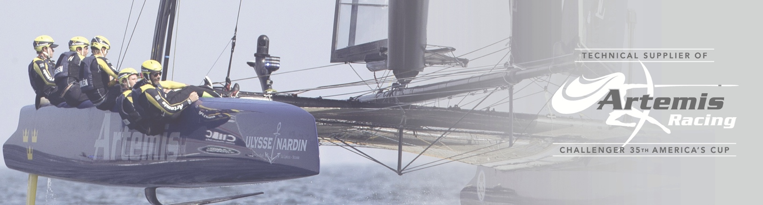
Survitec Group holds market-leading positions worldwide in marine, defence and aerospace survival technology. Headquartered in Birkenhead, the company employs 2000 people across 10 manufacturing sites and 50 service centres, operating through a network of a further 550 distributors and agents to bring its best-in-class products and services to a global customer base. With an extensive history spanning over 160 years and a portfolio of some of the most reputable brands in the safety and survival industry, Survitec is committed to product innovation, technological advancement and quality assurance.
Key products within Survitec’s portfolio include marine, defence and aviation liferafts, world leading submarine escape technology, lifejackets for commercial airlines and the offshore industry as well as pilot flight equipment, including anti-g clothing used for the Eurofighter and JSF programmes. The Group also pioneered marine evacuation technology and today the unique MarinArk system is used on many major cruise ships across the globe.

www.survitecgroup.com

