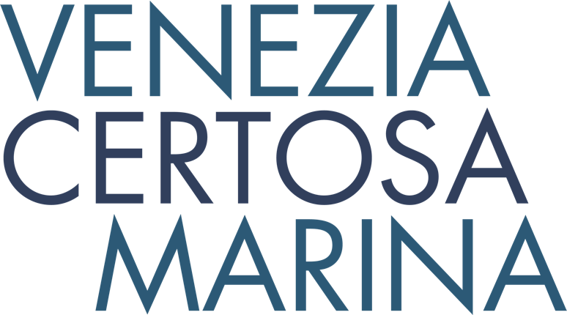

**N e w s R e l e a s e**

**For immediate release**

**5th January 2017**

**Venice’s hidden gem attracts top sailors**

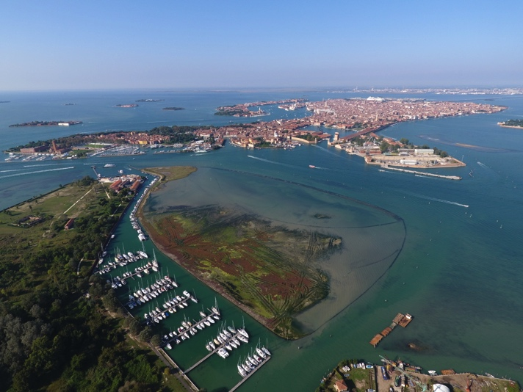**The Venezia Certosa Marina in Venice is a hidden gem that boasts Bruno Troublé, founder of the Louis Vuitton Cup, amongst its berth holders. The 300-berth marina is situated less than 10 minutes from St Mark’s Square on Certosa island, a 24-hectare natural paradise which has been recently regenerated to showcase its valuable natural heritage.**

The marina is ideally located to make the most of Venice, which is what attracted Bruno Troublé, “What a discovery! Peace and quiet, no tourists, only 10nm from the centre… a wonderful place to make the most of Venice and the Adriatic Sea.”

Franck Cammas is another top sailor who has discovered the marina’s charms, “Sailing on the Grand Canal between San Marco and San Giorgio is amazing! We based our 100ft trimaran at La Certosa and have benefited from their local infrastructures and know-how.”

Berth holders can effectively use their boat as a pied-à-terre for short breaks and year-round holidays exploring the city, its monuments, museums and cultural events such as La Biennale, the film festival and numerous ‘happenings’.

The marina is just 15 minutes by public transport from the city and lagoon. Visitors can also discover Venice lagoon aboard their own boat, visiting the islands of Murano, Burano and Torcello, as well as the lesser known islands in the Northern lagoon. Short and long term moorings are available, and live aboards are welcome.

Being inside the lagoon, and less than one mile from the open sea, the marina is easy to access with sheltered moorings as all boats are protected by the surrounding islands and by a 4m wide breakwater. Deep draft yachts can also be accommodated. Fresh water, power and WiFi are all available and 24 hour security and regular boat checks when berth holders are away, give peace of mind. Shoreside facilities include indoor or outdoor dry storage, hotel, a restaurant and bar, chandlery, and laundry and dry cleaning facilities. The on-site boatyard, where craftsmen build traditional Venetian boats, is also available for maintenance (lifting, anti-fouling, etc.), refits and repairs. A sailing school, hotel and the possibility of kayak excursions into Venice are also all available.

Venice is easy to access with low cost flights from across the UK to Venice Marco Polo airport, only 20 minutes from the marina. The possibilities to explore beyond Venice are numerous; the Adriatic is a perfect cruising ground, Trieste or Rovigno are 50 nautical miles away, the marina is 200 nautical miles from Split, Croatia, and for onshore exploring, the mountains (the Dolomites) are just two hours drive away, while Verona is only 100km away.

Venice played host to the America’s Cup World Series in 2012, and Venezia Certosa Marina itself hosted the second edition of the Dragons in Venice Invitational in 2016.

Berthing in Italy is surprisingly cost effective, an annual berth for 2017 at the Venezia Certosa Marina, just minutes from open sea, costs around £3800 for a 12m monohull, compared with around £10,000 for an equivalent annual berth at a UK south coast marina.



For more information visit <http://marina.ventodivenezia.it/>

ENDS

**Media enquiries:**

Alison Willis

Marine Advertising Agency

T: 023 92 52 2044, Mobile: 07980 009653

E: Alison@marineadagency.com