**News Release**

**For immediate release**

**6th January 2016**

**Dazzling UK launch for Prestige 630 at London Boat Show 2017**

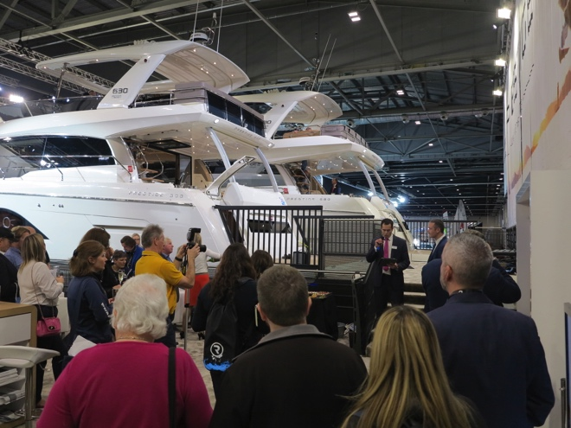**The Prestige 630, the newest luxury motor yacht from Prestige, dazzled on its UK launch on Friday 6th January 2017 at London Boat Show.** The Prestige 630 is the latest in a series of impressive launches from Prestige Luxury Motor Yachts and the UK launch at London Boat Show indicates the importance that Prestige places on the UK market.

The 2017 London Boat Show sees three of the largest Prestige models on display. Antoine Chancelier, Sales Director for Prestige, commented, ‘This is the largest line-up we have ever brought to London in terms of models. Prestige is a truly global brand, there are currently 3,500 Prestige yachts worldwide. The UK market is very important to us, in terms of our design direction, and potential for growth. Our aim is to constantly innovate, as well as private access to the master cabin, this new model gives guests additional privacy with a ‘loft’ style guest cabin.’

Nick Hatfield, Prestige Brand Manager at Ancasta, the UK’s largest Prestige Luxury Motor Yacht dealer and Prestige Dealer of the Year in 2016, added, ‘Looking round the show, the Prestige brand now sits comfortably alongside Princess and Sunseeker. Its position as a major player in the motor yacht market has been established. We are seeing huge demand for Prestige amongst our customer base, and London Boat Show gives us the ideal opportunity to showcase Prestige to the UK market.’

The three models that Prestige has on display at London have been chosen for their suitability for the UK market, and the size of the yachts in particular reflects both the demand that Prestige is seeing from Brits and the brand’s understanding of the market. Visitors to London Boat Show can see the Prestige 630, Prestige 560 and Prestige 680, which won a coveted 2016 Motorboat of the Year Award.

The Prestige 630 Yacht, a 19m luxury flybridge motor yacht is destined to be yet another highly popular yacht from the Prestige yard. Coming from the drawing board of Garroni Design and with a J&J Design hull, the Prestige 630 reflects the lines and layout of the other successful motor yachts in the Prestige range. The Prestige 630 is powered by Twin Volvo IPS950 engines, which give superb economy and easy manoeuverability especially when short-handed. She is capable of a top speed of 28 Knots and a cruising speed of 24 Knots.

The interior of the Prestige 630 is bathed in light. It offers one level living and the galley aft. Luxurious furnishings in a selection of materials and colour schemes create a level of interior design



usually reserved for larger cruising yachts. Three cabins, each with their own ensuite, mean both the owners and their guests are spoilt in the exceptional accommodation and there is an additional

cabin for crew. The galley offers a bar-like opening to the cockpit, while the huge flybridge provides a superb area to relax or entertain in absolute comfort.

The Prestige 630 boasts all the key features, which have made the range so successful. High tech design solutions combined with the selection of the IPS950 pod transmission engines leave the Prestige 630 positioned at the cutting edge of technology.

Prestige 630 specification:

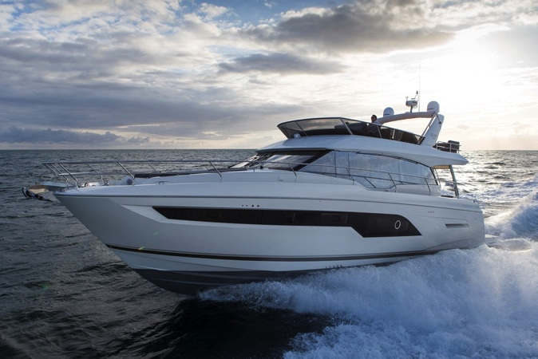**Designer** Garroni Design / J&J Design

**Base price** £990,435 ex VAT

**On the Water Price** £1.082m ex VAT

**LOA** 19.02m

**Hull length** 16.83m

**Maximum beam** 5.15m

**Engine size** Twin Volvo IPS950 D11-725HP

**Cruising speed** 24 Knots

**Maximum speed** 30 Knots

**Maximum range** 305 NM @ 24 Knots

**Dry (light) weight** 23,800 kg

**Displacement** 33,000 kg

**Cabins** Three cabins plus crew

**Standard fuel capacity** 2,700 litres

**Standard water capacity** 920 litres

The Prestige 630, Prestige 560 and Prestige 680 are at London Boat Show until 15th January 2017, contact Ancasta now to make an appointment to view, email Nick Hatfield ([nickhatfield@ancasta.com](mailto:nickhatfield@ancasta.com)) or call +44 2380 450000.

For more information on the Prestige 630 visit <http://www.ancasta.com/boats-for-sale/new-boats/prestige/prestige-yachts/630/>

**ENDS**

**Notes to editors**

* Ancasta International Boat Sales has 14 offices across Europe
* Ancasta is the UK’s largest Prestige Luxury Motor Yachts dealer, the UK’s largest Beneteau Power and the UK’s largest Beneteau Sail dealer
* Ancasta is exclusive UK dealer for Lagoon Catamarans
* In addition Ancasta is a new boat dealer for CNB Yacht Builders and McConaghy Yachts
* The Ancasta Group incorporates Hamble Yacht Services Refit & Repair and Advanced Rigging and Hydraulics, both operating from Port Hamble.
* For more information on Ancasta visit www.ancasta.com

Media enquiries via Marine Advertising Agency:

Alison Willis - [alison@marineadagency.com](mailto:alison@marineadagency.com) Tel: 023 9252 2044