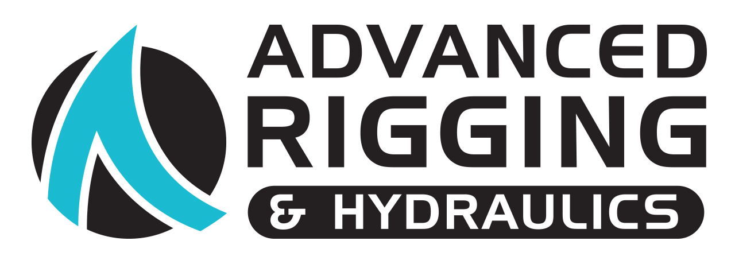

News Release
For Immediate Release
15th February 2017
Advanced Rigging & Hydraulics extends supply of replacement rigging UK-wide
Advanced Rigging & Hydraulics has launched a service supplying the highest quality replacement rigging to boats based anywhere in the UK at a price that is on average 10% below the manufacturers’ RRP.

Hamble-based Advanced Rigging & Hydraulics can now supply replacement rigging to boats based anywhere in the UK, allowing more boat owners to benefit from its expertise and competitively priced quality rigging. The company already offers rig inspections and installation of replacement rigging to boats based within the Solent region, but for those further afield, this new service will be ideal. When replacement rigging is needed for boats based outside the Solent region, the company arranges collection of the existing rigging and produces a full set of the highest quality replacement rod or wire rigging before arranging free delivery (subject to location and boat size) back to the customer or a trusted local rigger to carry out the installation. All products use the best materials and come with a standard 12-month guarantee. This service ensures that all customers can benefit from the best fit, best quality and best price.

For boats based locally, Advanced Rigging & Hydraulics is offering 50% off rig inspections and rigging reports until the end of April 17. Inspections allow the company’s expert technicians to provide a completely impartial overview of the condition of a boat’s mast and its standing and running rigging. Rigging inspections are essential given that standard yacht insurance policies require rigging to be kept in a fit and proper seaworthy condition and these reports provide an excellent record for maintenance purposes.

For more information on replacement rigging and to arrange an inspection at 50% off the usual price, please contact Advanced Rigging on 02380 454 280.

http://advancedrigging.co.uk/services/rig-inspection-reports/

- ENDS -

NOTES TO EDITORS:
- Advanced Rigging & Hydraulics is part of the Ancasta Group
- The Ancasta Group incorporates Ancasta International Boat Sales, Hamble Yacht Services Refit & Repair and Advanced Rigging & Hydraulics
- Advanced Rigging & Hydraulics are the UK’s main dealer for Reckmann Yacht Equipment, OYS Leisure Furl, and suppliers of Gottifredi Maffioli, Kingfisher, Liros, Future Fibres, BSI, Axxon
- Ancasta International Boat Sales Ltd registered address is: Port Hamble Marina, Hamble, Hampshire, SO31 4QD. Tel: 023 80 450 000. Email: reception@ancasta.com

For media enquiries contact:
Alison Willis, Marine Advertising Agency, T: 02392 522044 alison@marineadagency.com

