*****Press release – Immediate release*****

2nd February 2017

MasterCraft Boats UK and Superyacht Tenders and Toys extend bespoke watersports tender range with the addition of the new XT21 available with Yanmar inboard diesel

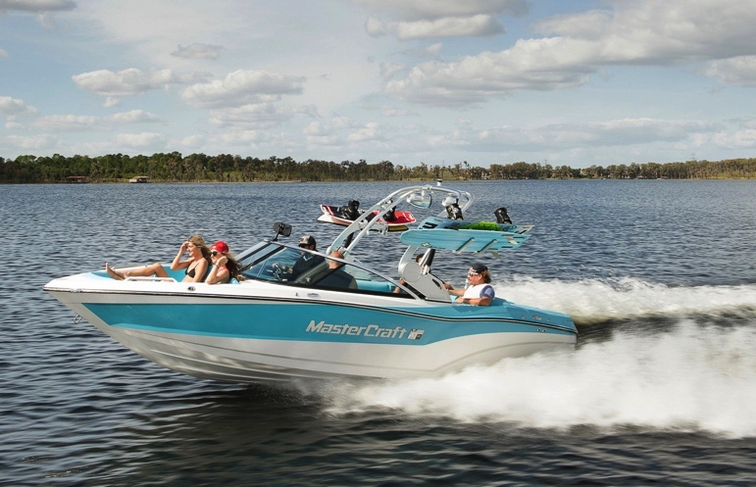
The new MasterCraft XT21 was launched on the European market at Boot Düsseldorf on Saturday 21st January 2017 and is now available through Superyacht Tenders and Toys as a bespoke superyacht tender with a Yanmar inboard diesel engine.

Superyacht Tenders and Toys is in a unique position to supply the bespoke XT21 having a proven track record selling highly specialised tenders. It makes sure that the purchase process runs smoothly, and can assist with all aspects from tax and customs to shipping. The company offers ongoing support for the lifetime of the tender; a comprehensive warranty, aftersales and support through an approved global service network.

At 6.5m, the new model is a middleweight crossover boat. The crossover range has been developed to suit the widest possible range of watersports needs, whether that be wakeboarding, waterskiing, wakesurfing, towsports or tubing. The ability to handle all towboat activities makes it an ideal multipurpose watersports tender.

The Yanmar 8LV diesel engine will make this a popular choice as a dedicated watersports tender for superyachts. Michael Hardicker, MD of MasterCraft Boats UK says, ‘We’re

consistently able to show that diesel power is every bit as good as petrol for sports boats. It gives the advantages of economy, durability and reliability, with no loss of power. Being able to easily refuel while at sea is a real advantage for many captains and is a significant benefit to superyachts spending long periods of time offshore.’

The all-new hull on the XT21 delivers responsive handling with minimum bow rise and improves performance in every on-water activity, from massive wakes to endless waves and smooth skiing. MasterCraft’s award-winning Gen 2 Surf System has been custom designed for the new hull to create three zones of perfectly sculpted lips and sizeable curling surf waves. The touchscreen controls mean that even inexperienced drivers can create the desired wake or waves and consistent speed. Crew members can be assured they are giving guests a great experience on the water whatever their preference.

The XT21 has a new cockpit layout to comfortably accommodate up to 14 while extensive storage space keeps the deck clear. The interior has a spacious helm with a new ergonomic captain’s seat, new dash and billet aluminium accents. The new Cool Feel vinyl that stays cool to the touch in direct sunlight is also an option as are under seat Cordova Coolers that keep everything and everyone chilled.

The XT21 has the new DockStar Handling System, an innovative flanking rudder system that enables boat drivers of any ability level to confidently drive in reverse and more easily navigate tight docks and crowded marinas. Whilst experienced superyacht crew will appreciate the ease of operation, DockStar comes into its own for less experienced drivers, particularly for those occasions when owners or guests want to be a bit more hands on.

The XT21 includes a choice of easy-lifting customisable towers, speaker layouts and vertical storage options. The exterior of the XT21 can also be completely customised thanks to a broadened palette of gel coat and flake colour patterns.

Superyacht Tenders and Toys will assess the space and position available for the tender. The bespoke service also includes a number of lifting options tailored to meet the widest possible range of requirements. Single or multi point lifting, spreader bars and keel line lifts are among the solutions offered to ensure that the best option is found in line with the superyacht’s crane positions and storage location on board.

Like all MasterCraft boats, the XT21 comes with the five year MasterCare protection plan. Hand-built by master craftsmen in the Company’s US manufacturing facility in Tennessee, MasterCraft boats are constructed with quality and reliability in mind, resulting in the highest resale values in the industry.

To enquire about the XT21, please contact Superyacht Tenders and Toys at info@superyachttendersandtoys.com

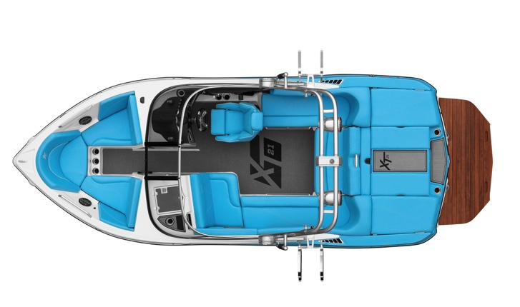
XT21 Specifications:
Length: 21’ 4” / 6.5 M
Width Amidship: 98” / 2.48 M
Interior Width: 81.5” / 2.07 M
Dry Weight: 4,800 LBS / 2,177 KG
Ballast Weight: 2,500 LBS / 1,133 KG
Fuel Capacity: 51 G / 193 L
Seating: 14 people
Storage: 87 cubic feet / 2.46 cubic metres
Hull: Vector Drive
Colour Options: Infinite

Find out more at http://superyachttendersandtoys.com/tenders/watersports/

ENDS

Media:
See more at https://youtu.be/8esB0kKCPVc
Media enquiries via Marine Advertising Agency:
Alison Willis, alison@marineadagency.com
Emma Stanbury, emma@marineadagency.com
T: 023 9252 2044

Josh Richardson, Superyacht Tenders and Toys
T: UK +442380016363
T: France +33489733347
T: US +19643029066
E: info@superyachttendersandtoys.com
Notes to Editors:
Superyacht Tenders and Toys is the leading independent consultancy and management company specialising in all superyacht tender and toy needs and provides practical solutions for the World’s finest yachts.

