******Press release - Immediate release*****
20th February 2017
Superyacht Tenders and Toys selected as preferred sales agent for Nautique Superyacht sales
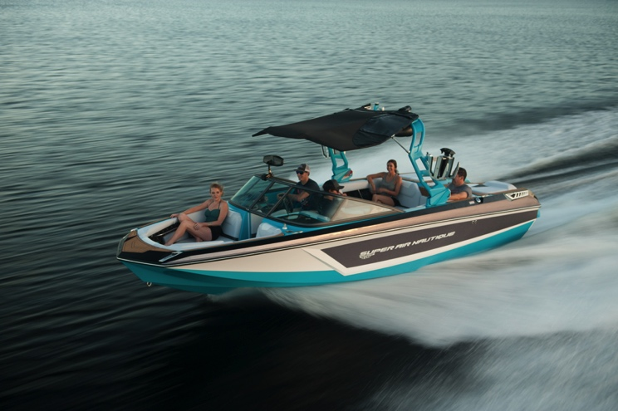
With sales of watersports tenders increasing, Superyacht Tenders and Toys (SYTT) is pleased to have been selected by Nautique to assist in the sales and service of these to yachts. Superyacht Tenders and Toys has long been providing tenders to yachts globally, and there is an increasing trend on larger yachts for there to be a dedicated watersports tender. These boats are excellent value compared to custom boats and also offer very large capacity for the volume. If owners, guests or crew are keen watersports enthusiasts, there is no compromise as RIBS and other ridged tenders do not compare to the crisp clear wake and surf systems offered by Nautique.
The Super Air Nautique watersports tender
A key aspect of the service offered by SYTT is assistance in the customisation of these boats to fit on, and be able to be used by, superyachts. Traditionally yachts struggle with the customisation required on Nautique tenders as they are a production boat, Superyacht Tenders and Toys can assist in the design and implementation of custom lifting kits, removable windscreens and towers to name but a few. Other options like real teak decking, custom upholstery are all offered to make these boats truly unique.
The new range of 2017 Nautique craft is very exciting, stepping up the user experience whether it be wake surfing, wakeboard, skiing or towables. With new integrated technology, comfort, convenience, function and style, they continue to deliver world-class boats.
Contact Superyacht Tenders and Toys for any new build enquiry.
To learn more about Superyacht Tenders and Toys, visit
http://www.superyachttendersandtoys.com
ENDS

High res image gallery here

Media enquiries via Marine Advertising Agency:

Alison Willis, alison@marineadagency.com
Emma Stanbury, emma@marineadagency.com
T: 023 9252 2044

Josh Richardson, Superyacht Tenders and Toys T: UK +442380016363
T: France +33489733347
T: US +19643029066
E: info@superyachttendersandtoys.com

Notes to Editors:
Superyacht Tenders and Toys is the leading independent consultancy and management company specialising in all superyacht tender and toy needs and provides practical solutions for the World’s finest yachts.

