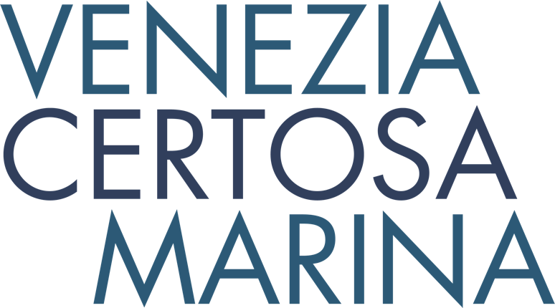

**N e w s R e l e a s e**

**For immediate release**

**20th February 2017**

**Venezia Certosa Marina announces first of cultural happenings for 2017**

**The Venezia Certosa Marina in Venice has announced that it will play host to a video art piece co-curated by Mary Bordeaux and Nancy Marie Mithlo from 11th-19th May 2017.** Boat owners who want to combine cruising with culture are encouraged to enquire now about berths.*Wah.shka* is a video art piece accompanied by large format photography; it will open at the international venue of the Venice Biennale. This moving film and video collaboration, centres around Indigenous rights and responsibilities in light of increased urbanization and environmental destruction. Certosa island, where the Venezia Certosa Marina is situated, will provide a stunning backdrop for the piece.

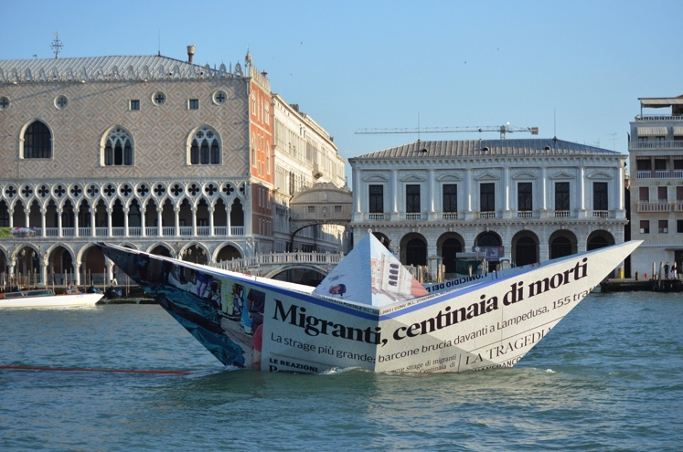

Venezia Certosa Marina is known for its collaborations with artists, making it an ideal base for boat owners who want to combine cruising with culture. In 2015 Brazilian artist Vik Muniz unveiled a floating installation, a giant paper boat called Lampedusa, highlighting the plight of migrants. The seaworthy wooden substructure was constructed by Venetian craftsmen from the boat yard at the marina, and it was covered with a scaled-up newspaper article about the migrant crisis. Also in 2015, creative instigator, Michèle Lamy, and her fashion designer partner, Rick Owens, created a hangout, installation artwork, pop-up restaurant and recording studio on a barge, which was moored at the marina in May 2015 at the start of the Biennale. The Bargenale, as it was christened, was open to the public, with Afro-Fusion chef, Dieuveil Malonga, in residence.

Vik Muniz’s 2015 floating installation

With a reputation for bringing cultural happenings to the marina, this year’s Biennale as seen from Venezia Certosa Marina promises to be unmissable, with the Mary Bordeaux and Nancy Mithlo video piece being the first of several events to be announced.

The marina is also ideally situated to take advantage of the other main events that take place on the Venetian calendar each year, from the Festa della Sensa (27th & 28th May 2017), which celebrates the marriage of Venice with the sea with an impressive water parade and traditional ceremony followed by rowing regattas, to the Redentore Feast (15th July 2017) a day when all of Venice gets afloat, culminating in a spectacular firework display which lights up the spires, domes and bell towers of the city. Sailors cruising in the Adriatic are advised to take advantage of the Venezia Certosa Marina to plan a trip that coincides with these unmissable events.

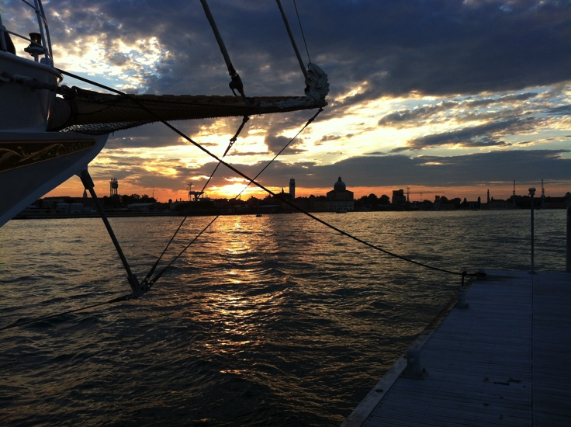

The marina is a hidden gem that boasts Bruno Troublé, founder of the Louis Vuitton Cup, amongst its berth holders. The 300-berth marina is situated less than 10 minutes from St Mark’s Square on Certosa island, a 24-hectare natural paradise which has been recently regenerated to showcase its valuable natural heritage.

The marina is ideally located to make the most of Venice. Berth holders can effectively use their boat as a pied-à-terre for short breaks and year-round holidays exploring the city, its monuments, museums and cultural events.

The marina is just 15 minutes by public transport from the city and lagoon. Visitors can also discover Venice lagoon aboard their own boat, visiting the islands of Murano, Burano and Torcello, as well as the lesser-known islands in the Northern lagoon. Short and long term moorings are available, and live aboards are welcome.

Being inside the lagoon, and less than one mile from the open sea, the marina is easy to access with sheltered moorings as all boats are protected by the surrounding islands and by a 4m wide breakwater. Deep draft yachts can also be accommodated. Fresh water, power and WiFi are all available and 24 hour security and regular boat checks when berth holders are away, give peace of mind. Shoreside facilities include indoor or outdoor dry storage, hotel, a restaurant and bar, chandlery, and laundry and dry cleaning facilities. The on-site boatyard, where craftsmen build traditional Venetian boats, is also available for maintenance (lifting, anti-fouling, etc.), refits and repairs. A sailing school, hotel and the possibility of kayak excursions into Venice are also all available.

Venice is easy to access with low cost flights from across the UK to Venice Marco Polo airport, only 20 minutes from the marina. The possibilities to explore beyond Venice are numerous; the Adriatic is a perfect cruising ground, Trieste or Rovigno are 50 nautical miles away, the marina is 200 nautical miles from Split, Croatia, and for onshore exploring, the mountains (the Dolomites) are just two hours drive away, while Verona is only 100km away.

Berthing in Italy is surprisingly cost effective, an annual berth for 2017 at the Venezia Certosa Marina, just minutes from open sea, costs around £3800 for a 12m monohull.



For more information visit <http://marina.ventodivenezia.it/>

ENDS

**Notes to editors:**

**Major events on the Venetian calendar for 2017**

8th - 28th February – Venice Carnival

13th May – 26th November – Biennale Art / Architecture

27th-28th May – Festa della Sensa

4th June – Vogalonga, huge regatta open to all with a 40km course around the Lagoon

15th July – Redentore Feast

31st August – 10th September – Venice Movie Festival

3rd September – Regata Storica, the rowing event of the year, preceded by a historical water pageant

22nd October – Venice Marathon & Veleziana, the closing regatta of the sailing season

**Media enquiries:**

Alison Willis

Marine Advertising Agency

T: 023 92 52 2044

E: Alison@marineadagency.com