For Immediate Release: 20/03/17

Crewsaver announces sponsorship of Gosport Marine Festival

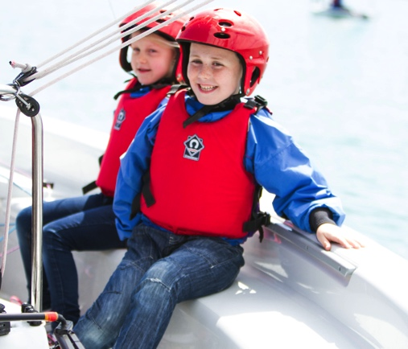
World-leading Gosport-based marine safety equipment manufacturer, Crewsaver, has announced that it is to be an official event sponsor of the Gosport Marine Festival 2017, which will take place on Saturday 27th May 2017.

The get-on-the-water activities at the Festival will be branded Crewsaver GoWaterSport sessions. These Crewsaver GoWaterSport sessions will include dinghy sailing, kayaking and rowing sessions in Haslar Marina for those over 12 years old, and windsurfing, paddleboarding and kayaking for 6 to 11 year olds at the Cockle Pond. There will be 800 places available for those who want to get on the water. Crewsaver will also be offering practical support to the festival’s Little Shipmates activities. The Little Shipmates zone will offer creative activities for children based around a ‘safety on and around the sea’ theme, so ideally matched to Crewsaver’s core #LifejacketSafe message.

Gosport Marine Festival aims to connect the people of Gosport with the sea, so as Gosport’s largest marine employer, it was natural for Crewsaver to get involved. The free community event will showcase boating of every kind from sailing dinghies and big yachts to paddleboarding and kayaking. There will be something for the whole family with the chance to get on the water as well as plenty of onshore activities.

Crewsaver Marketing Manager, Hannah Burywood commented, ‘We’re very excited to be involved with the 2017 Gosport Marine Festival. It’s a great opportunity to promote safety on and around the water, especially to a younger audience through Little Shipmates. To be able to help enable people to get on the water to try a range of boating activities with the Crewsaver GoWaterSport sessions is fantastic, and we’re delighted to be able to support our local community.’

Gosport Marine Festival Chairman, John Beavis MBE, said, ‘It’s great to have Crewsaver involved. The festival attracted 5,000 visitors in 2015 and we really value the support of Crewsaver in helping us make the festival a success again in 2017.’

Gosport Marine Festival will take place from 10am to 5pm on Saturday 27th May 2017. There will be more than 800 places available for those who want to get afloat. Further details and booking for all the activities can be found at www.gosportmarinefestival.org.uk

Crewsaver manufactures a complete range of personal lifesaving products including lifejackets and a new buoyancy aid range. Crewsaver offers personal flotation solutions for every level, whatever on-water activity is being undertaken; Crewsaver has a product to suit.

www.crewsaver.com

//ENDS//

For media information, hi-res images or product tests please contact:

Crewsaver
Hazel Proudlock, Marketing Dept
T +44 (0) 1329 820406
E hazel.proudlock@survitecgroup.com

Alison Willis – Marine Advertising Agency Ltd
T +44 (0) 23 9252 2044
E Alison@marineadagency.com

Notes to Editors

Crewsaver is a world-leading manufacturer of marine safety equipment and clothing for the commercial and leisure marine industries. Based in Gosport, Hampshire, the company designs and manufactures bespoke safety equipment for several countries’ Special Forces, and the aviation and oil industries. Crewsaver is the only company to hold an exclusive contract to supply lifejackets to the UK government’s Environment Agency and the Royal National Lifeboat Institution (RNLI). They are part of the Survitec Group.

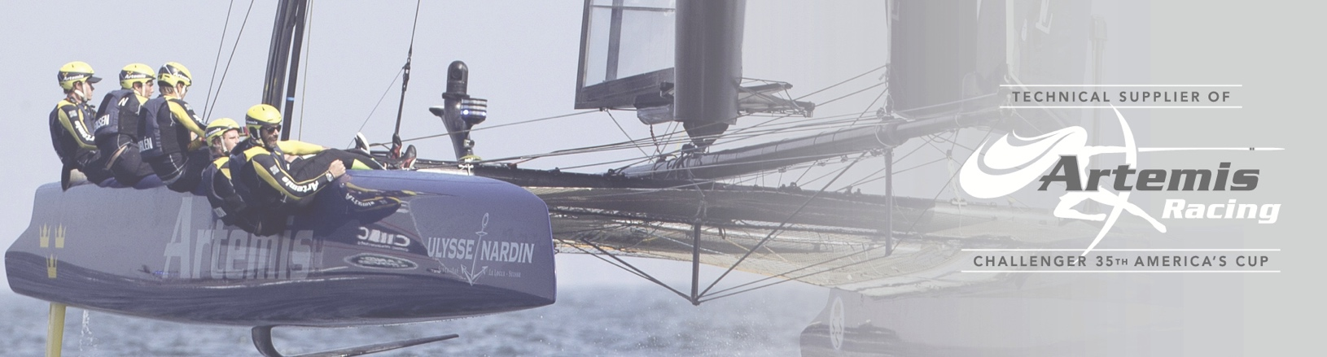
www.crewsaver.com

Survitec Group is a global leader in survival and safety solutions to the marine, defence, aviation and offshore markets. Survitec has over 3,000 employees worldwide covering 8 manufacturing facilities, 15 offshore support centres and over 70 owned service stations. It is further supported by a network of over 500 3rd party service stations and distributors. Across its 160-year history, Survitec Group has remained at the forefront of innovation, design and application engineering and is the trusted name when it comes to critical safety and survival solutions.
www.survitecgroup.com

