1 March 2017

PRESS RELEASE

DEAN & REDDYHOFF ACQUIRES HAMBLE MARINA AND BOATYARD
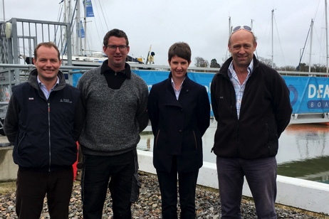
South coast marina operators, Dean & Reddyhoff Ltd, has today, 1st March 2017, completed the purchase of Deacons Boatyard Ltd, located in Hamble, Hampshire.
With 130 marina berths and a full-service boatyard for 150 boats ashore on the river Hamble, Deacons complements the existing Dean & Reddyhoff marina network, which has 1500 berths at Haslar, East Cowes, Portland and Weymouth marinas, plus a modern boat yard at Portland.
L-R: Michael Prideaux, Dean & Reddyhoff Managing Director, Nick Gill, Deacons Marina Boatyard Manager, Rachael Foster, Deacons Marina Manager and Lucas Shotts, Dean & Reddyhoff Director (previously Deacons Marina Managing Director)
The two companies have been working closely together for the last year, with Deacons offering boat yard services to Dean & Reddyhoff Solent-based berth holders.
Dean & Reddyhoff Managing Director, Michael Prideaux, comments “It is a great location on the Hamble River, and we respect their history and heritage. Deacons has developed a really good reputation for helping customers look after their boats, and will be a great fit with our existing marinas.”
Deacons Managing Director Lucas Shotts will become a Director at Dean & Reddyhoff, developing boat care services at Deacons and Portland boat yards. “Being part of the larger Dean & Reddyhoff group offers great opportunities for our customers, our staff and our on-site tenants” he said.
From April onwards, Deacons annual berth holders will receive the same boating benefits as all other Dean & Reddyhoff berth holders, including 21 free overnight visits to group marinas, discounts at on-site restaurants and free tickets for Southampton Boat Show.
ENDS
Notes
- Dean & Reddyhoff Ltd own and operate marinas at Haslar in Portsmouth Harbour, East Cowes on the Isle of Wight, and Portland and Weymouth in Dorset.
- With the addition of Deacons Marina, Dean & Reddyhoff now offers over 1600 berths and two full service boatyards across the five sites.
- Dean & Reddyhoff was started by John Dean and Richard Reddyhoff in the early 1990s, and both remain involved in the company.
- Deacons was established at Bursledon on the river Hamble in 1922, and has been in the same family ownership of the Fuller Group since the 1950s.
- Dean & Reddyhoff www.deanreddyhoff.co.uk
For more details, contact Rachel Hibberd, Group Marketing Manager Dean & Reddyhoff 07817 138322 rachelh@deanreddyhoff.co.uk

