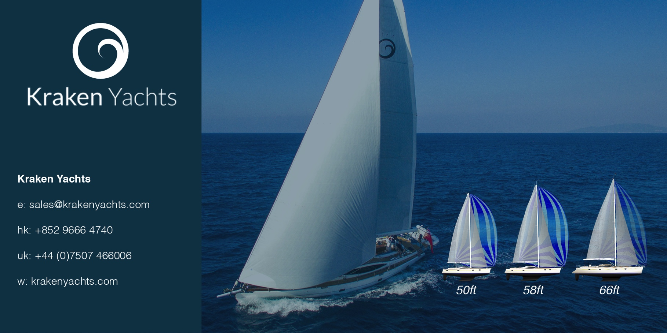

PRESS RELEASE. KRAKEN YACHTS. MARCH 2017
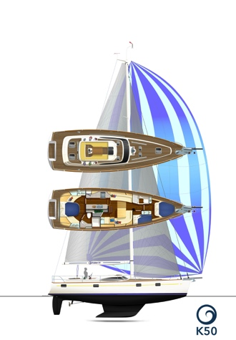
The new Kraken 50 is now in production

The Kraken 50 is our second model to go into production. The first order for this exciting new blue water cruiser has already been received and the 50 is due to be launched at the end of 2017.

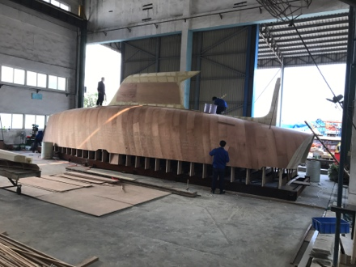
Kraken yachts, designed in New Zealand by Dibley Marine Yacht Design, are true blue water cruisers. An easily handled twin headsail rig gives outstanding upwind and downwind performance for a small crew in all weathers. The Kraken 50 also offers comfort, stability and safety at sea (thanks to Kraken’s integral Zero Keel™), while the semi-custom interior and finish are to a high standard. And as a bonus, all Krakens are exceptional value for money.
The Kraken 50

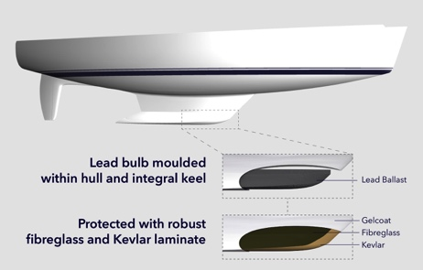
The plugs and mould tools are well under way at the yard of long established ISO9001 certified and multiple award-winning builders Xiamen Hansheng Yacht Building Co in China.
Kraken 50 hull, keel and skeg plug under construction

The keel and hull plugs (shown above right in their early stages) have now been built. The Kraken 50 incorporates Kraken’s Zero Keel™ - so called because zero bolts are needed to hold it in place. The lead ballast is inside the keel bulb and the hull, keel and rudder skeg are just one piece. As a result, this design has eliminated any possibility of the keel falling off the hull. It is simply impossible.
Zero Keel™ system

Kraken chairman Dick Beaumont says; “It has long been accepted that a blue water cruiser needs a long keel rather than a short one to gain good directional stability. All Kraken yachts are designed this way. But we do not believe that the keel should be bolted onto the hull. Because it can (and too often does) come off.”

This low CG bulbed Zero Keel™ is a unique feature. Older integral keel designs did not incorporate bulbs. The Zero Keel™ is even more valuable now that the world’s oceans are becoming littered with hazardous floating objects. It is estimated that 10,000 shipping containers fall in the sea every year, many of which remain afloat for a long time.

In the recent Vendée Globe around the world race, several IMOCA 60 yachts suffered serious damage - including rudder and keel loss - as a result of hitting UFOs (unidentified floating objects). The Kraken 50’s Zero Keel™ and robust skeg-supported rudder greatly reduce the risk of severe damage to the integrity of the hull and rudder if severe impact occurs...and the integral keel cannot fall off. (The image above shows how the Zero Keel™ is built).

Other News

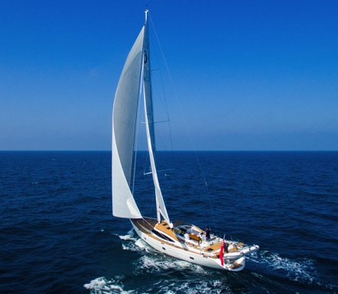
Meanwhile White Dragon – the first Kraken 66 – has cruised from Hong Kong to the Philippines and back (2000nm). Her owner is delighted with her.

What’s more Grant KcKinnon from Southern Spars – who manufactured her carbon fibre mast and boom – said “I might give up race boats if cruising yachts sail like this. 10 knots boat speed in 15 knots of wind is pretty impressive”. While Rod Taylor of On Board Systems Ltd (supplier of the Kraken 66’s hydraulic sail systems) said “She sails with the motion and stability of a yacht twice her size.” Both these men have sailed on numerous yachts, so their praise counts for a lot.
Kraken 66 under sail.... elegant, comfortable, fast, steady, safe and easy

ENDS

Notes to Editors

Kraken Yachts, Gold Coast Marina, 1 Castle Peak Rd., Castle Peak Bay, N.T., Hong Kong.... and shortly in the UK on the Hamble, Hampshire.
www.krakenyachts.com
sales@krakenyachts.com

Hong Kong: +852 26189335
Hong Kong cell phone: +852 9666 4740
UK cell phone: +44 7507 466006

High resolution images for editorial use can be found online at:http://marineadagency.com/gallery/new-kraken-50-now-production/

Chairman: Dick Beaumont. He has developed companies and has lifelong extensive business interests worldwide. He has covered over 100,000 miles cruising the world under sail.
Managing Director: Roger Goldsmith. He oversees business affairs and design coordination that are managed from the Hong Kong headquarters
Sales Director: Mark Williams; previously sales manager at Discovery Yachts.

Price from US $695,000 Ex VAT Ex Hong Kong. Delivery, launch, rig and commissioning are also available at Hamble, UK.

KRAKEN 50
Length Overall | 15.24 m | 50 ft
Waterline Length | 13.74 m | 45 ft
Beam Overall | 4.50 m | 14.76 ft
Draft | 2.30 m | 7.5 ft
Displacement | 16,850 kg (lightship) | 37,148 lbs
Ballast Weight | 6,327 kg | 13,948 lbs
Sail Area (Main & Foretriangle) | 133.59 sq.m | 1,438 sq.ft
Engine Power | 80 HP | 60 KW
Fuel Tank | 860 litres | 227US Gallons
Fresh Water Tanks | 700 litres | 185US Gallons
CE Certification | RCD Category ‘A’ Ocean

