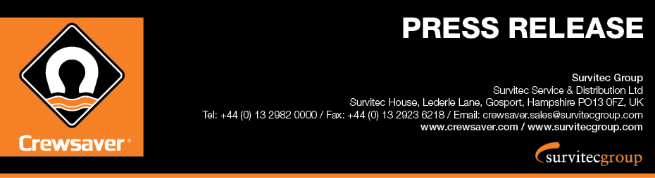
For Immediate Release: 21st April 2017
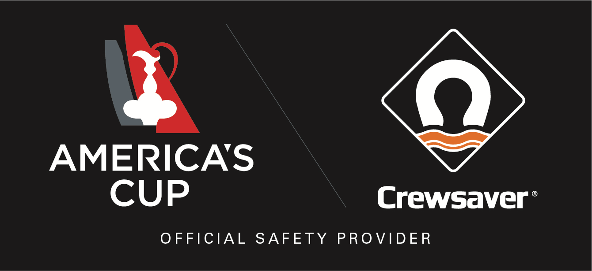

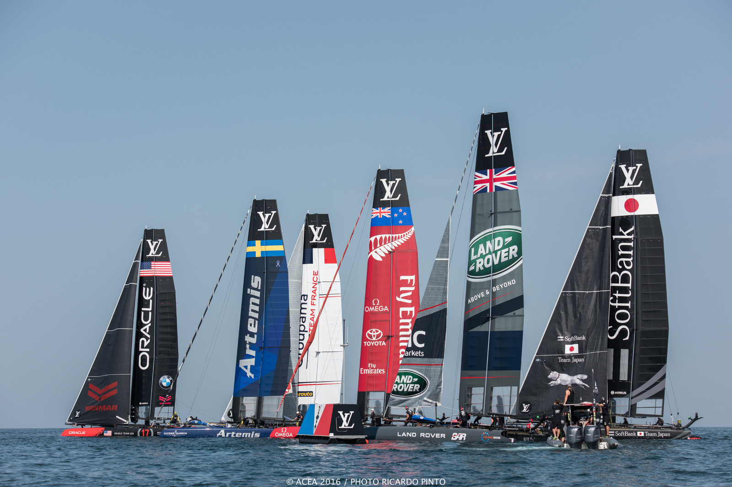
Crewsaver appointed as Official Safety Provider to the 35th America’s Cup
Crewsaver has announced today, 21st April 2017, that it has been selected to be the Official Safety Provider to the 35th America’s Cup, which will take place in Bermuda from 26th May to 27th June 2017.
With just over a month until the start of the 35th America’s Cup, one of the most hotly anticipated sports events worldwide, there is mounting tension and excitement as the teams prepare to take each other on in Bermuda.
Crewsaver, a Survitec company, and one of the world’s leading safety equipment manufacturers, is excited to announce its exclusive safety equipment partnership with the 35th America’s Cup. Crewsaver will be providing the America’s Cup with all of the safety equipment needed for their chase boats including lifejackets, helmets, first aid kits, knifes, pyrotechnics and man-overboard rescue equipment, along with a number of marker buoys to help with shepherding boats to the race course.
Dan Barnett, Chief Commercial Officer of the 35th America’s Cup said: “we are very pleased to welcome Crewsaver into the America’s Cup family and are all excited about working with their world class products. Safety is obviously a core focus area for the America’s Cup, so having a company of the calibre of Crewsaver as our Official Safety Provider is the perfect fit for us in this incredibly important area.”

‘We are delighted to have been selected as official safety provider to the America’s Cup, it is very clear that our two organisations share many of the same values as far as safety on the water is concerned, making this the ideal partnership opportunity. We look forward to working together to help share these messages to a wider audience through our #LifejacketSafe campaign,’ commented Brian Stringer, Survitec Group Chief Executive Officer.

With help from Crewsaver, the America’s Cup will very shortly be launching a number of safety videos, providing viewers with a number of top tips to help them stay safe when out on the water.

In addition, the partnership will provide America’s Cup viewers with the opportunity to win a limited edition, and not on general sale (or not available to the public), America’s Cup branded Crewfit 180N Pro lifejacket through a competition being run by Crewsaver, details of which will be announced soon.

//ENDS//

For media information, hi-res images or product tests please contact:

Crewsaver
Hazel Proudlock, Marketing Dept
T +44 (0) 1329 820406
E hazel.proudlock@survitecgroup.com

Alison Willis – Marine Advertising Agency Ltd
T +44 (0) 23 9252 2044
E Alison@marineadagency.com

Notes to Editors

Crewsaver is a world-leading manufacturer of marine safety equipment and clothing for the commercial and leisure marine industries. Based in Gosport, Hampshire, the company designs and manufactures bespoke safety equipment for several countries’ Special Forces, and the aviation and oil industries. Crewsaver is the only company to hold an exclusive contract to supply lifejackets to the UK government’s Environment Agency and the Royal National Lifeboat Institution (RNLI). They are part of the Survitec Group.

www.crewsaver.com

Survitec Group is a global leader in survival and safety solutions to the marine, defence, aviation and offshore markets. Survitec has over 3,000 employees worldwide covering 8 manufacturing facilities, 15 offshore support centres and over 70 owned service stations. It is further supported by a network of over 500 3rd party service stations and distributors. Across its 160-year history, Survitec Group has remained at the forefront of innovation, design and application engineering and is the trusted name when it comes to critical safety and survival solutions.
www.survitecgroup.com

