NEWS RELEASE
Issued: Wednesday, 10th May 2017

Crewsaver renews its partnership with the
Andrew Simpson Foundation

Crewsaver has today announced the renewal of its partnership with the Andrew Simpson Foundation (ASF).

Extended for an additional three years, the partnership sees Crewsaver supply not only the equipment required for the Andrew Simpson Sailing Centre (ASSC) in Weymouth, UK, and prizes for Bart's Bash but in addition, through a new extended agreement, the supply of equipment to a variety of sailing projects that are also supported by the Foundation.

In addition to all of the safety equipment and on-the-water clothing donated to the ASSC, Crewsaver will also be supplying 'Club Safety Packs' to the organisations supported by the Foundation. These packs will consist of a number of items such as buoyancy aids, helmets and on-the-water clothing.

Some of the first to benefit from this new agreement include Tideway Sailability, Hong Kong Sailabilty and Prestwick Sailing Club.

Richard Percy, CEO of the Foundation, commented:
"It is absolutely fantastic news that Crewsaver is continuing its support for the Foundation for another three years. The safety equipment that Crewsaver provides to the Andrew Simpson Sailing Centre at the National Sailing Academy is invaluable and ensures all our young people are wearing world-class safety equipment.

"Owing to Crewsaver's ongoing support, the Foundation is also delighted to announce that we will be funding and supplying 'Club Safety Packs' to some of the amazing sailing projects that work with disadvantaged young people both within the UK and abroad. As part of this, the Foundation will be supplying Crewsaver buoyancy aids, helmets and waterproofs to Sailability Centres that provide access to sailing for the disabled."

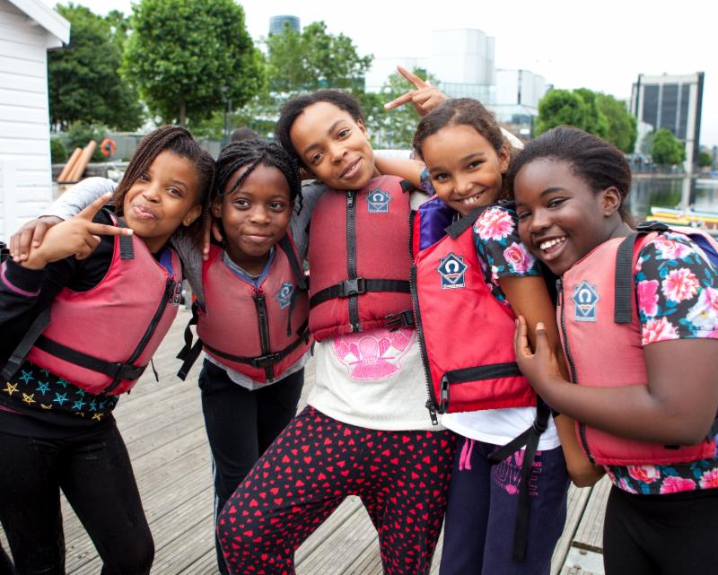
Hannah Burywood, Marketing Manager for Survitec Group and Crewsaver is also delighted, saying:
"It has been a great pleasure to support the Foundation over the last three years and we are delighted to be able to renew for another three years. Over the last three years, we have watched the Foundation support some fantastic projects, that we wanted to ensure could benefit from the same safety equipment as the Foundation itself."

ENDS

ASF Media Enquiries/Images/Interviews:
Peta Stuart-Hunt | PR Works
Communications & Media Manager
Andrew Simpson Foundation
M: +44 (0) 7711 477707
peta@prworksuk.com

For Crewsaver media information, hi-res images or product tests please contact:

Crewsaver
Hazel Proudlock, Marketing Dept
T +44 (0) 1329 820406
E hazel.proudlock@survitecgroup.com

Alison Willis - Marine Advertising Agency Ltd
T +44 (0) 23 9252 2044
E Alison@marineadagency.com

Notes to Editors

Andrew Simpson Foundation www.andrewsimpsonfoundation.org
The registered charity 'Andrew Simpson Sailing Foundation' now also referred to as the 'Andrew Simpson Foundation : The Sailing Charity', was set up in memory of, and inspired by the Olympic sailing Gold medallist, Andrew 'Bart' Simpson. The Founding Trustees are Sir Ben Ainslie, Iain Percy OBE and Andrew's wife Leah. A yearly grant-giving process from the charity offers a wide range of support, both financial and/or practical to not-for-profit sailing initiatives and related organisations around the world.
#sailonbart

Bart's Bash www.bartsbash.com
17-18 September 2017
Bart's Bash, launched in 2014, is the world's largest sailing event that is run by sailing clubs, community sailing programmes, sail training centres, yacht clubs, scout groups, sea cadets and even groups of sailors, all around the world. The main aims of the event are to increase international awareness of participation in sailing, and to raise funds for the Andrew Simpson Foundation to help support a range of sustainable projects, using sailing and watersports to improve the lives of children and young people globally.
#bartsbash

Crewsaver www.crewsaver.com
Crewsaver is a world-leading manufacturer of marine safety equipment and clothing for the commercial and leisure marine industries. Based in Gosport, Hampshire, the company designs and manufactures bespoke safety equipment for several countries' Special Forces, and the aviation and oil industries. Crewsaver is the only company to hold an exclusive contract to supply lifejackets to the UK government's Environment Agency and the Royal National Lifeboat Institution (RNLI). They are part of the Survitec Group.

Survitec Group www.survitecgroup.com
Survitec Group is a global leader in survival and safety solutions to the marine, defence, aviation and offshore markets. Survitec has over 3,000 employees worldwide covering 8 manufacturing facilities, 15 offshore support centres and over 70 owned service stations. It is further supported by a network of over 500 3rd party service stations and distributors. Across its 160-year history, Survitec Group has remained at the forefront of innovation, design and application engineering and is the trusted name when it comes to critical safety and survival solutions.

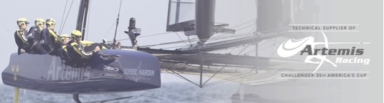
Andrew Simpson Sailing Foundation is a company limited by guarantee
and registered charity in England & Wales No 1153060

