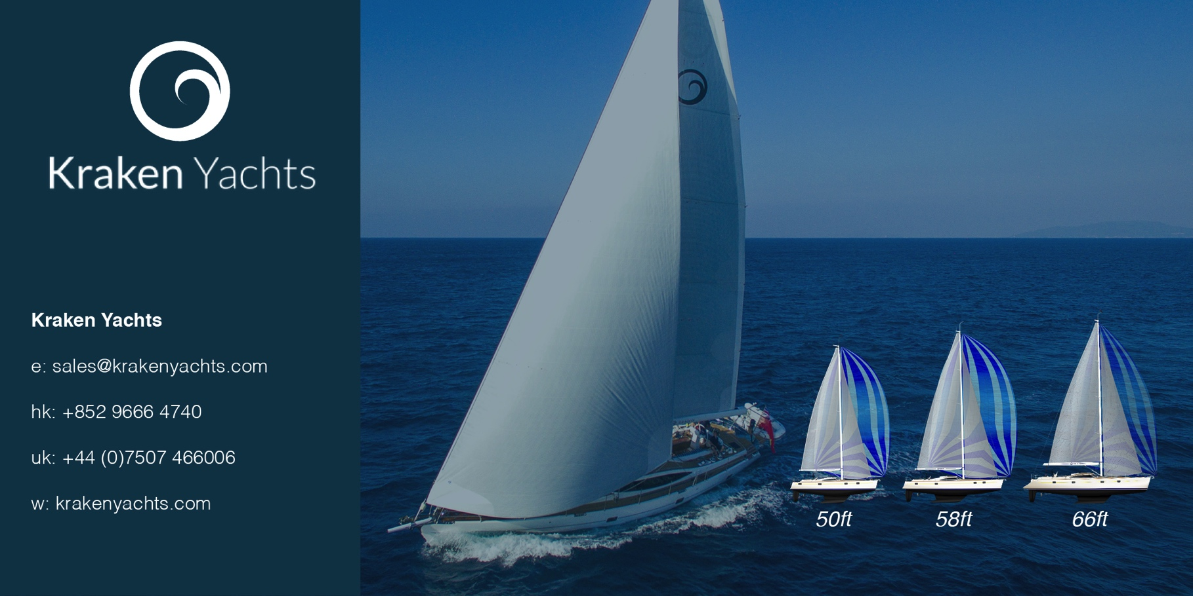
For immediate release
11th May 2017

PRESS RELEASE. KRAKEN YACHTS.

Kraken Yachts Ltd exhibits at the 2017 London On-Water show

The new range of Kraken Yachts, designed by recent award winner Kevin Dibley of leading New Zealand company Dibley Marine, has already made its mark in the blue water cruising yacht market.

Sales Director Mark Williams is using the London On-Water show (June 8th to 11th at St Katharine Docks, London E1) to introduce the Kraken 50, Kraken 58 and Kraken 66 models to potential UK buyers and to international visitors who fly in to visit the show.

The first Kraken 50 has already been ordered and Kraken chairman Dick Beaumont’s Kraken 66 is afloat and sailing.

The Kraken range built by long-established and multiple award-winning Hansheng Yachts – majors on blue water cruising. These semi-custom yachts are competitively priced and “built for purpose” - and this purpose is to cruise in great comfort and above all in safety.

Kraken’s unique Zero Keel™, for example, is so called because the lead ballast inside a streamlined keel bulb forms an integral part of the yacht. So there are zero bolts; meaning the keel cannot fall off. And – unlike many modern production yachts – Krakens have a robust and full depth integral skeg to protect the rudder from UFOs (unidentified floating objects that now litter the oceans).

Kraken chairman Dick Beaumont - who is currently cruising his Kraken 66 in the South China Sea – says “Our new Zero Keel™ design answers the prayers of every blue water sailor. If you've ever got a cold shiver down your spine wondering what would happen if your keel fell off hundreds of miles from the coast, you can rest in your bunk secure in the knowledge that with a Kraken Yacht that can never happen.”

Find out more at http://www.krakenyachts.com/

ENDS

Notes to Editors

Kraken Yachts, Gold Coast Marina, 1 Castle Peak Rd., Castle Peak Bay, N.T., Hong Kong.... and in the UK on the Hamble, Hampshire.
www.krakenyachts.com
sales@krakenyachts.com

Hong Kong: +852 26189335
Hong Kong cell phone: +852 9666 4740
UK cell phone: +44 7507 466006

High resolution images of the Kraken 50 for editorial use can be found online at: http://marineadagency.com/gallery/new-kraken-50-now-production/

Chairman: Dick Beaumont. He has developed companies and has lifelong extensive business interests worldwide. He has covered over 100,000 miles cruising the world under sail.
Managing Director: Roger Goldsmith. He oversees business affairs and design coordination that are managed from the Hong Kong headquarters
Sales Director: Mark Williams; previously sales manager at Discovery Yachts.

