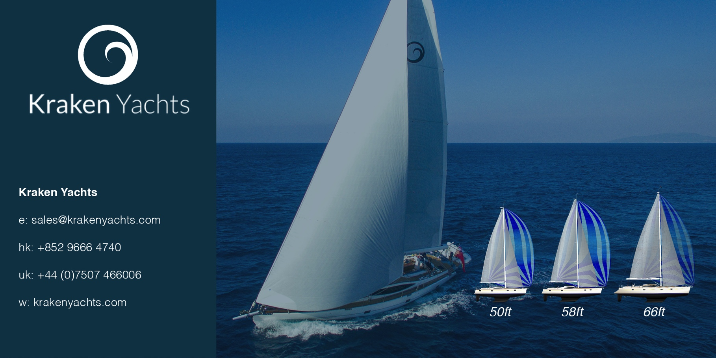
For immediate release
24th May 2017

PRESS RELEASE. KRAKEN YACHTS.

International boat company, Kraken Yachts Ltd., expands its operation to the UK.
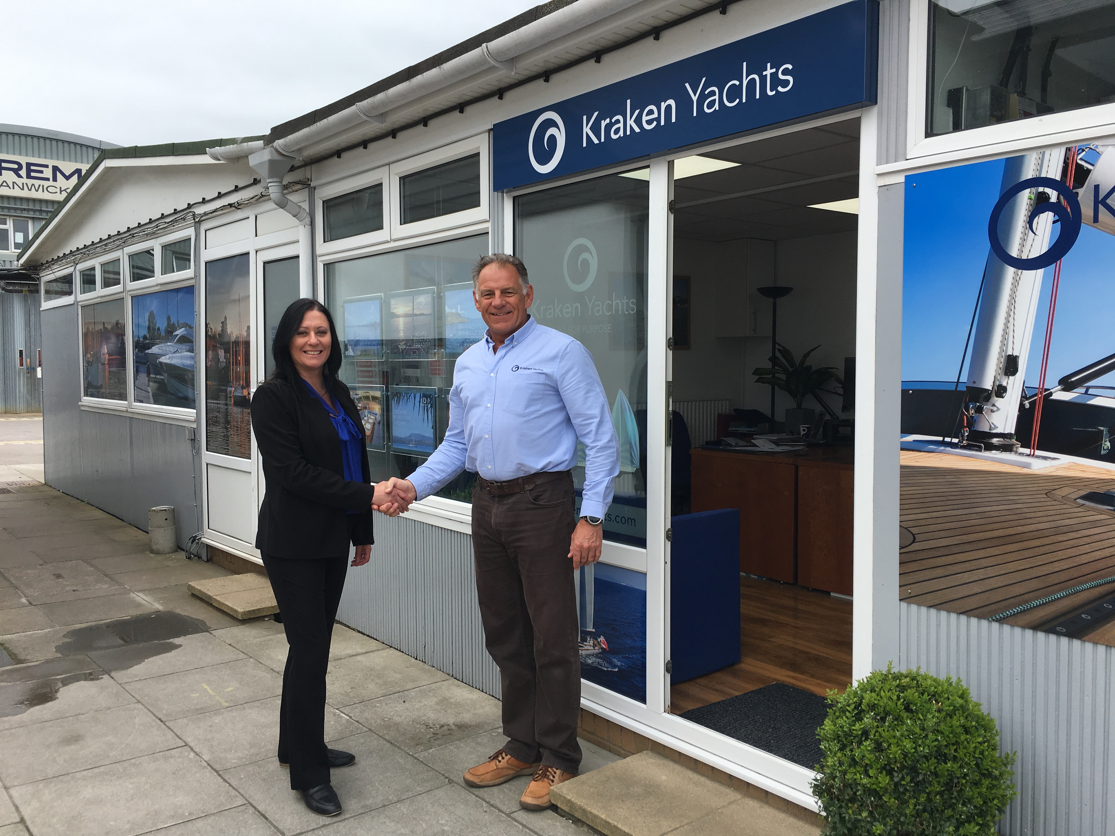
Kraken Yachts Ltd. has opened up a new sales head office near Southampton (UK) in Swanwick Marina on the river Hamble – adding to its existing central operations and design office in Hong Kong. The new sales office, set up by Kraken Sales Director Mark Williams, will be the central hub for worldwide sales of Kraken Yachts; dedicated to the sales and marketing of luxury blue water cruising yachts. The company also has progressive plans to open offices in the USA and Australia over the next 12 months.
Mark Williams, Kraken Sales Director, is officially welcomed to Swanick Marina, Southampton (UK), the location of Kraken’s new office, by Nicola Walsh, Swanick Marina Manager
Kraken Yachts strives to develop and build the best yachts for their defined blue water cruising market; and is committed to building high quality sailing yachts designed for the cruising sailor who appreciates safety and comfort along with excellent sailing performance. With a yacht model range of 50, 58 and 66 feet, Kraken Yachts has positioned itself in a unique place in the market, with prices similar to the mass-produced manufacturers; but with the quality associated with mainstream blue water sailing brands. International Sales Director, Mark Williams, said: “Swanwick Marina, belonging to the Premier Marina group, was a natural choice for reasons of accessibility for customers travelling from around the globe, great network capabilities and a premier location”.

Find out more at http://www.krakenyachts.com/

ENDS

Notes to Editors

Kraken Yachts, Gold Coast Marina, 1 Castle Peak Rd., Castle Peak Bay, N.T., Hong Kong.... and in the UK on the Hamble, Hampshire.
www.krakenyachts.com
sales@krakenyachts.com

Hong Kong: +852 26189335
Hong Kong cell phone: +852 9666 4740
UK cell phone: +44 7507 466006

High resolution images of the Kraken 50, which is currently in build, can be found online at: http://marineadagency.com/gallery/new-kraken-50-now-production/

Chairman: Dick Beaumont. He has developed companies and has lifelong extensive business interests worldwide. He has covered over 100,000 miles cruising the world under sail.
Managing Director: Roger Goldsmith. He oversees business affairs and design coordination that are managed from the Hong Kong headquarters
Sales Director: Mark Williams; previously sales manager at Discovery Yachts.

