News Release
For immediate release
12th May 2017

America’s Cup top of the agenda at MAA Press Lunch
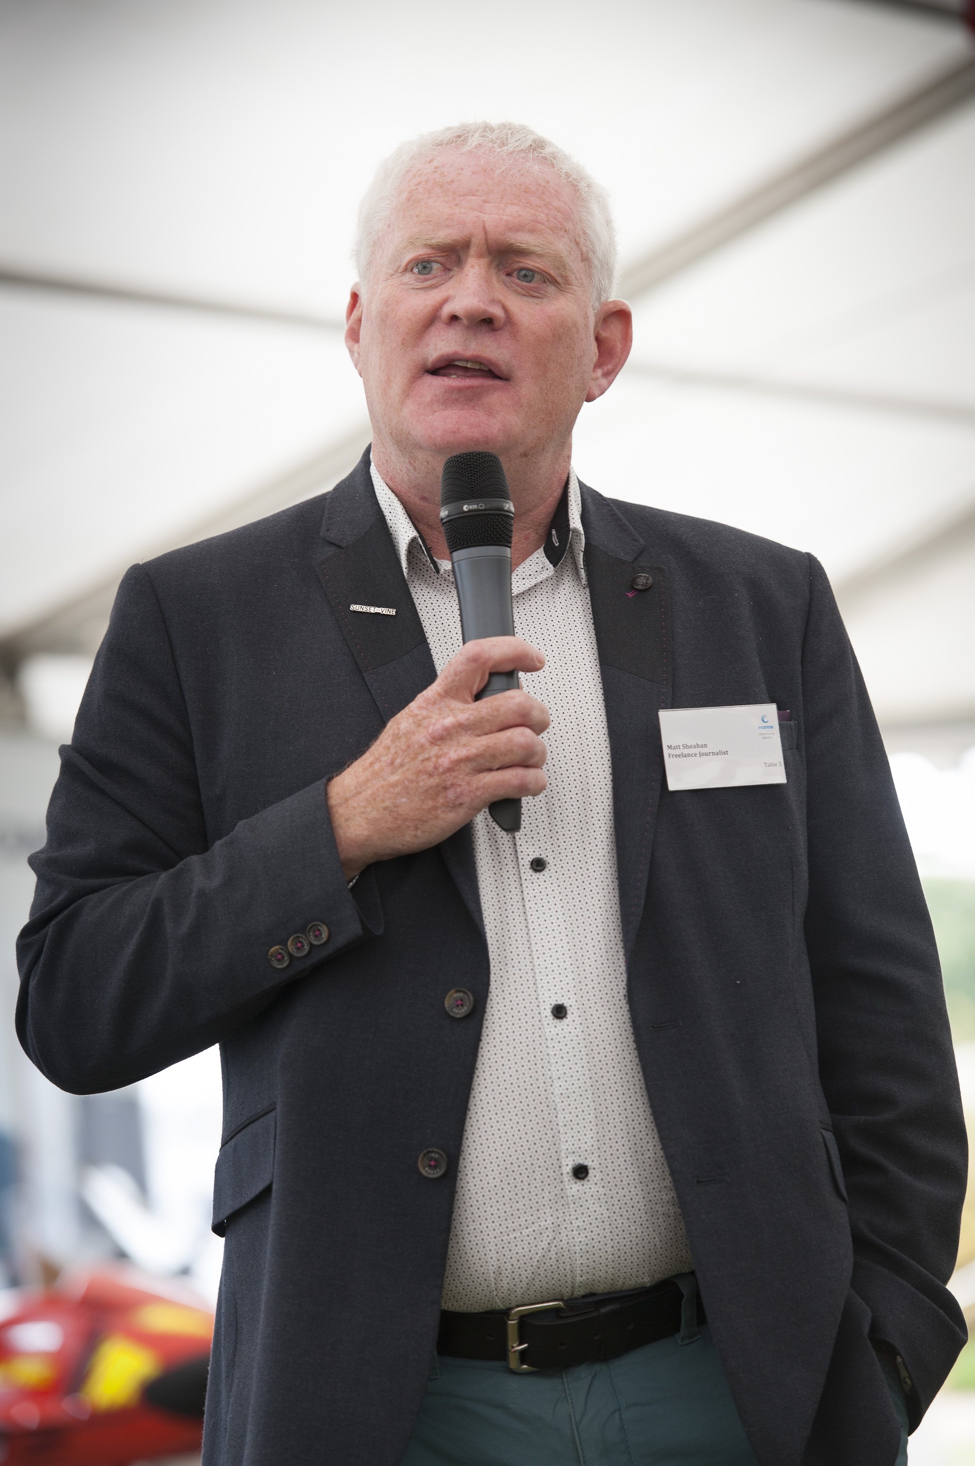
Matt Sheahan spoke to over 130 press and industry guests at the sixth annual MAA Press Lunch, which took place today, Friday 12th May 2017. Matt shared his thoughts on the 2017 America’s Cup, which takes place in Bermuda in two weeks time. The event, which is held at Haslar Marina, is organised by the Marine Advertising Agency (MAA) with sponsorship from Dean & Reddyhoff.

This year’s event kicked off with tours of Ocean Youth Trust’s new sail training vessel, Prolific, which has undergone an extensive refit and modifications to meet the Trust’s unique requirements.
Matt Sheahan speaks at the 2017 MAA Press Lunch
With the America’s Cup in Bermuda just two weeks away, Matt Sheahan, Head of Performance Sailing at Sunset & Vine, who produce the TV coverage of the America’s Cup for BT Sport, spoke at the lunch to give his perspective on the challenges facing the teams. Mark Todd, Chief Executive of Ocean Youth Trust South, also spoke at the lunch. He talked about the OYT’s work with disadvantaged young people and the chance that sailing gives to improve outcomes for these young people.

Companies can choose to showcase products and services to guests at the event. MAA client Navico was present with its B&G, Simrad and Lowrance brands. Kraken Yachts used the lunch as an opportunity to introduce the UK marine media to its range of blue water cruising yachts, the Kraken 50, Kraken 58 and Kraken 66. Crewsaver, Ancasta, the Andrew Simpson Foundation and Landau were amongst the other exhibitors. Guests were also able to see Mara Buoy’s unique mooring buoy. Mara Buoys are currently in use by the Royal Navy Sailing Association in Portsmouth Harbour and the company has gained large orders from across the country and the USA.
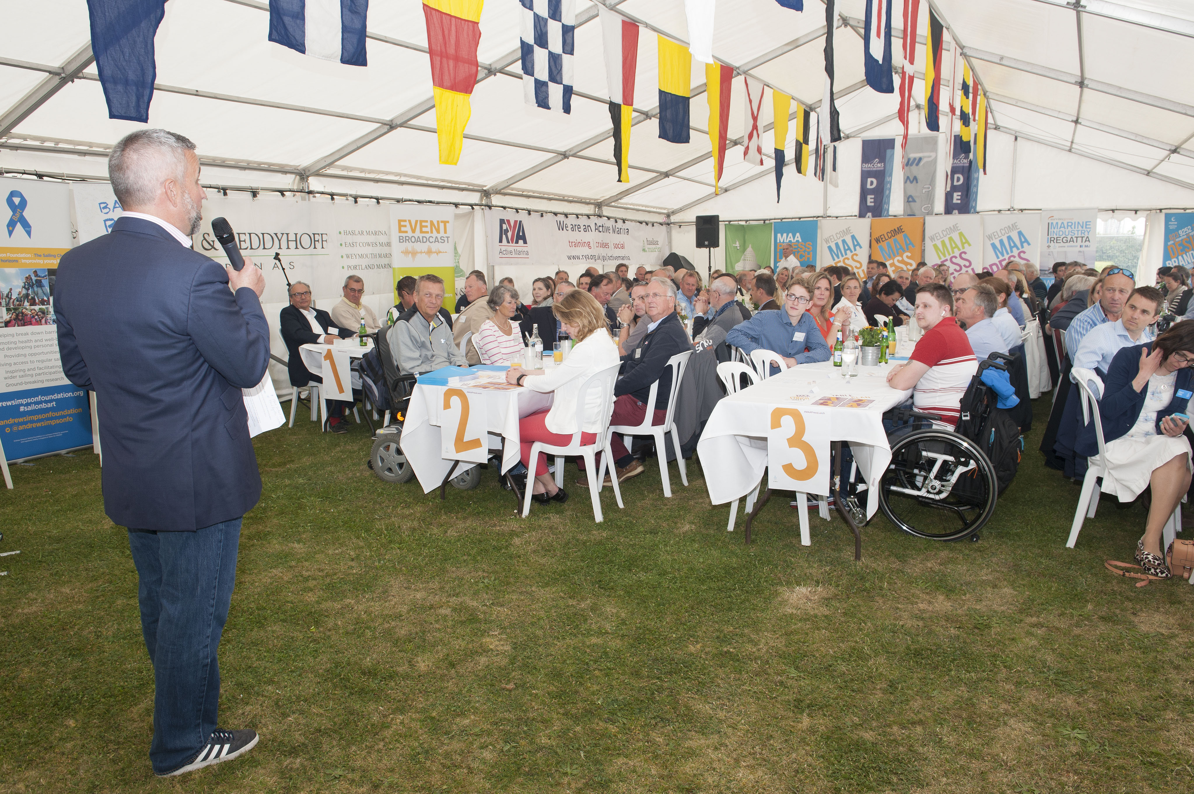
The MAA Press Lunch is now well established on the industry calendar. The event has grown considerably, attracting top journalists, editors and leading industry names from across different marine sectors.

MAA was set up by Mike Shepherd in 2009, since then the company has experienced consistently strong growth. MAA was awarded Best Marine Company to Work For at the 2016 British Marine awards and is now firmly established as one of the foremost agencies in the marine industry.
Mike Shepherd welcoming guests to the 2017 MAA Press Lunch
Continued//

Mike Shepherd, Director of MAA, said: “Today has been about getting journalists and our industry together, not only to talk about new products and generate news stories, but also to talk about issues that matter to our industry. We’re delighted that we’re able to facilitate that and that our sixth annual MAA Press Lunch has brought so many of the industry’s key figures together.”

Michael Prideaux, Managing Director of Dean & Reddyhoff Marinas, said: “It’s a pleasure to host the marine industry at Haslar Marina for the MAA Press Lunch again this year. The event builds on relationships and facilitates connections, which can only be positive for our industry, and being able to showcase what Haslar has to offer is a nice bonus!”

MAA can help companies with everything from media planning and buying, PR, and social media to brand development, eCommerce and website design and development.

For more information visit www.marineadagency.com

ENDS

Media enquiries:

Alison Willis, Alison@marineadagency.com
Emma Stanbury, emma@marineadagency.com

T: 023 9252 2044

Notes to editors

The Marine Advertising Agency Ltd provides simple, no-nonsense solutions to marine companies` advertising, PR, media buying and communications needs. From brand development and marketing materials to website, eCommerce, email campaigns and social media, MAA offers a straightforward, knowledgeable and service-orientated approach. MAA is able to offer unrivalled value to help clients reach their target markets.

For more information visit www.marineadagency.com

Haslar Marina is surrounded by bars, restaurants, shops and tourist attractions, and is home to a wide range of marine-related businesses. Road and rail access is very good, with excellent transport links to London via Portsmouth Harbour station and the Gosport Ferry. Haslar Marina provides a great base for all types of vessel with 650 berths, with no tidal restrictions, offering great access to the Solent and the surrounding cruising areas.

For more information visit: www.haslarmarina.co.uk

