News Release
For immediate release
10th June 2017

Second Gosport Charity Pursuit another great success!

The second edition of the Gosport Charity Pursuit officially started off at Gilkicker Point in the eastern Solent on Saturday the 10th of June. The sunny weather was perfect.

23 yachts had registered but only 16 were able to cross the start line and head off on a fetch towards the Nab Tower. The historic High Speed Launch 102 was at the start line with a number of dignitaries on board to watch the action. The little brig CAROLINE ALLEN marked the start line and fired her cannon to mark the opening of each starting window.

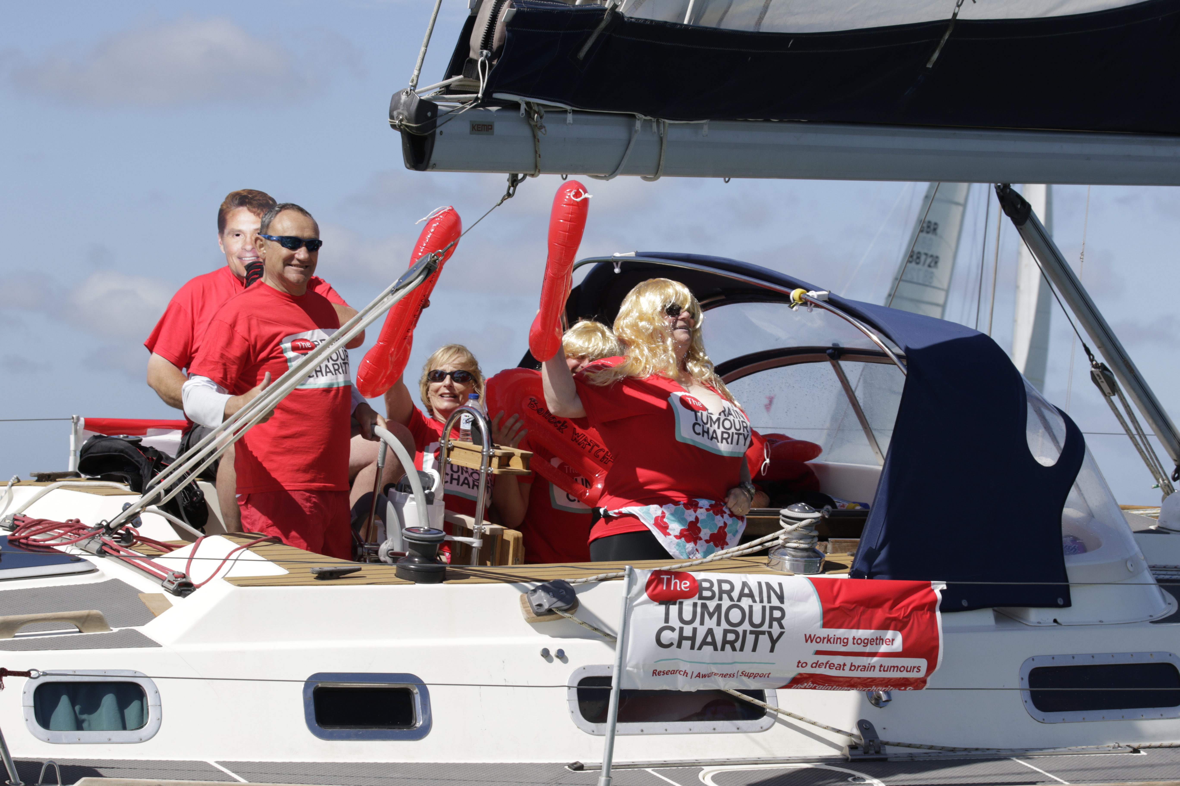
The event, modelled on the Eddystone Charity Pursuit in Plymouth, is mainly about fundraising for good causes rather than winning the trophy, The Gosport Challenge
Cup. However, there was no shortage of friendly banter during the skippers’ briefing at Hornet Services Sailing Club on Friday afternoon and on the water during the Pursuit itself. The weather conditions were perfect and allowed the fleet to make the most of the 22 mile course, sailing around the Nab Tower and back to Gilkicker via Browndown. The Pursuit is organised by Gosport Marine Scene CIC as part of the Gosport Marine Festival events series.

Pursuit Director Peter Newell explained “this is not a race, it’s a timed run over the course, with the slower yachts starting first and the fleet divided into five 10-minute starting windows.” He added “It’s more about raising money for charity and having a good time than winning, though I know many of the crews will be keen to put a fast time in.”

The support of local businesses and residents, as well as the excellent sailing conditions, made the second Gosport Charity Pursuit a tremendous success, raising a lot of money that will benefit local charities. Following the race, a Prize Giving and BBQ took place.

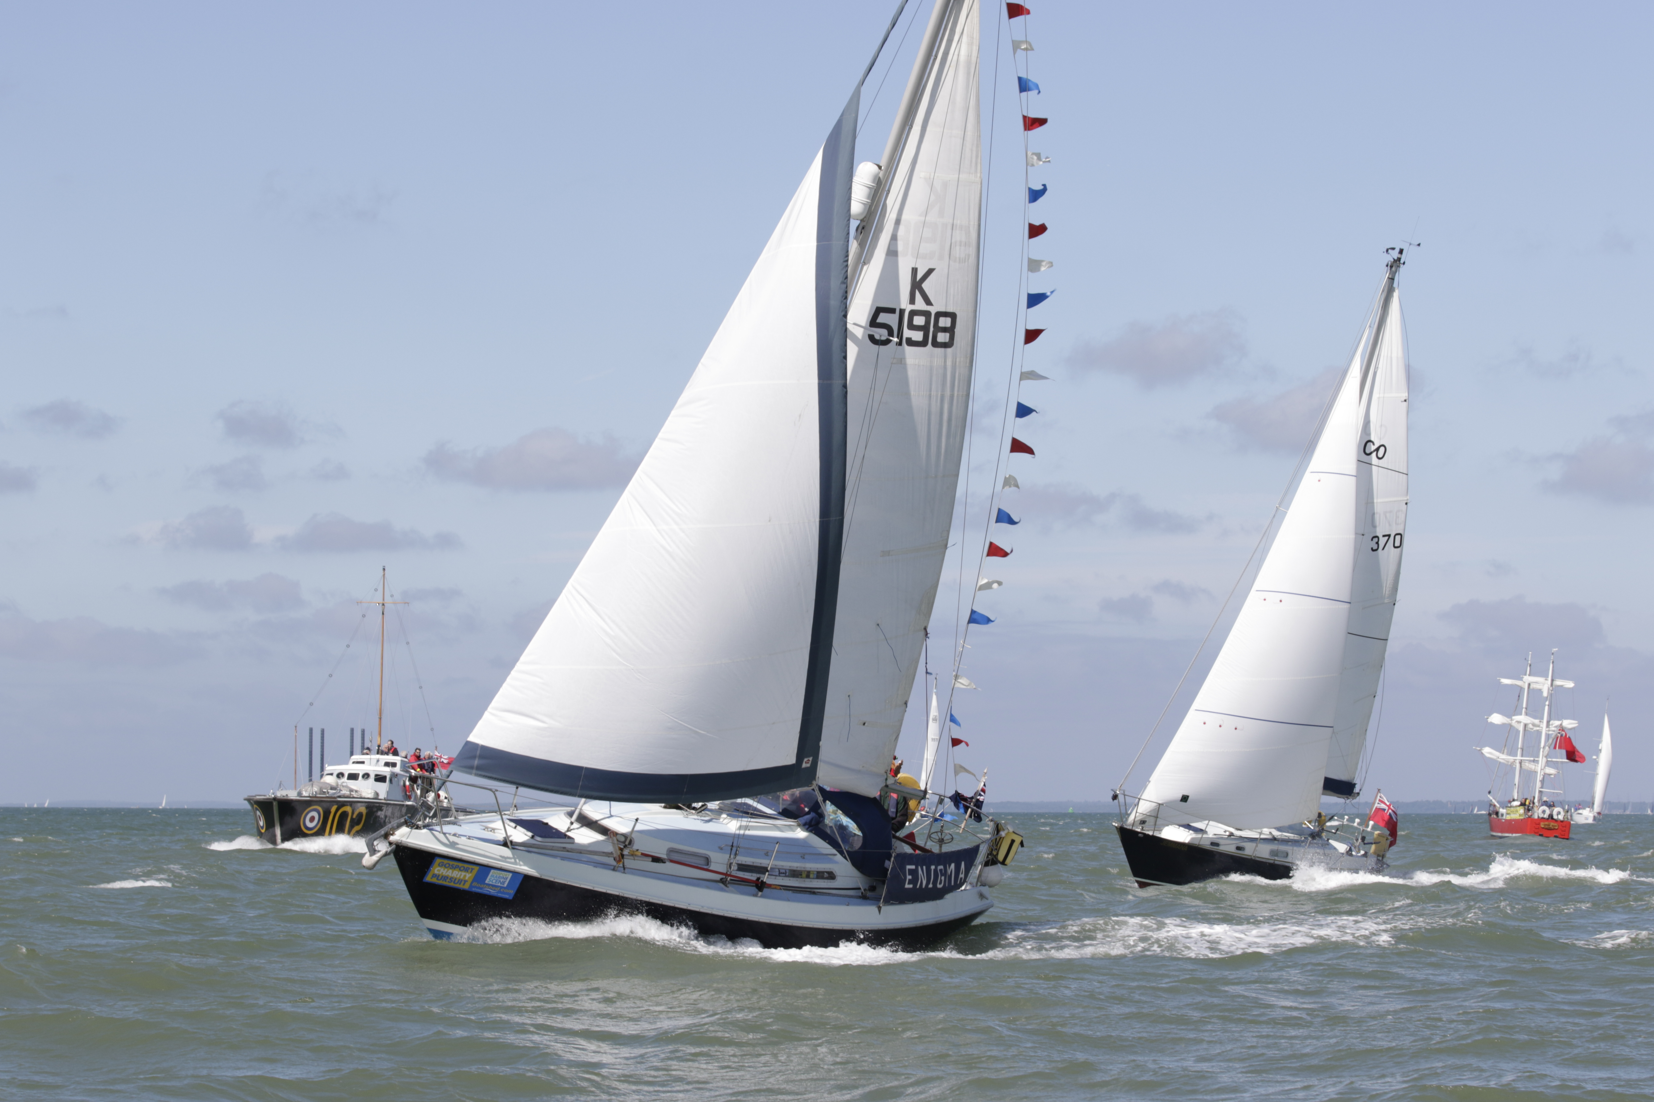

ENDS

Notes for Editors
About Gosport Marine Scene and Gosport:
Organiser of Gosport's: Marine Business Network, Gosport Marine Festival June 2015, Gosport Marine Festival 2017, Talent & Career Programme
Gosport Peninsula is a centre of excellence in ocean racing, sail training, marine tourism and trade.
Gosport is the home of: Alex Thomson Racing & Hugo Boss, Clipper Round the World Race, Global Ocean Race, Sail Training International, ASTO, Ocean Youth Trust South, Lee-on-Solent RYA Onboard, Toe in the Water . . . just for starters

