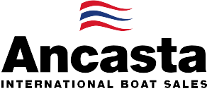

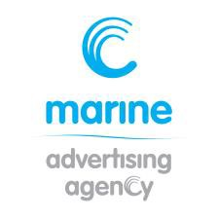
N e w s R e l e a s e
28th June 2017

Ancasta scoops the Best Global Sailboat Dealer Award 2017 at
Beneteau dealer meeting
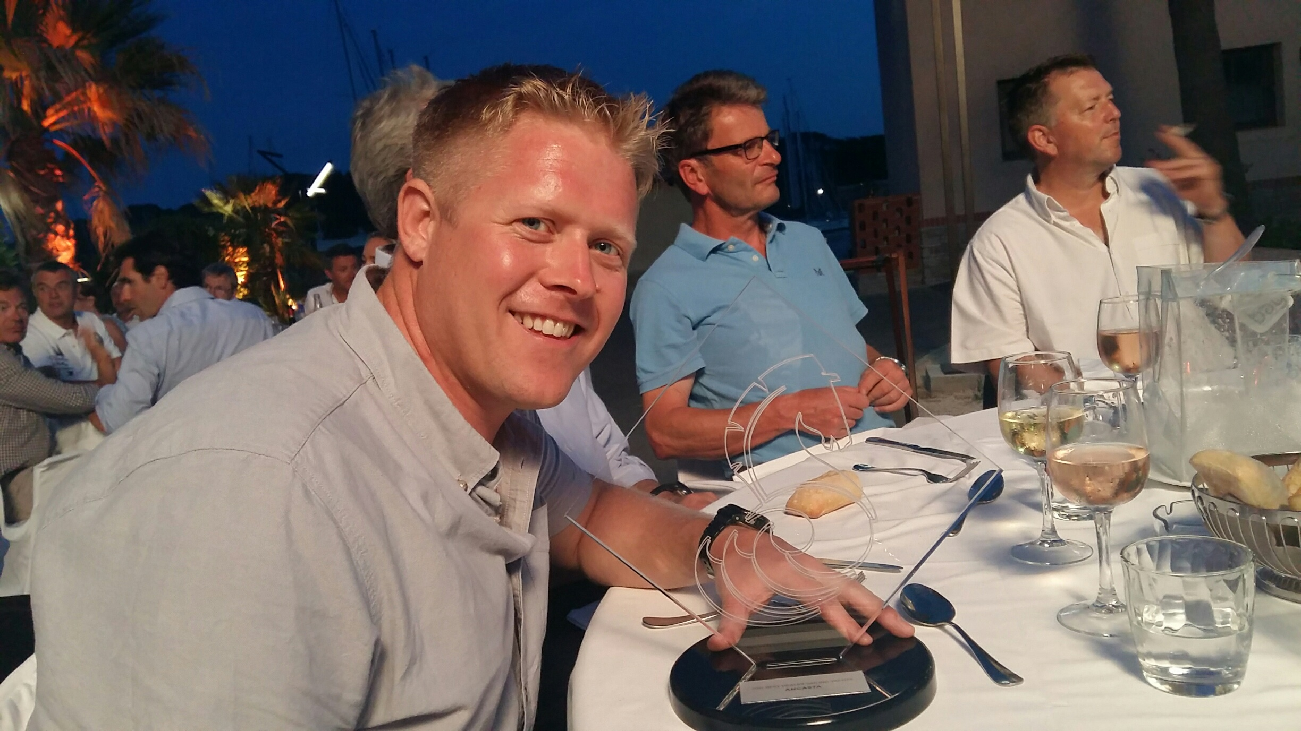
Ancasta was awarded 2017 Best Dealer Sailing Yachts at the annual Beneteau Dealer Awards last night, 27th June 2017, which were held in Bordeaux, France.

Stuart Brotherton, Ancasta Brand Manager for Beneteau Sailboats collected the award for Ancasta, “We are thrilled to be recognised by Beneteau. This is testament to the hard work of our new boat sales network and our commitment to our customers and to the Beneteau brand.”
Stuart Brotherton collected Ancasta’s award

Ancasta’s relationship with Beneteau benefits its clients through an unrivalled understanding of Beneteau’s products, technical detail and aftersales support allowing its brokers to match clients to their ideal Beneteau sailing yacht.

For more information on Ancasta visit http://www.ancasta.com

ENDS

Notes to editors

Ancasta Group
  - Ancasta International Boat Sales has 13 offices across Europe
  - Ancasta is the UK’s largest Prestige Luxury Motor Yachts dealer, the UK’s largest Beneteau Power and the UK’s largest Beneteau Sail dealer
  - Ancasta is exclusive UK dealer for Lagoon Catamarans
  - In addition Ancasta is a new boat dealer for CNB Yacht Builders and McConaghy Yachts
  - The Ancasta Group incorporates Hamble Yacht Services Refit & Repair and Advanced Rigging and Hydraulics, both operating from Port Hamble.
  - For more information on Ancasta visit www.ancasta.com
Media enquiries via Marine Advertising Agency:
Alison Willis - alison@marineadagency.com
Tel: 023 9252 2044

