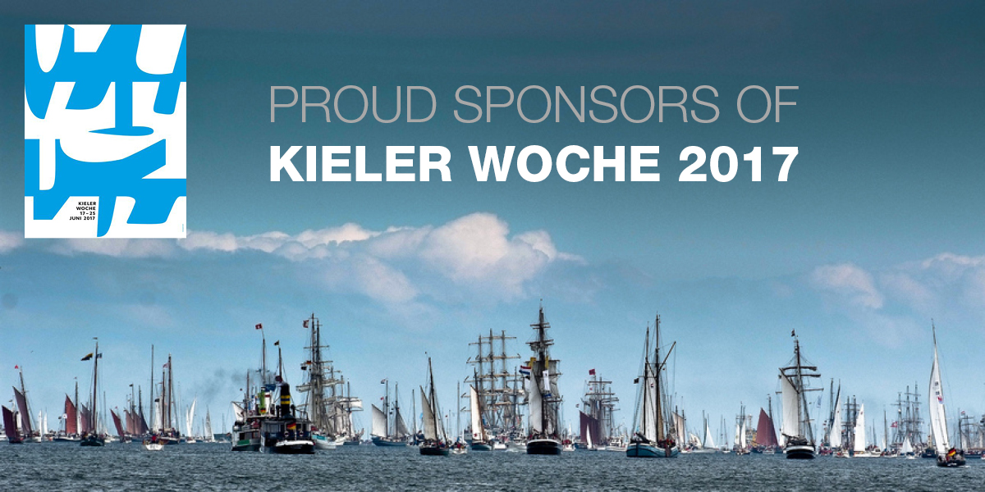
For immediate release
12th June 17

Leading Survitec brands Crewsaver & DSB to sponsor Kieler Woche 2017
Survitec is delighted to announce that two of its leading brands, Crewsaver & DSB will be sponsoring Kieler Woche which takes place 17th – 25th June 2017.
DSB, who are known for the design and manufacture of rescue boats and are located in Germany have had a long standing partnership with Kieler Woche for more than a decade. The new, combined and extended partnership sees Survitec supply integral safety support using the DSB range of inflatable boats, Crewsaver Crewfit 180N Pro lifejackets for rescue and jury crews and Crewsaver inflatable marker buoys for the race course.
In addition, throughout the event competitors and spectators will have the opportunity to purchase a number of items from DSB and the Crewsaver product range including the brand new ErgoFit 50N buoyancy aid, designed exclusively for Artemis Racing, one of the 35th America’s Cup teams. The stand is located in the ‘event area Kiel Schilksee’ and jointly run with PAX and will be supported by German Crewsaver Distributor Nordwest-Funk. The Crew will offer help with integral product advice and assist with your safety equipment needs.
Axel Schuen, Survitec Director of Boats said ‘Kieler Woche is a fantastic event and we are only too delighted to be involved in such a big way. Our award winning product portfolio will be accessible to all throughout the event; we look forward to seeing you there!’
‘We are very happy that Survitec has extended the long lasting partnership, based on the competent support DSB has delivered over the last years’ said Dirk Ramhorst, Organizing Director of Kiel Week, and added ‘As a global leader in its business, Survitec perfectly fits to our sponsor pool and enriches the services offered to us as the organizers and the participants as well.’
//ENDS//

For media information and hi-res images please contact:
Alison Willis – Marine Advertising Agency Ltd
T +44 (0) 23 9252 2044
E Alison@marineadagency.com

Note to editors:
Survitec is a global leader in survival and safety solutions to the marine, defence, aviation and offshore markets. Survitec has over 3,000 employees worldwide covering 8 manufacturing facilities, 15 offshore support centres and over 70 owned service stations. It is further supported by a network of over 500 3rd party service stations and distributors. Across its 160-year history, Survitec Group has remained at the forefront of innovation, design and application engineering and is the trusted name when it comes to critical safety and survival solutions.
www.survitecgroup.com

