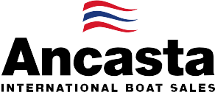

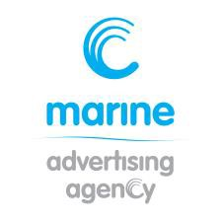
N e w s R e l e a s e
17th July 2017

Ancasta to present Beneteau world launch and UK debuts from Beneteau & Prestige at TheYachtMarket.com Southampton Boat Show 2017

Ancasta will present the world launch of the Beneteau Swift Trawler 35 at this year’s TheYachtMarket.com Southampton Boat Show, as well as the UK launch of the Prestige 520.

As the UK’s largest dealer for both Beneteau Power and Beneteau Sail, Ancasta will also present the UK debuts of the brand new Beneteau Oceanis 51.1, the Oceanis Yacht 62, and the Swift Trawler 50. TheYachtMarket.com Southampton Boat Show takes place 15-24th September 2017.
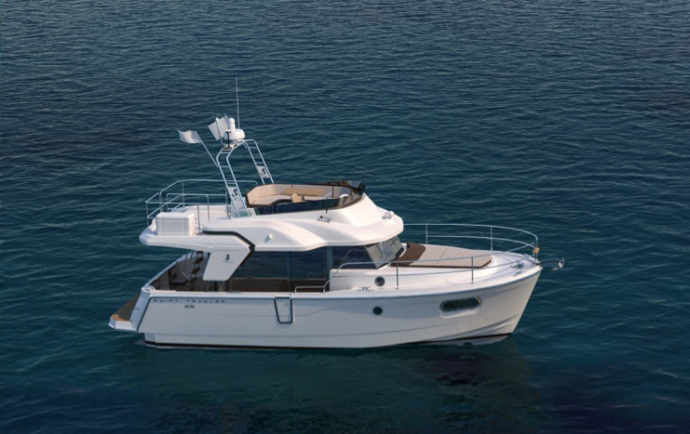
The Beneteau Swift Trawler 35, with its semi-planing flared hull, will have its world launch in Southampton this year. Designed for long cruises, the harmonious lines of the Swift Trawler 35, and its light-filled wheelhouse with 360º view, will make this one for visitors’ wish lists.
Prestige has chosen the show for the UK launch of the Prestige 520, the latest in the luxury motor yacht brand’s Flybridge line. The range is known for offering a vast spacious flybridge with socialising, sunbathing and dining in mind.
Beneteau Swift Trawler 35
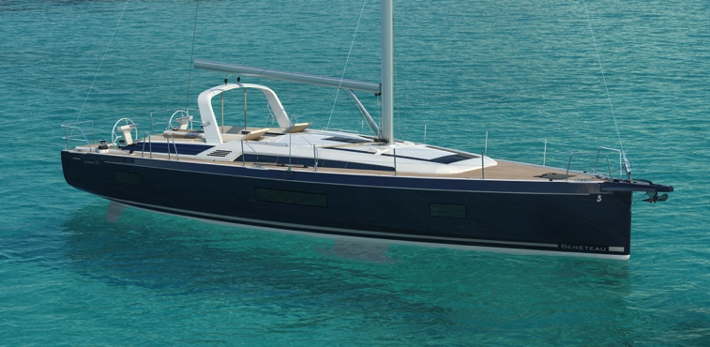
Also new from Beneteau, Ancasta is presenting the UK debut of the Oceanis 51.1 (which launches in Cannes days before the Southampton show). The 51.1. is the first in a new generation of Oceanis sailing yachts celebrating the 30th anniversary of the range. This will be an exciting addition to the Oceanis range, an on-trend, highly customisable, cruising yacht. The Oceanis Yacht 62 will also debut at the show. From Beneteau Power, the Swift Trawler 50 will showcase a new interior on its UK debut.
Beneteau Oceanis 51.1
Once again this year, the entire Beneteau Power and Beneteau Sail display will be on the water, giving easy access to all models and enabling visitors to see the boats afloat.
The full list of new boats that Ancasta will be presenting at TheYachtMarket.com Southampton Boat Show is as follows:
Lagoon 560
Lagoon 42
Prestige 630
Prestige 560
Prestige 520 UK LAUNCH

T: 023 9252 2044
E: Alison@marineadagency.com www.marineadagency.com
Marine Advertising Agency
15 Haslar Marina
Gosport PO12 1NU

Prestige 460
From Beneteau Sail –
Oceanis 51.1 UK DEBUT
Oceanis 45
Oceanis 41.1
Oceanis 38.1
Oceanis 35.1
Sense 57
Oceanis Yacht 62 UK DEBUT
From Beneteau Power –
Swift Trawler 35 WORLD LAUNCH
Swift Trawler 50 UK DEBUT
Swift Trawler 30
Gran Turismo 40
Gran Turismo 46

Ancasta will be at TheYachtMarket.com Southampton Boat Show from 15th to 24th September 2017. Contact Ancasta now to make an appointment to view any of the above, email enquiries@ancasta.com or call +44 2380 450000.
Ancasta will also be present at Cannes Yachting Festival (12-17th September 2017), where visitors will be able to see world launches of the Beneteau Oceanis 55.1, Prestige 520 and Prestige 630s, as well as the new Beneteau Gran Turismo 50 (plus its Sportfly version). Cannes Yachting Festival will also host world launches from Lagoon of the Lagoon 40, Lagoon 50 and Lagoon 78 Motor Yacht. Across the shows in Southampton and Cannes, boat buyers uniquely have the opportunity to see the full Lagoon range, enabling those looking to purchase a multi-hull to compare all models. With brokers on hand at the show, Ancasta is able to help UK buyers looking to visit Cannes, and can set up appointments to view the range of yachts and powerboats on display from its new boat brands.

For more information visit: http://www.ancasta.com

ENDS

Notes to editors
  - Ancasta International Boat Sales has 14 offices worldwide
  - Ancasta is the UK’s largest Prestige Luxury Motor Yachts dealer, the UK’s largest Beneteau Power and the UK’s largest Beneteau Sail dealer
  - Ancasta is exclusive UK dealer for Lagoon Catamarans
  - In addition Ancasta is a new boat dealer for CNB Yacht Builders and McConaghy Yachts
  - The Ancasta Group incorporates Hamble Yacht Services Refit & Repair and Advanced Rigging and Hydraulics, both operating from Port Hamble.
  - For more information on Ancasta visit www.ancasta.com Media enquiries via Marine Advertising Agency:
Alison Willis - alison@marineadagency.com Tel: 023 9252 2044

T: 023 9252 2044
E: alison@marineadagency.com www.marineadagency.com
Marine Advertising Agency
15 Haslar Marina
Gosport PO12 1NU

