News Release
For immediate release
7th August 2017

Marine Futures set sail again!

9 teenagers from the Gosport area have been selected to take part in this year’s Gosport Marine Futures course. The programme aims to inspire young people to take part in watersports and discover what Gosport has to offer. The long term ambition is to encourage more young people to take up careers in the marine industry.

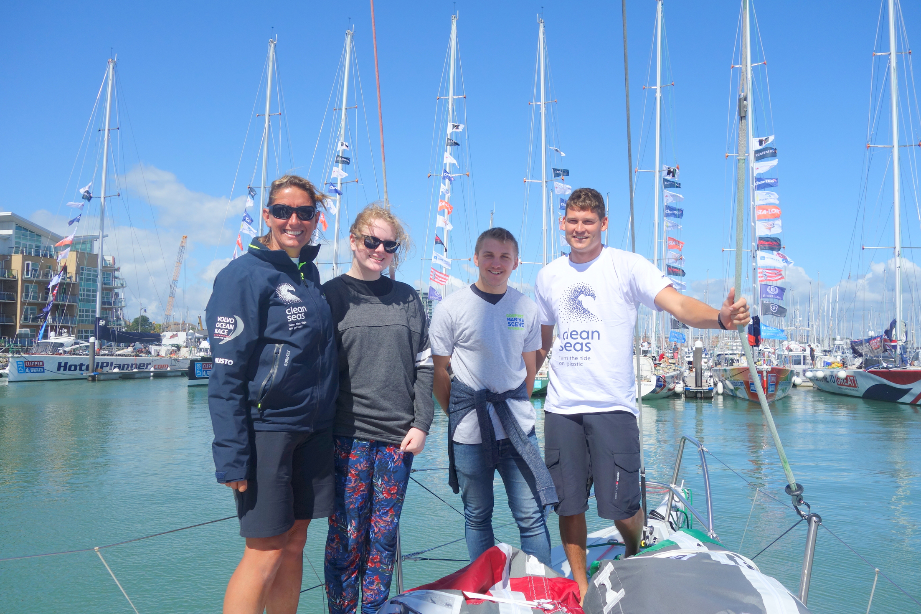
This year’s crew have already taken a look around a Clipper Round the World race yacht, and two Volvo Ocean Race boats. The highlight of their programme will be a week’s sail with the Discovery Sailing Project at the end of August.

After visiting the Volvo Ocean 65 ‘Turn the Tide on Plastic’, Ethan Roberts (17) said: “I enjoyed meeting Round the World Skipper Dee Caffari on our visit today, she was so friendly and down to earth. It was extremely interesting, with very experienced crew member Henry telling us how to sail the boat in different weather conditions and about the very basic living conditions on board; it was a real eye opener. I am looking forward to my week on board Discovery later this month so that I can learn more about sailing”.

Lucy Gross, Gosport Marine Scene, said:
‘I am delighted that 9 local young people have taken up the challenge to stretch their horizons and learn something new. Gosport has huge amounts to offer on the water but not just for the professionals: opportunities abound for young people to try sailing, kayaking, rowing, get involved in marine engineering and boat maintenance. Some of last years’ Futures crew are now sailing on a regular basis and are thinking about marine careers.’

Gosport Marine Futures is organised and funded by Gosport Marine Scene, a community interest company established to use the thriving marine sector as a
key to the future prosperity of Gosport, and to engage with young people to inspire them in sailing and marine related careers. Further details on www.gosportmarinescene.com.

ENDS

Notes for Editors
About Gosport Marine Scene and Gosport:
Organiser of Gosport's: Marine Business Network, Gosport Marine Festival June 2015, Gosport Marine Festival 2017, Talent & Career Programme
Gosport Peninsula is a centre of excellence in ocean racing, sail training, marine tourism and trade.
Gosport is the home of: Alex Thomson Racing & Hugo Boss, Clipper Round the World Race, Global Ocean Race, Sail Training International, ASTO, Ocean Youth Trust South, Lee-on-Solent RYA Onboard, Toe in the Water . . . just for starters.

