Cupernham House, Cupernham Lane, Romsey, Hampshire SO51 7LF

T +44 (0) 1794 521 111 F +44 (0) 1794 521 271

techsupport@westsysteminternational.com

westsysteminternational.com

WSI shares decades of epoxy knowledge at TheYachtMarket.com Southampton Boat Show

11 July 2017

West System International (WSI) is again attending TheYachtMarket.com Southampton Boat Show 2017. Visitors to stand J401 can discuss their project face to face with WSI’s technical experts for advice on the use of epoxy for boat building, repair and maintenance in addition to using epoxy to construct composites structures.

The team will be conducting live demonstrations covering the use of WEST SYSTEM epoxies, showing visitors how to get the most from their epoxy products. Demonstrations will be held at 12:00 and 14:30 each day.

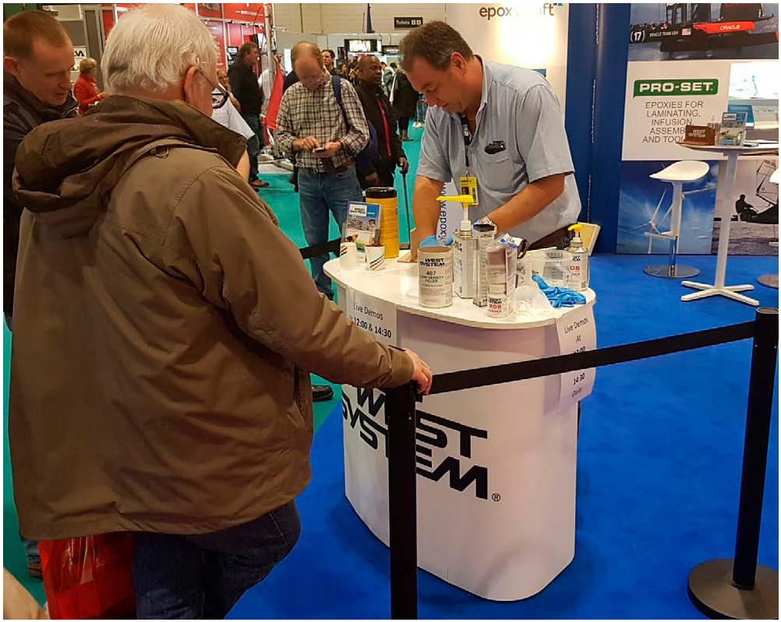
“It is our company ethos to openly share our decades of accumulated epoxy knowledge;
these demonstrations are the perfect vehicle for us to showcase how to use our products. We thoroughly enjoy Southampton Boat Show every year and the opportunity it provides for us to engage with our customers and end users of our products.” Says Ian Oliver, Managing Director of WSI.

WEST SYSTEM and PRO-SET products are market-leading and trusted by both professional boat builders and home project hobbyist’s worldwide.

West System International, manufactures WEST SYSTEM and PRO-SET epoxy products in the
UK under license from Gougeon Brothers Inc., and distributes these leading brands across the whole of Europe, Africa and the Middle East via a well-respected distribution network.

This year’s TheYachtMarket.com Southampton Boat Show runs from Friday 15th to Sunday 24th September 2017. The show is located at Mayflower Park / Town Quay, Southampton.

WSI will be exhibiting in the newly laid-out Ocean Hall at stand number J401.

Buy your One Day tickets for a special discounted price, with savings of up to 40%. Just follow this link https://nbs-southampton.yourticketbooking.com/p/2700 and use the promotion
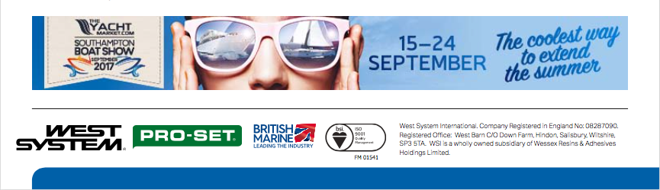
code EPTOQ7TJFT.

