For immediate release:
1st August 2017

Yak announces the return of the #WheresYakAt photo competition
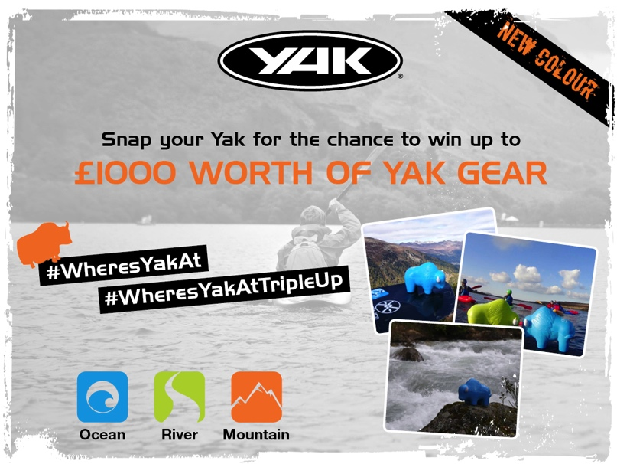
Yak is excited to announce that the popular #WheresYakAt photo competition is back and this time squishy Yak is popsicle orange! Last year’s competition saw the Yaks get up to all sorts of mischief. Not only were they getting involved in paddling adventures but they were also seen coasteering, enjoying a drink (or two!), chilling in a lighthouse and even scuba diving!
The 2017 #WheresYakAt photo challenge promises to be bigger and better with even more Yaks on the loose. Keen photographers and thrill seekers will be in the running to receive a huge bundle of Yak gear with £1000 and £500 Yak vouchers up for grabs, plus loads of mystery prizes for the runners up!

How to enter… Yak is running two competitions* alongside each other, #WheresYakAt and #WheresYakAtTripleUp
#WheresYakAt
- Grab a popsicle orange Yak from your local Yak stockist or Yak sponsored event
- Take your new Yak friend on an adventure
- Snap Yak in action
- Publicly post your photos on Facebook or Twitter using the hashtag #WheresYakAt for the chance of winning £500 worth of Yak gear! Don’t forget to tag the Yak page using @Yak.Adventure.Equipment (Facebook) or @Yak_Adventure (Twitter)
#WheresYakAtTripleUp – For the squishy Yak addict who has collected the previous green and blue Yaks!
- Grab a popsicle orange Yak from your local Yak stockist or Yak sponsored event
- Unite orange Yak with the rest of the gang
- Snap the orange, green and blue Yak in action
- Publicly post on any of the Yak social media pages with the hashtag #WheresYakAtTripleUp for the chance of winning £1000 worth of Yak gear! Don’t forget to tag the Yak page using @Yak.Adventure.Equipment (Facebook) or @Yak_Adventure (Twitter)
Both competitions will run from the 1st August to the 3rd December 2017. Yak is looking for the most daring and adventurous squishy yak out there and winners will be chosen based on this as well as photo originality. Winners will be announced during the week of the 4th December 2017 via the Yak social media pages; Twitter and Facebook.

Belong to a canoe club…?

If your club, school or organisation would like to be involved please email yak.marketing@survitecgroup.com to enquire about obtaining the orange squishy Yaks (while stocks last!)
* T&C’s apply. E&OE.
T&C’s
- By posting competition images on to the Yak social media sites, the entrant is agreeing to the terms and conditions of the competition set out below
- Yak will not be held accountable or liable for the images posted by entrants and reserve the right to remove any posts deemed inappropriate at their discretion
- Yak’s decision to disqualify an entry is final and no correspondence will be entered into
- Yak is permitted to use the entrant’s names and images posted for any commercial purpose, including future promotional marketing and publicity purposes without remuneration to the entrants.
- The prize is non-transferable and non–redeemable for cash
- E&OE

//ENDS//

For media information, hi-res images or product tests please contact:

Hazel Proudlock, Marketing Dept - Yak Adventure Equipment
T +44 (0) 1329 820406
E hazel.proudlock@survitecgroup.com

Or

Alison Willis – Marine Advertising Agency Ltd
T +44 (0) 23 9252 2044
E Alison@marineadagency.com

Notes to Editors
Part of the Survitec Group which also owns Crewsaver. Yak Adventure Equipment produces and manufactures products that are purposely designed for whitewater, recreational and touring kayaking as well as canoeing. A wide range of products suit all styles and experience, giving paddlers more choice and opportunity to enjoy their sport with total peace of mind. Yak’s products include buoyancy aids, drysuits, cags, trousers, spray decks, gloves, footwear, headwear and buoyancy bags. Together with Crewsaver, Yak has 60 years of experience manufacturing marine safety products that combine cutting edge technology with high performance and ultimate practicality.
www.yakadventureequipment.com

Survitec Group is a global leader in survival and safety solutions to the marine, defence, aviation and offshore markets. Survitec has over 3,000 employees worldwide covering 8 manufacturing facilities, 15 offshore support centres and over 70 owned service stations. It is further supported by a network of over 500 3rd party service stations and distributors. Across its 160-year history, Survitec Group has remained at the forefront of innovation, design and application engineering and is the trusted name when it comes to critical safety and survival solutions.
www.survitecgroup.com

