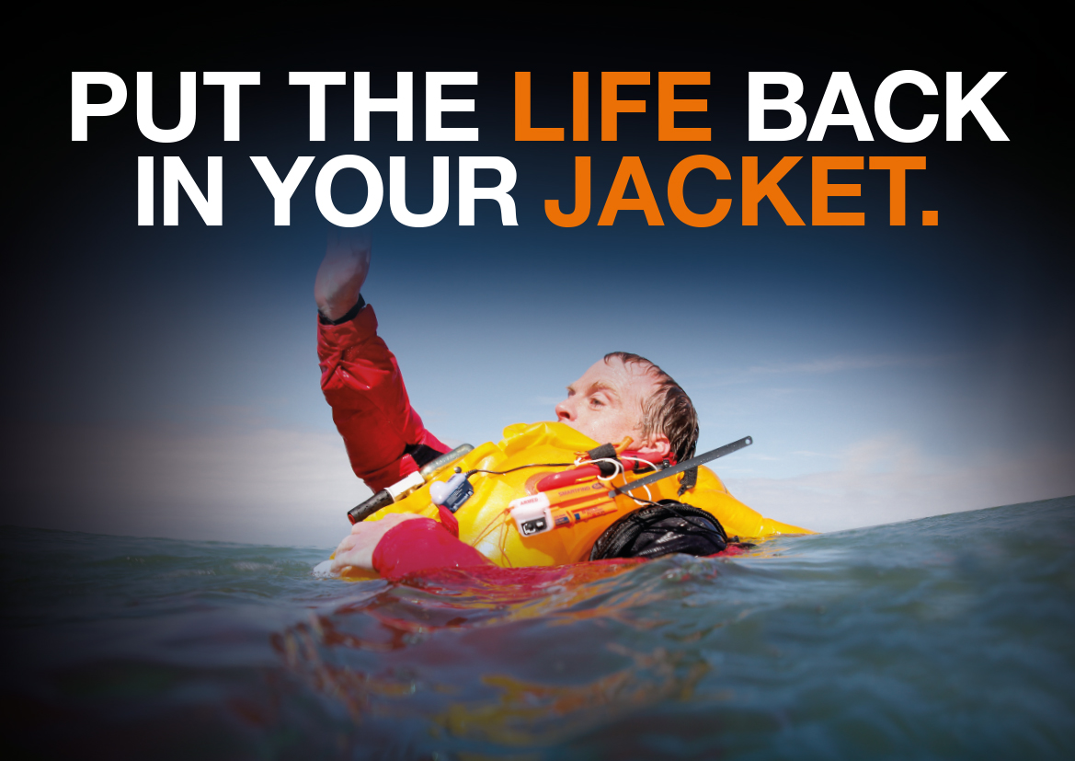
For Immediate Release: 14.09.17
Put the life back in your jacket - Crewsaver, #LifejacketSafe campaign champion, enhances product registration platform.
Lifejackets and liferafts need to be well maintained and serviced to perform at their optimum. Crewsaver recognises the necessity of this and urges Crewsaver lifejacket and liferaft owners to register their products. Through Crewsaver’s enhanced product registration platform, Crewsaver will then send the owner a reminder of when their service may be due. Helping them to remain as safe as possibly when out on the water.
“Here at Crewsaver we believe when you purchase your safety equipment it is only the beginning of your relationship with us. Registering your product with us is easy to do and may just save your life!” – Guy Page, Crewsaver Training Manager
Why register?
- Crewsaver will send you email reminders to get your lifejacket or liferaft serviced
- Your product details will be held on Crewsaver’s system - invaluable if you ever need to contact the Crewsaver team with an enquiry or if your lifejacket or liferaft is ever found
- Receive #LifejacketSafe safety tips
- Receive a FREE lifejacket bag if you register your product on the Crewsaver stand (J340) at TheYachtMarket.com Southampton Boat Show 2017
Registering your lifejacket is easy, simply head to the Crewsaver website with your serial number to hand and Crewsaver will do the rest. To register, visit: www.crewsaver.com/uk/product-registration
What is the #LifejacketSafe campaign?
The #LifejacketSafe campaign is championed by Crewsaver and aims to increase safety awareness by highlighting the importance of not only wearing a personal flotation device, but also making sure it is worn correctly and is well maintained. To find out how you can stay #LifejacketSafe, visit: http://crewsaver.com/uk/lifejacketsafe/
//ENDS//

For media information, hi-res images or product tests please contact:

Crewsaver
Hazel Proudlock, Marketing Dept
T +44 (0) 1329 820406
E hazel.proudlock@survitecgroup.com

Alison Willis – Marine Advertising Agency Ltd
T +44 (0) 23 9252 2044
E Alison@marineadagency.com

Notes to Editors

Crewsaver is a world-leading manufacturer of marine safety equipment and clothing for the commercial and leisure marine industries. Based in Gosport, Hampshire, the company designs and manufactures bespoke safety equipment for several countries’ Special Forces, and the aviation and oil industries. Crewsaver is the only company to hold an exclusive contract to supply lifejackets to the UK government’s Environment Agency and the Royal National Lifeboat Institution (RNLI). They are part of the Survitec Group.

www.crewsaver.com

Survitec Group Survitec is a global leader in survival and safety solutions to the marine, defence, aviation and offshore markets. Survitec has over 3,000 employees worldwide covering 8 manufacturing facilities, 15 offshore support centres and over 70 owned service stations. It is further supported by a network of over 500 3rd party service stations and distributors. Across its 160-year history, Survitec Group has remained at the forefront of innovation, design and application engineering and is the trusted name when it comes to critical safety and survival solutions.
www.survitecgroup.com

