N e w s R e l e a s e
15th September 2017

Beneteau Swift Trawler 35 celebrates World Launch at TheYachtMarket.com Southampton Boat Show 2017

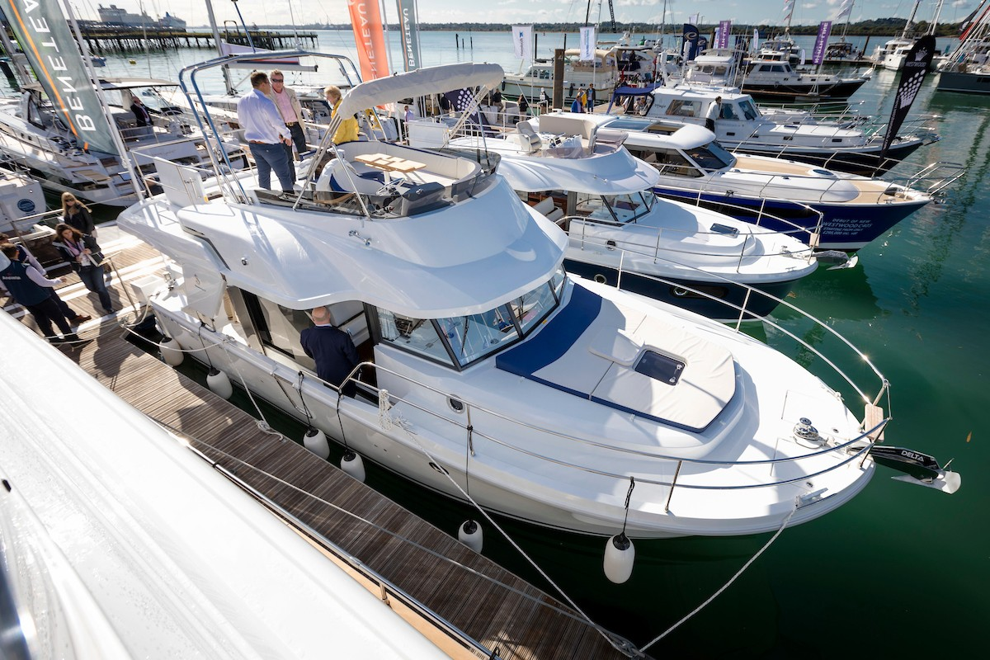
The world launch of the Beneteau Swift Trawler 35 took place on Friday 15th September 2017 at
TheYachtMarket.com Southampton Boat Show (15th- 24th September 2017).

The Beneteau Swift Trawler 35 is taking over from the extremely successful Swift Trawler 34, which sold over 400 boats in her tenure. Not an easy task but this completely new boat with a redesigned hull takes on this challenge and not only succeeds but brings a trawler style boat bang up to date! Designed for comfortable cruising whether for long periods or
Swift Trawler 35
short hops, the Swift Trawler 35 will certainly tick the boxes for owners and guests alike. It’s evident that its harmonious lines and light-filled wheelhouse with 360o view are making this one for show visitors’ wish lists.

The Cummins 425hp engine and newly designed semi-planing hull work together to make this Swift Trawler 35 easy to manoeuvre and a pleasure to pilot. The design team has focussed on making the hull shape as efficient as possible to increase her cruising range, while tweaking the entry to make her comfortable at sea no matter what is thrown at you. The flybridge can either be protected by a bimini or soft top, and there is plenty of space to relax and enjoy the sea views. Broad walkways, lots of hand rails and high pushpits (higher than required by regulations) illustrate the importance attached to safety on board.
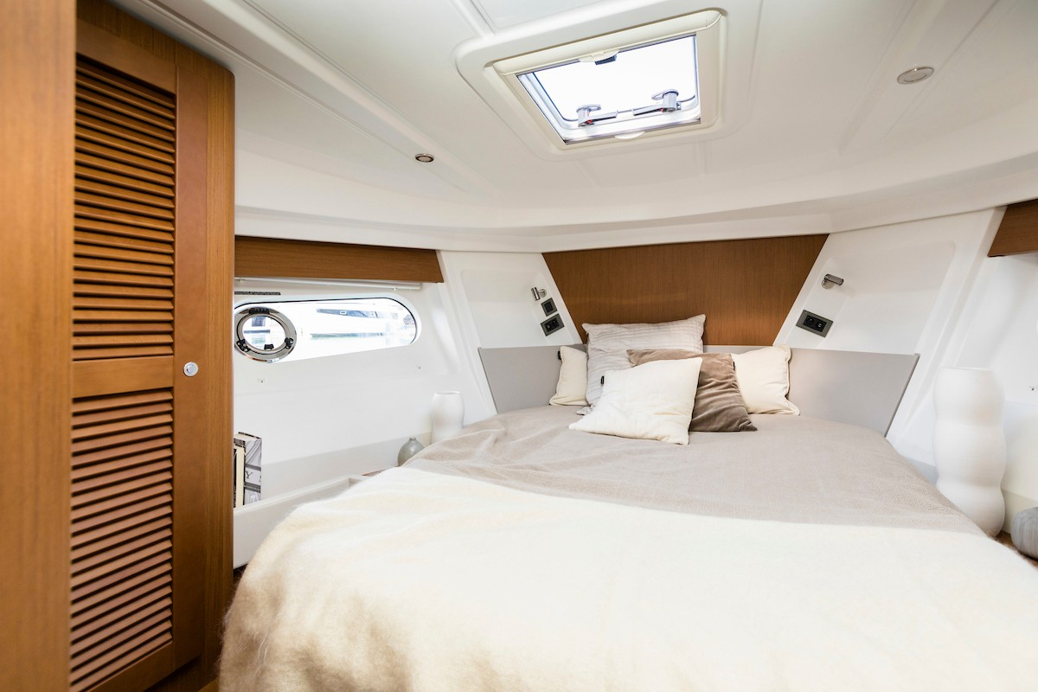
The spacious interior benefits from ingenious contemporary fittings. The owner’s cabin has a walkaround double berth bathed in light from the large hull windows and an en-suite shower room, while the second cabin is equipped with comfortable twin bunks. The U-shaped galley is fitted with a twin sink that converts to add additional worktop space, and also has an extra forward-facing seat. Seating in the saloon converts simply to add a comfortable double berth to the accommodation. The Swift Trawler 35, on its world launch, is

becoming one of the must-see boats at TheYachtMarket.com Southampton Boat Show and with availability limited for 2018 is sure to sell quickly!
Swift Trawler 35 - interior

T : 02392 522044
E: alison@marineadagency.com
www.marineadagency.com
Marine Advertising Agency
15 Haslar Marina Gosport, PO12 1NU

Beneteau Area Sales Manager, Matthieu Baillorge, said of the Swift Trawler 35, “Launching a new boat is always difficult, but when it comes to replacing such a successful model as the ST 34, it becomes a even trickier challenge! But our team did an amazing job with this brand new ST35, thanks to the feedback from our owners all over the world during our Swift Trawler Rendez-Vous. The new owner’s cabin, the fly, and the brand new hull design with amazing fuel efficiency, will make this boat an incredible success.”

Beneteau Power is also showcasing a new redesigned interior for the Swift Trawler 50 at the show. The entire Beneteau Power display is on the water, giving easy access to all models and enabling visitors to see the boats afloat.

The full list of Beneteau Power models available to view at TheYachtMarket.com Southampton Boat Show is as follows:

Swift Trawler 35 WORLD LAUNCH Swift Trawler 50 NEW INTERIOR Swift Trawler 30
Gran Turismo 40
Gran Turismo 46

TheYachtMarket.com Southampton Boat Show is on from 15th to 24th September 2017.
Contact Ancasta now to make an appointment to view any of the above, call +44 2380 450000. For more information visit: http://www.ancasta.com
ENDS

Notes to editors

- Ancasta International Boat Sales has 14 offices worldwide
- Ancasta is the UK’s largest Prestige Luxury Motor Yachts dealer, the UK’s largest Beneteau Power and the UK’s largest Beneteau Sail dealer
- Ancasta is exclusive UK dealer for Lagoon Catamarans
- In addition Ancasta is a new boat dealer for CNB Yacht Builders and McConaghy Yachts
- The Ancasta Group incorporates Hamble Yacht Services Refit & Repair and Advanced Rigging and Hydraulics, both operating from Port Hamble.
- For more information on Ancasta visit www.ancasta.com

Media enquiries via Marine Advertising Agency:

Alison Willis - alison@marineadagency.com Tel: 023 9252 2044

T: 02392 522044
E: alison@marineadagency.com www.marineadagency.com
Marine Advertising Agency
15 Haslar Marina Gosport, PO12 1NU

