Kraken 66 wins Sailing Today 2017 award for best blue water cruiser.

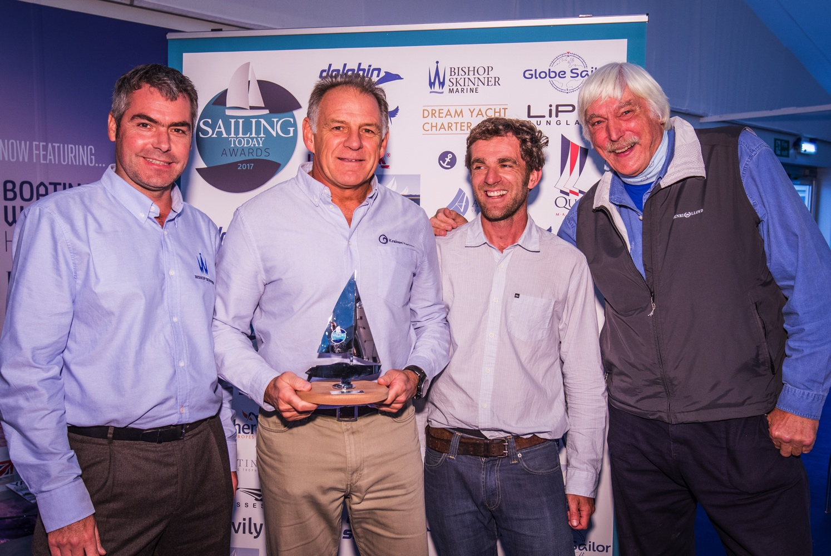
Kraken Sales Director, Mark Williams (2nd from left), receives the Sailing Today Award for Best Blue Water Cruiser for the Kraken 66 from Sailing Today Editor Sam Jefferson (2nd from right), Tom Cunliffe (far right) and Paul Birch, Managing Director, Bishop Skinner Marine (far left).

Kraken Yachts Ltd is delighted to announce that its flagship Kraken 66 has been elected the winner of the Blue Water Cruiser category in the prestigious 2017 Sailing Today Awards presented at TheYachtMarket.com Southampton Boat Show on September 15th.

The Kraken 66 was selected from a star-studded shortlist comprising models from the Najad, Amel, Hallberg-Rassy and Bénéteau ranges. Kraken Yachts Ltd would like to thank Sailing Today for awarding this singular honour to the Kraken 66.

Designed by award-winning New Zealander Kevin Dibley and his team, the new Kraken range – comprising the Kraken 66, 58 and 50 – does not set out to be all things to all people. Instead it is aimed specifically at the blue water cruising market. It therefore incorporates numerous features designed to give maximum safety, comfort and easy handling under sail to owners looking for a yacht that can take them – short handed if that’s their preference - on extended voyages.

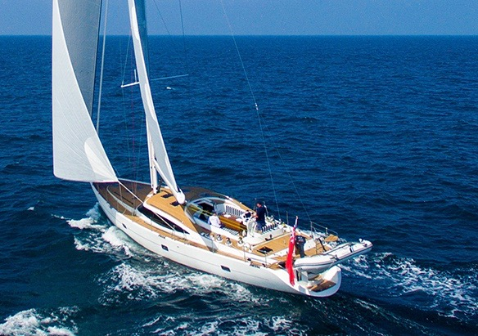

To prove the point, Kraken’s Chairman Dick Beaumont has already covered 10,000nm in his Kraken 66 White Dragon. He set sail from Hong Kong in February 2017 and is currently in Madagascar.

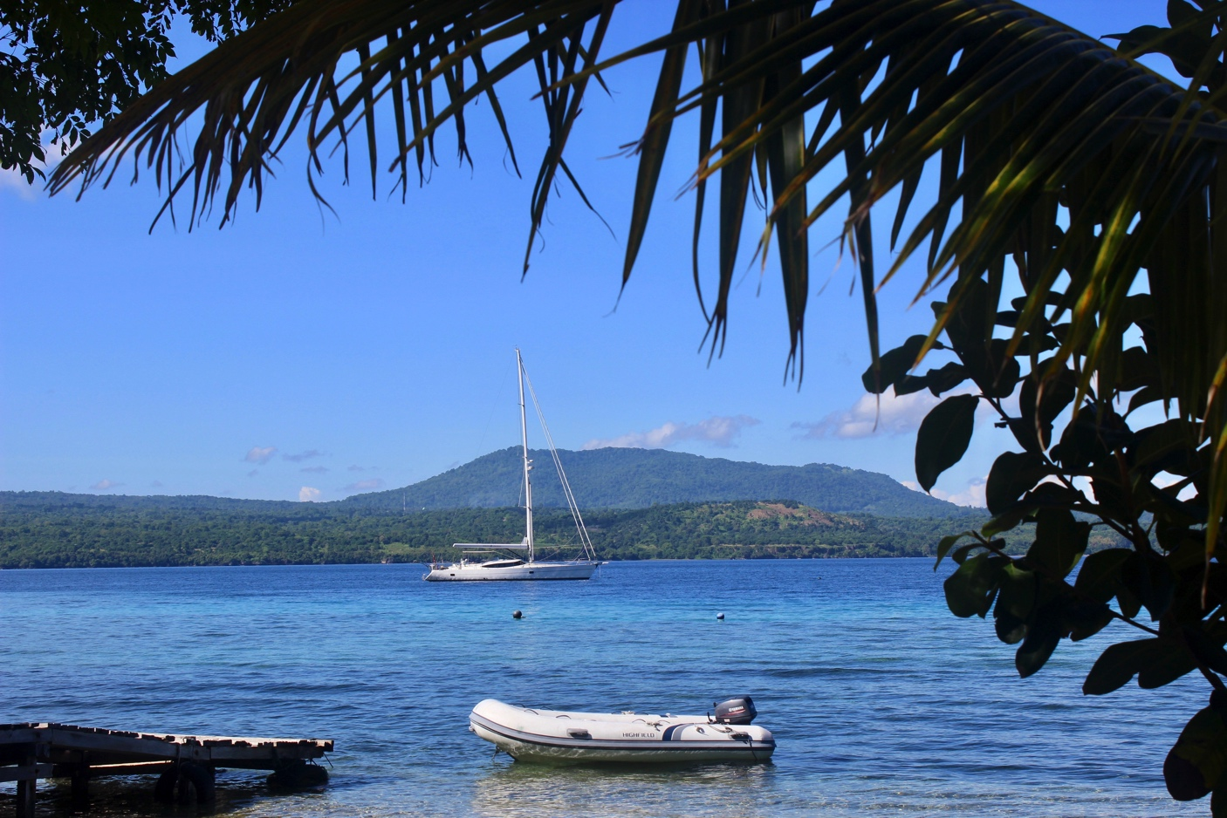
Tropical paradise. White Dragon pauses in Mauritius

After the first 576nm passage of this trip Beaumont wrote in his soon to be published blog “White Dragon has exceeded our best expectations, sailing at a comfortable and impressive 9kn average speed for the duration of the trip. She has coped beautifully with big seas coming dead across the beam and she maintained a very steady motion the whole way.”

White Dragon aims to arrive in Cape Town in December where the Kraken team will hold a month-long promotion of the Kraken 66 from 16th January to 16th February 2018. Potential clients can contact Sales Director Mark Williams to book and so combine their winter break in sunny South Africa with a private viewing and trial sail.

Beaumont said of the trip so far “After 10,000nm crossing the South China Sea, the Sulu Sea, the Java Sea and a 4,000nm crossing of the Indian Ocean we can say she is truly fit for the purpose of short handed ocean cruising. As I write this, just two of us are sailing her down the east coast of Madagascar doing 10kts with 25kts of wind on the beam.” After time in Cape Town, he will then sail on to St.Helena, Ascension Island, Brazil, the Azores and back to Gibraltar. So White Dragon will have covered about 17,500nm. As Beaumont says “Not bad for a shakedown trip!”

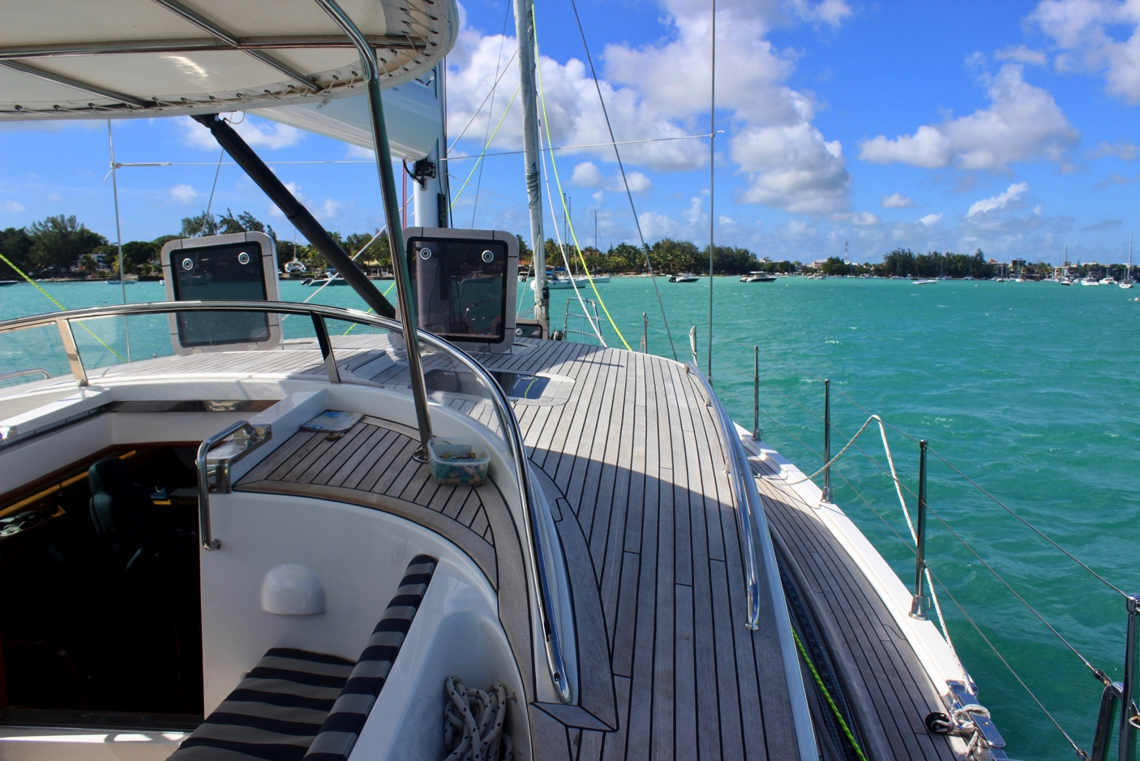
A fixed bimini and lots of ventilation are essential under a hot sun

Find out more at http://www.krakenyachts.com/

Notes to Editors

Kraken Yachts Ltd.
Gold Coast Marina, 1 Castle Peak Rd., Castle Peak Bay, N.T., Hong Kong.
Swanwick Marina, Southampton, SO31 1ZL, UK

www.krakenyachts.com
sales@krakenyachts.com

Hong Kong: +852 26189335
Hong Kong cell phone: +852 9666 4740
UK +44 (0) 1489 809126
UK cell phone: +44 7507 466006

More high-resolution images of the Kraken 66 can be found online at:
http://marineadagency.com/gallery/kraken-66-luxury-bluewater-cruiser/

Chairman: Dick Beaumont. He has developed companies and has lifelong extensive business interests worldwide. He has covered over 100,000 miles cruising the world under sail.

Managing Director: Roger Goldsmith. He oversees business affairs and design coordination that are managed from the Hong Kong headquarters

Sales Director: Mark Williams; previously worked with several other prestigious sailboat manufacturers.

KRAKEN 66
Price. US$ 1,795,000 ex VAT ex Hong Kong.
Length Overall | 20.12 m | 66ft
Waterline Length | 18.11 m | 59.42 ft
Beam Overall | 5.50 m | 18.0 ft
Draft | 2.65 m | 8.7 ft
Displacement | 37,750 kg | 83,224 lb
Ballast Weight | 12,500 kg | 27,557 lb
Sail Area | 215.8 sq.m | 2,322 sq.ft
Sail Area (100% Foretriangle) | 87.10 sq.m | 937.54 sq. ft
Sail Area (Including Roach) | 128.71 sq.m | 1,385.42 sq. ft
Engine Power | 150 KW | 200 HP
Fuel Tank | 1,900 litres | 500 Gallon
Fresh Water Tanks | 1,200 litres | 330 Gallon
CE Certification: | RCD Category ‘A’ Ocean

