N e w s R e l e a s e

15th September 2017

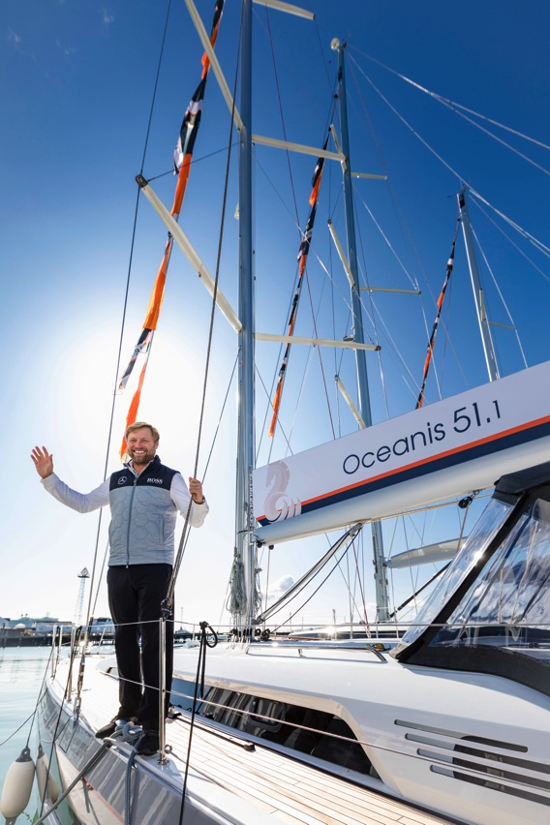
Beneteau Oceanis 51.1 launched in the UK by Alex Thomson at TheYachtMarket.com Southampton Boat Show 2017

The new Beneteau Oceanis 51.1, the first in a new generation of Oceanis cruising yachts, was launched in the UK at TheYachtMarket.com Southampton Boat Show by Alex Thomson on 15th September 2017.

The Oceanis 51.1 is truly pushing the boundaries in both design and technology. As the first of a new generation of Oceanis cruising yachts, the 51.1 features a new stepped hull, stylish deck plan and genuine high-end performance options. These all culminate in a cleverly designed, fast, spacious yacht that is exciting yet easy to handle.

Beneteau is proud to present the Beneteau Oceanis 51.1 and the Oceanis Yacht 62 on their UK debuts at this year’s show, which takes place 15-24th September 2017.

British sailor Alex Thomson is the fastest Brit to sail solo, non-stop around the world on a monohull, finishing second in the 2016 Vendée Globe, just hours behind the winner Armel Le C’leach. Sponsored by HUGO BOSS since 2003, Thomson has been pushing boundaries and breaking records since his offshore sailing career started in 1995.

Both Beneteau and Alex Thomson challenge the norm, making Alex the natural choice to launch the first of the new Oceanis range of yachts, which reinvents the concept of this cruising yacht.

The Beneteau Oceanis 51.1 has already been nominated for European Yacht of the Year 2018, and is the first in a new generation of Oceanis sailing yachts celebrating the 30th anniversary of the range. Described as a smart cruiser, features include a self-tacking jib, in-mast furling mainsail, and Beneteau’s Dock&Go system, with the option for a deep keel / tall rig performance version. In terms of comfort, a large bathing platform and sun beds add to the appeal of this cruiser. Fast, comfortable and easy to sail, this will be an exciting addition to the Oceanis range, an on-trend, highly customisable, cruising yacht.

"It’s an honour to launch the new Beneteau Oceanis 51.1 having such a connection with the French through the Vendée, I’m delighted to be involved in launching this innovative cruising yacht, the first in a new generation.” – Alex Thomson

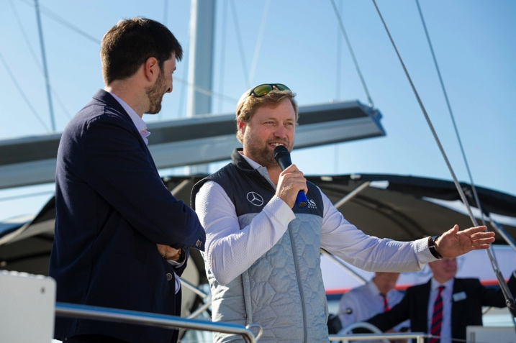
Matthieu Baillorge, Area Sales Manager for Beneteau, said “We are very proud to welcome Alex Thomson to our stand. He pushes the boundaries of the extreme sailing world, keeping the suspense of the last Vendée going right to the end, making it very exciting for all of us. That’s what we are trying to do with the latest generation of Oceanis. This a completely new generation of boat, starting with the Oceanis 51.1, with a new shape and a new hull design, which gives the owner a lot more space inside the boat without compromising performance.”
Once again this year, the entire Beneteau Sail display at the show is on the water, giving easy access to all models and enabling visitors to see the boats afloat.
Matthieu Baillorge and Alex Thomson onboard the Beneteau Oceanis 51.1, which launched in the UK at TheYachtMarket.com Southampton Boat Show on 15th September 2017
The full list of new sail boats that Beneteau is presenting at TheYachtMarket.com Southampton Boat Show is as follows:

Oceanis 51.1 UK DEBUT
Oceanis 45
Oceanis 41.1
Oceanis 38.1
Oceanis 35.1
Sense 57
Oceanis Yacht 62 UK DEBUT

TheYachtMarket.com Southampton Boat Show is open from 15th to 24th September 2017. Contact Ancasta now to make an appointment to view any of the above, or call +44 2380 450000. For more information visit: http://www.ancasta.com/

ENDS

Notes to editors
  - Ancasta International Boat Sales has 14 offices worldwide
  - Ancasta is the UK’s largest Prestige Luxury Motor Yachts dealer, the UK’s largest Beneteau Power and the UK’s largest Beneteau Sail dealer
  - Ancasta is exclusive UK dealer for Lagoon Catamarans
  - In addition Ancasta is a new boat dealer for CNB Yacht Builders and McConaghy Yachts
  - The Ancasta Group incorporates Hamble Yacht Services Refit & Repair and Advanced Rigging and Hydraulics, both operating from Port Hamble.
  - For more information on Ancasta visit www.ancasta.com

Media enquiries via Marine Advertising Agency:
Alison Willis - alison@marineadagency.com
Tel: 023 9252 2044

