For Immediate Release: 08.09.2017

Yak Adventure Equipment is back at PADDLEexpo 2017! Find us on stand I54

Whether you’re a lover of whitewater, touring or ripping up the surf, Yak Adventure Equipment has you covered. Join the Yak team at PADDLEexpo 2017 (19th-21st Sept 2017, Germany), to see how the Yak range expertly combines safety with practicality and style.

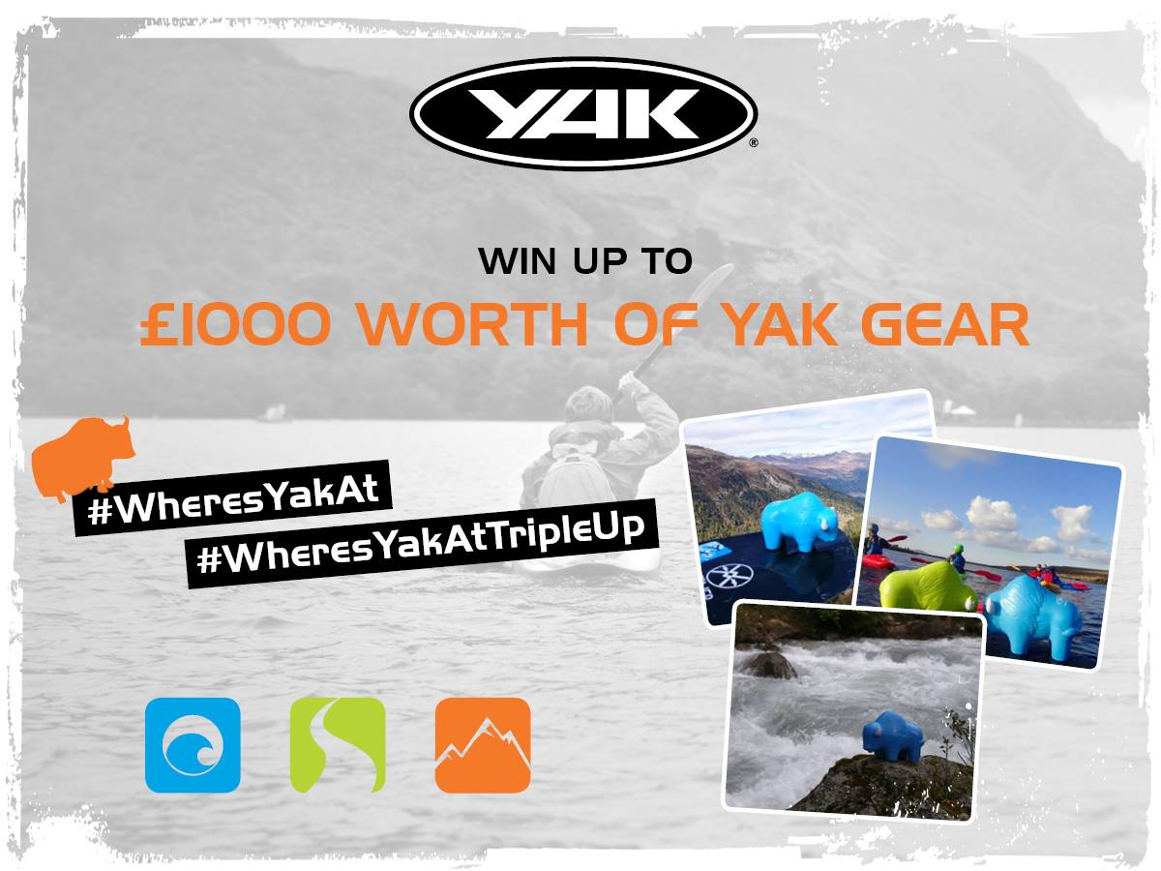
The Yak range is packed full of vibrant buoyancy aids, technical clothing and accessories, all designed to enhance performance and make your paddle time extra comfortable. Check out the newest addition to the Yak range, the High Back 60N buoyancy aid. Its raised-back profile means that no matter what type of boat you are in, you can be assured of its comfort properties. Yak’s technical experts will be on stand I54 to answer any questions you have.

In addition, visitors to the show have the chance to get their hands on a free squishy Yak and take part in the photo challenge to win up to £1000 worth of Yak adventure gear! *

#WheresYakAt photo challenge
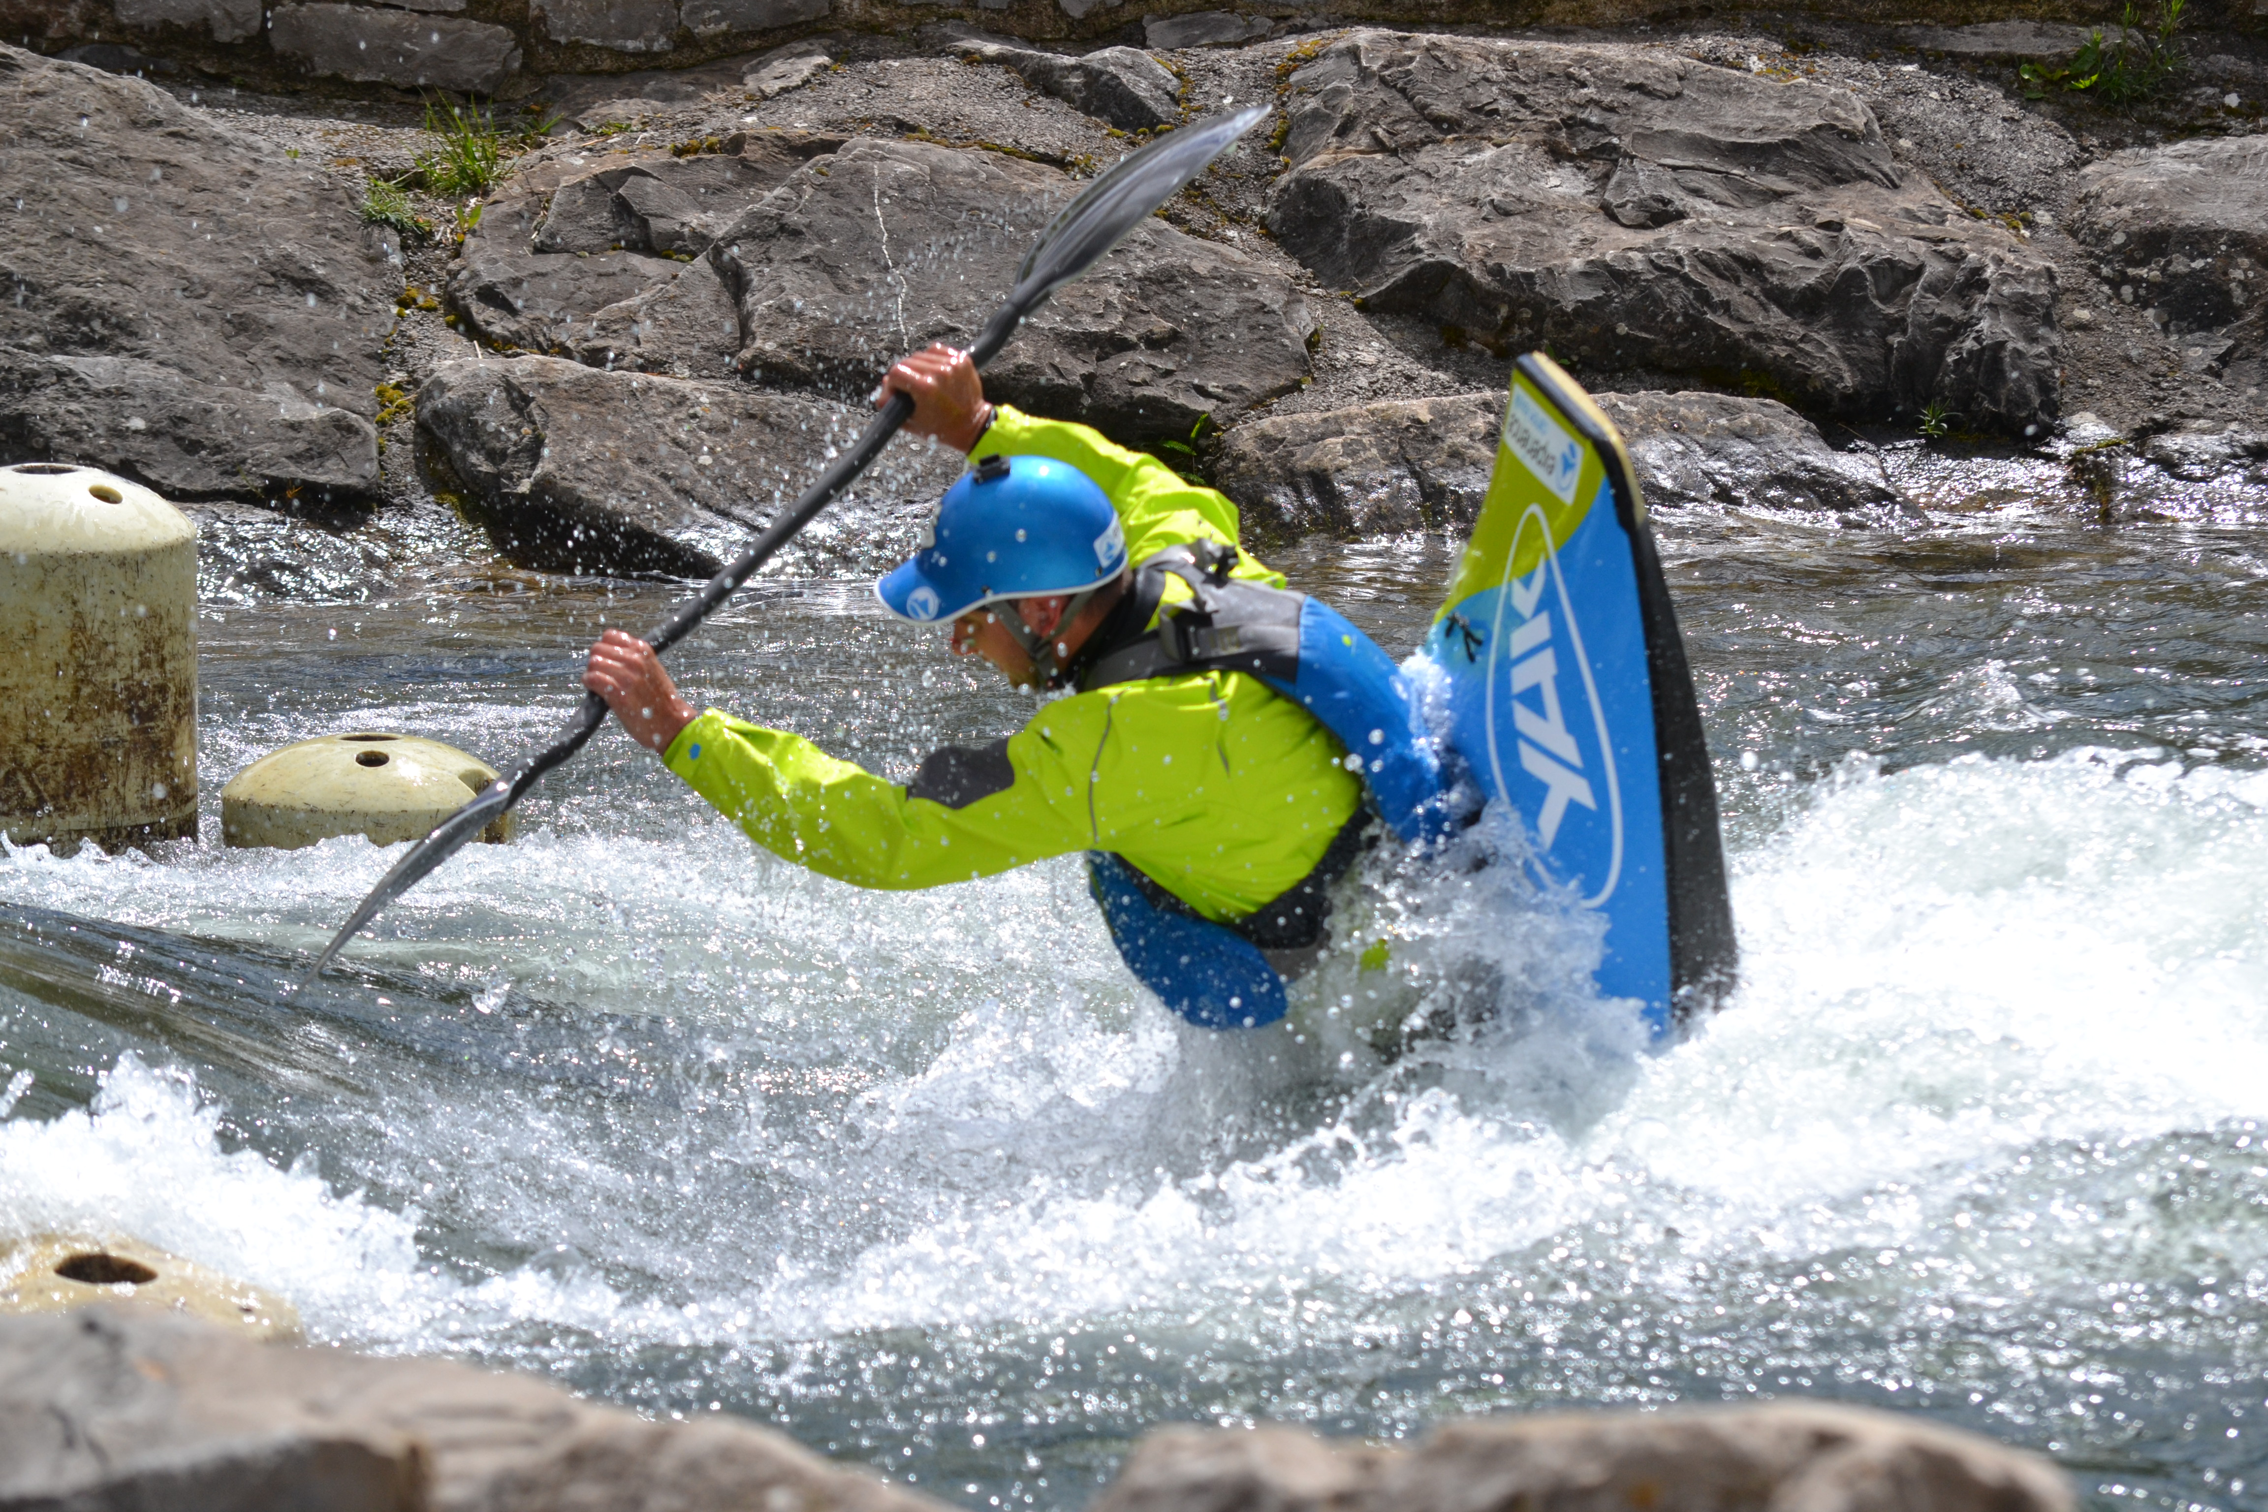
- Head to the Blue & White stand, I54, to pick up your FREE orange Yak
- Take your new Yak friend on an adventure
- Snap Yak in action
- Publicly post your photos on Facebook or Twitter using the hashtag #WheresYakAt for the chance of winning £500 worth of Yak gear! Don’t forget to tag the Yak page using @Yak.Adventure.Equipment (Facebook) or @Yak_Adventure (Twitter)

#WheresYakAtTripleUp photo challenge – For the squishy Yak addict who has collected the previous green and blue Yaks!
- Head to the Blue & White stand, I54, to pick up your FREE orange Yak
- Unite orange Yak with the rest of the gang
- Snap the orange, green and blue Yak in action
- Publicly post on any of the Yak social media pages with the hashtag #WheresYakAtTripleUp for the chance of winning £1000 worth of Yak gear! Don’t forget to tag the Yak page using @Yak.Adventure.Equipment (Facebook) or @Yak_Adventure (Twitter)

Both competitions will run until the 3rd December 2017. Yak is looking for the most daring and adventurous squishy Yak out there and winners will be chosen based on this as well as photo originality. Winners will be announced during the week of the 4th December 2017 via the Yak social media pages; Twitter and Facebook

* T&C’s apply, to view in full visit: http://crewsaver.com/uk/yak/news/yak-announces-the-return-of-the-wheresyakat-photo-competition/

ENDS//

For media information, hi-res images or product tests please contact:

Hazel Proudlock, Marketing Dept - Yak Adventure Equipment
T +44 (0) 1329 820406
E hazel.proudlock@survitecgroup.com

Or

Alison Willis – Marine Advertising Agency Ltd
T +44 (0) 23 9252 2044
E Alison@marineadagency.com

Notes to Editors
Part of the Survitec Group which also owns Crewsaver. Yak Adventure Equipment produces and manufactures products that are purposely designed for whitewater, recreational and touring kayaking as well as canoeing. A wide range of products suit all styles and experience, giving paddlers more choice and opportunity to enjoy their sport with total peace of mind. Yak’s products include buoyancy aids, drysuits, cags, trousers, spray decks, gloves, footwear, headwear and buoyancy bags. Together with Crewsaver, Yak has 60 years of experience manufacturing marine safety products that combine cutting edge technology with high performance and ultimate practicality.
www.yakadventureequipment.com

Survitec Group is a global leader in survival and safety solutions to the marine, defence, aviation and offshore markets. Survitec has over 3,000 employees worldwide covering 8 manufacturing facilities, 15 offshore support centres and over 70 owned service stations. It is further supported by a network of over 500 3rd party service stations and distributors. Across its 160-year history, Survitec Group has remained at the forefront of innovation, design and application engineering and is the trusted name when it comes to critical safety and survival solutions. www.survitecgroup.com

