***Press release – Immediate release*****

Superyacht Tenders and Toys (SYTT) offers new Refit Programme service
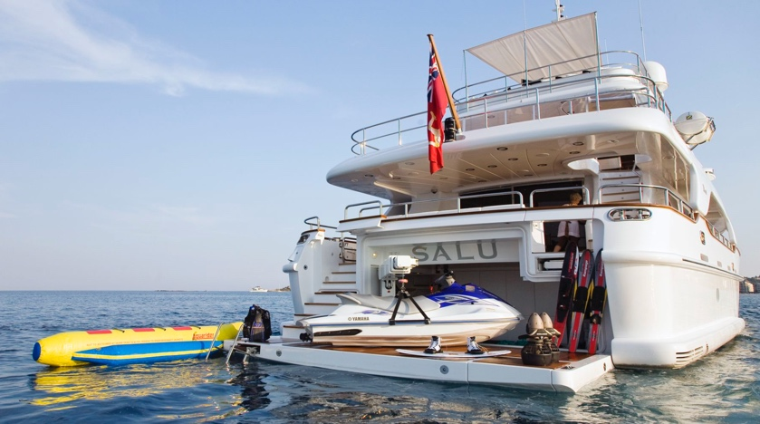
Superyacht Tenders and Toys, who recently won the Queens Award for International Trade 2017 and is already well known for new-build outfitting, is expanding its services to specifically tailor them to superyachts undergoing refits.
SYTT has identified a need in the market to assist yachts during yard refit periods by collecting, storing, repairing and replacing equipment on board. This includes water toys, diving, gym and safety equipment, tenders, jetskis and more. With technicians trained to service and repair, along with under cover storage facilities within reach of the main refit hubs of the South of France, Italy, Spain, Holland and Germany this service ensures that the equipment can be removed, checked, itemised, cleaned and repairs or replacements can be quoted for as required. They can then be returned when the yacht requires them in the best possible condition ready for the next season. With vehicles regularly delivering and collecting in these locations shared loads are possible, keeping shipping and logistics costs down.
SYTT is also a member of ABYA (Association of Brokers and Yacht Agents) and is able to offer the Customs Warehousing Scheme for tenders. This means that they can store tenders which were purchased ex-VAT, ensuring no VAT liability for the yacht when taken off board and shipped for storage.
Mark Peak, Yacht Toy Specialist, says “We are very excited to offer this new service to yachts. We focus a lot on new build yachts but many of the operational yachts get their equipment worked hard over the season, especially when busy with charters. This ensures that the yacht can simply offload all equipment when entering a yard period and they have the peace of mind of knowing that it is going to be looked after and that they get it back when required in fully working order. If anything needs repairing or replacing we offer the best value packages in the industry and can discuss trade-in options where relevant.”
To learn more about Superyacht Tenders and Toys, visit
www.superyachttendersandtoys.com
ENDS
Media enquiries via Marine Advertising Agency:
Alison Willis, alison@marineadagency.com
Emma Stanbury, emma@marineadagency.com
T: 023 9252 2044
Or
Josh Richardson, Superyacht Tenders and Toys
T: UK +442380016363
T: France +33489733347
T: US +19643029066
E: info@sytt.co
Notes to Editors:
Superyacht Tenders and Toys is the leading independent consultancy and management company specialising in all superyacht tender and toy needs and provides practical solutions for the World’s finest yachts. Superyacht Tenders and Toys won the Queen’s Award for Enterprise: International Trade 2017, the most prestigious business award in the UK.

