News Release

6th November 2017

See flagship Beneteau boats, the Lagoon 40 and the stunning CNB 66 in Paris with Ancasta
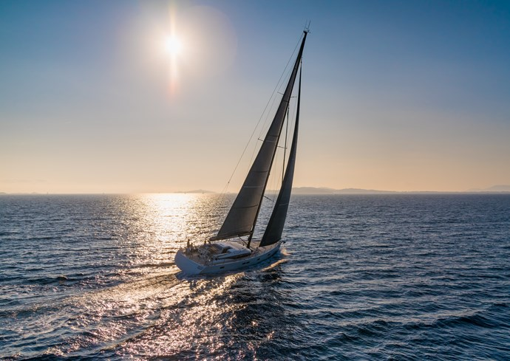

Beneteau is exhibiting a comprehensive selection of boats from its sail and power ranges at Nautic Paris (2-10 December 2017). The new CNB 66 will also be at the show for the first time along with the Lagoon 40. UK buyers should contact Ancasta International Boat Sales (02380 450 000, www.ancasta.com) to arrange appointments to view.

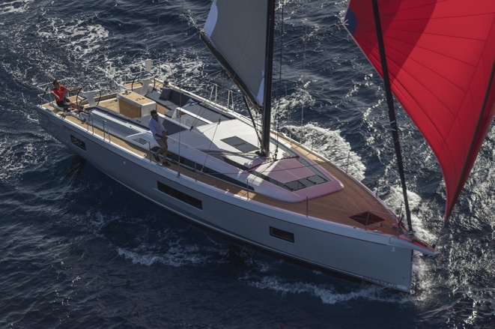
Ancasta is offering support to those wishing to attend the show where, in addition to the CNB 66 and Lagoon 40, Ancasta will be presenting Beneteau’s First 25, the Oceanis range, the Antares 36, and boats in the Gran Turismo and Swift Trawler ranges.
See the CNB 66 at Nautic Paris with Ancasta

The Ancasta team can help UK buyers get the most out of a visit to Nautic, the Paris boat show. The team can ensure that UK buyers have appointments to see the new Beneteau, CNB and Lagoon boats on show. Ancasta can also help with travel arrangements. Those planning to visit are encouraged to contact Ancasta as soon as possible for help organising their trip.
See the Oceanis 51/1 at Nautic Paris with Ancasta
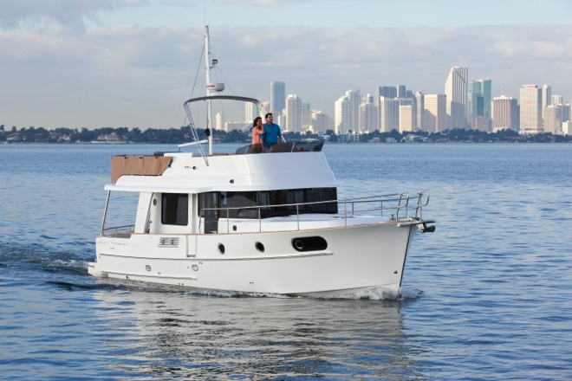

The impressive list of boats on show is as follows:

Beneteau Sail

First 25

Figaro 3 (TBC – see the much-anticipated prototype of this exciting new race boat)

Oceanis 35.1/38.1/41.1/45/51.1

Sense 51

Beneteau Power
See the Swift Trawler 44 at Nautic Paris with Ancasta

Antares 36

Gran Turismo 40/46/50 Sportfly

Swift Trawler 30/35/44

Lagoon Catamarans

Lagoon 40

CNB Yacht Builders

CNB 66

Contact Ancasta now to make an appointment to view any of the above, email enquiries@ancasta.com or call +44 2380 450000.

For more information visit:

https://www.ancasta.com/events/paris-boat-show-2017/

ENDS

Notes to editors
- Ancasta International Boat Sales has 14 offices across Europe
- Ancasta is the UK’s largest Prestige Luxury Motor Yachts dealer, the UK’s largest Beneteau Power and the UK’s largest Beneteau Sail dealer
- Ancasta is exclusive UK dealer for Lagoon Catamarans
- In addition Ancasta is a new boat dealer for CNB Yacht Builders and McConaghy Yachts
- The Ancasta Group incorporates Hamble Yacht Services Refit & Repair and Advanced Rigging and Hydraulics, both operating from Port Hamble.
- For more information on Ancasta visit www.ancasta.com
Media enquiries via Marine Advertising Agency: Alison Willis - alison@marineadagency.com Tel: 023 9252 2044

